Exhibit A
11551 Forest Central
Suite 102

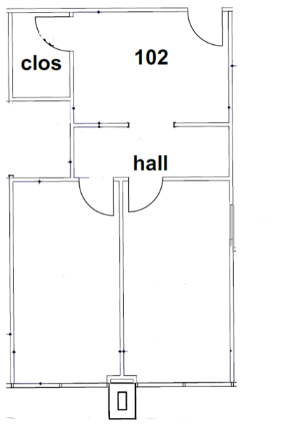

Approximately 700 SF

