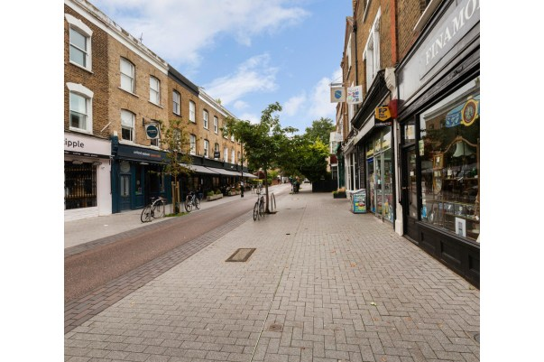
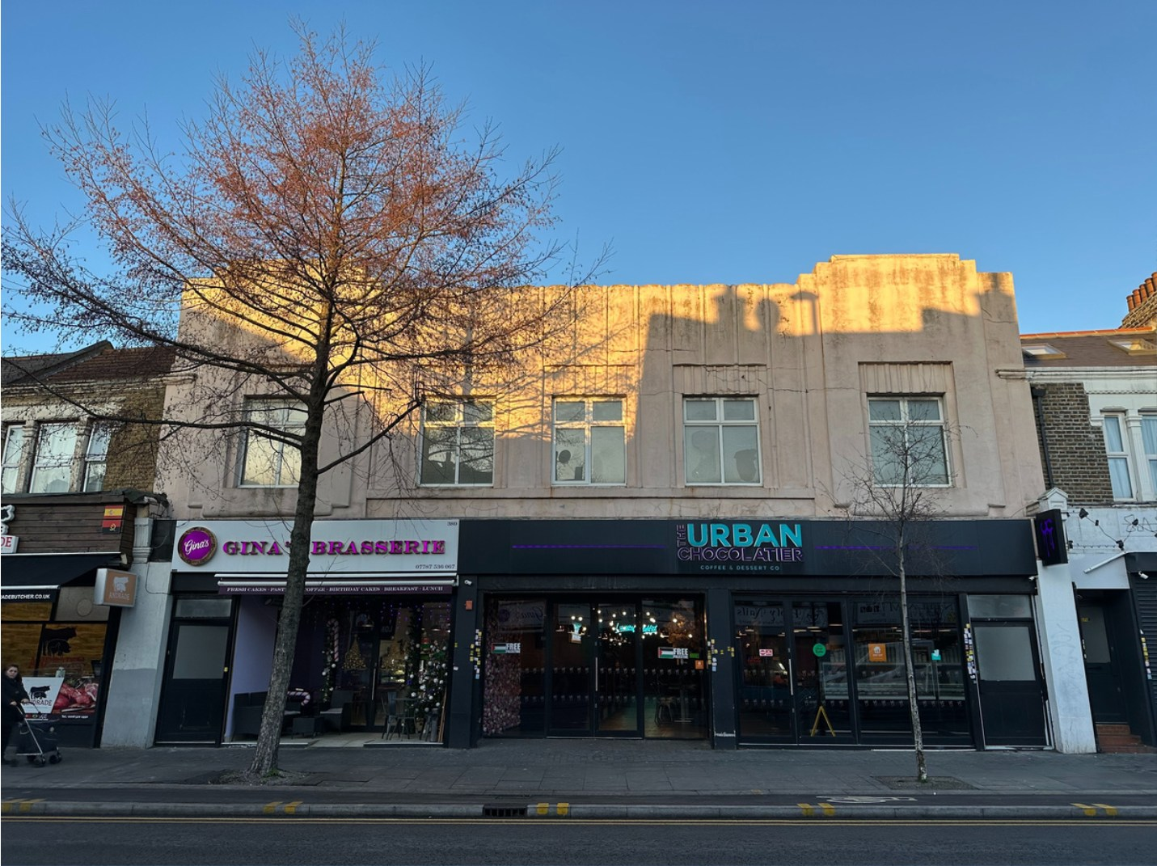

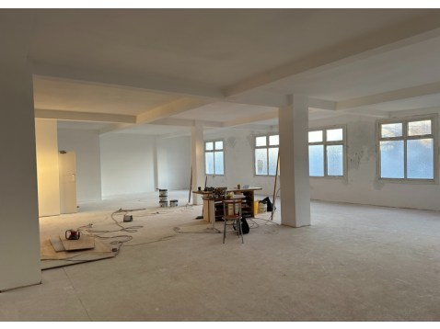
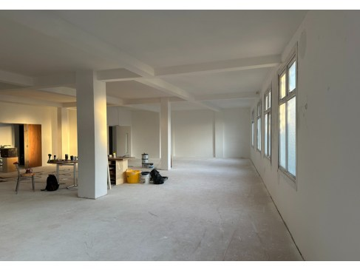

AVAILABLE - TO LET


First Floor, 389 Hoe Street, Walthamstow, London, E17 9AH Office/Class E premises 2,500 Sq Ft
£30,000 Per Annum Exclusive

All enquiries to
0203 576 3331

Assemblycre.co.uk

Assembly. Commercial Real Estate

F/F, 389 Hoe Street, Walthamstow, LondonE17 9AH Office/Class E premises, 2,500 Sq FT

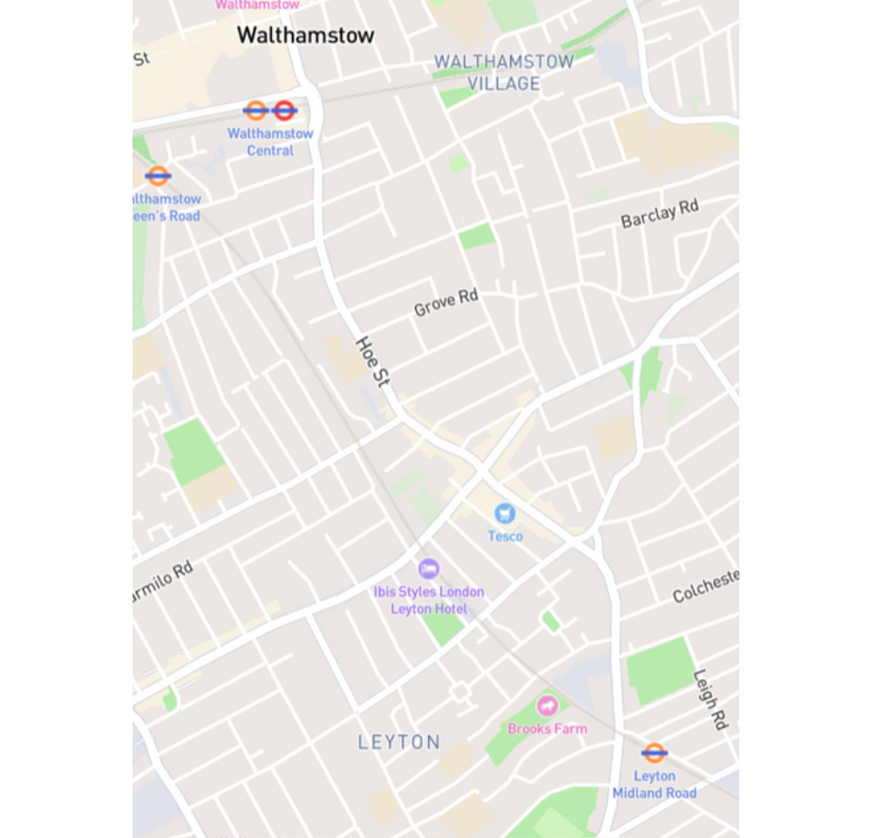
Location
The property is situated in the heart of the Bakers Arms junction. Transport links for the property are excellent, with Walthamstow Station 8mins walk to the north. Road links are also excellent with the A12 and A406 approximately 1.5 miles away.

The property is in close proximity to a variety of shops, restaurants, and supermarkets including Tesco’s and Costa Coffee situated on the Lea Bridge Road. The property benefits from an abundance of local amenities with parks and leisure facilities.

Description
The property is a located on the first floor and accessed by a two entrances from Hoe Street. The current layout comprises of an open plan area with good height, W/Cs and a large kitchen area.

Rent
£30,000 per annum exclusive Business Rates
Available upon request Building type Office/Class E
VAT
The premises are not elected for vat EPC Rating
Available upon request
Lease Details A new lease for a term to be agreed.
Accommodation 2,500 sq ft (232 sqm)

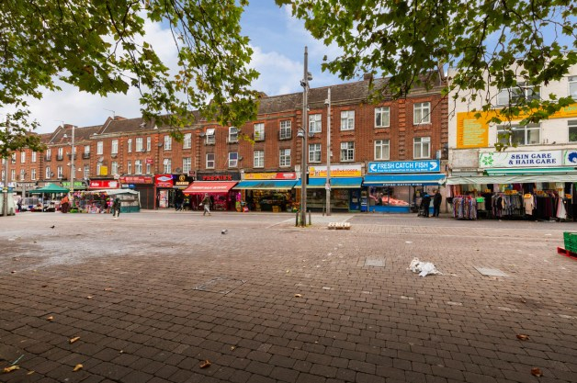
Contact us

Assembly CRE 020 3576 3331
www.assemblycre.co.uk

Abas Anwar
Mobile 0785 322 7619 Abas@assemblycre.co.uk

Assembly. Commercial Real Estate
These particulars do not constitute an offer or contract. Applicants should satisfy themselves as to the correctness of the details.

Value added tax may be payable on rents, prices or premiums. Photographs are for illustration only and may depi ct items which are not included in the sale of the property.

