Retail Space Available For Lease
TDK Realty LLC
470 Ridgedale Avenue
East Hanover, NJ 07936
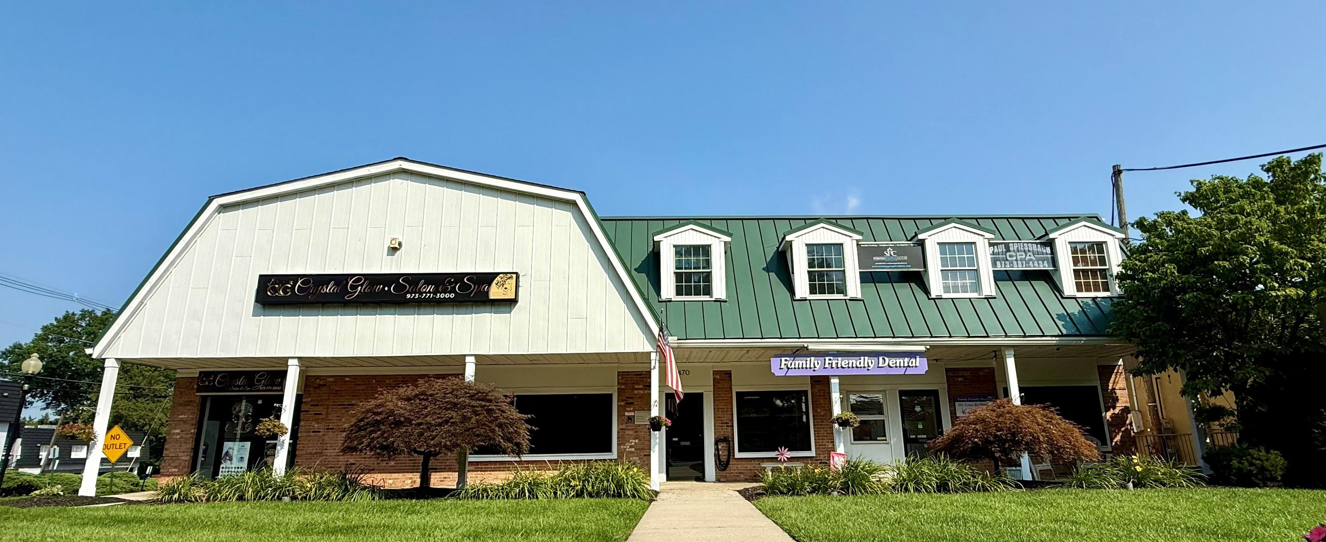

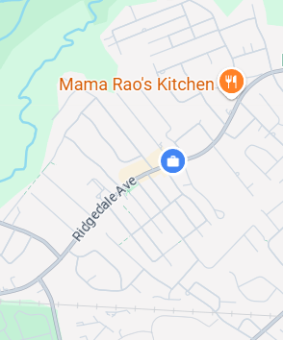
Property Overview
470 Ridgedale Ave
Building SF: 7,000SF

Available SF: 600 SF 2nd Flr Unit

Asking Rate: $20 PSF NNN

Taxes & CAM: $3.72 PSF

Parking: Abundant Parking on the
back side of the building

Location: Direct access to RT 10 East &
West. Within Minutes from Route
For More Information Contact
Dr Lina Koffman
(973) 884-1046 / Familyfriendlydental@gmail.com
280 & 80 East & West

