SUITE


200

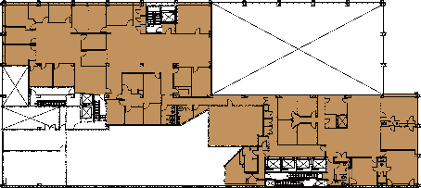
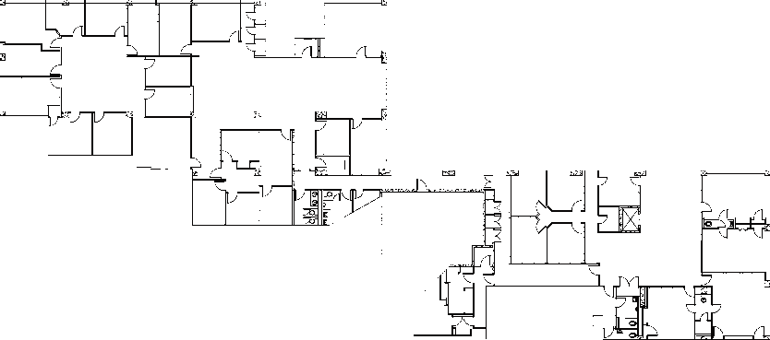

THE SPACE

 |  | 736 MARKET ST, CHATTANOOGA, TN 37402

12,421 RSF
For more information please contact
Gail Battle, Senior Vice President
704-333-3866 / gail@simpsonorg.com
FEATURES
- Great views of Chattanooga and the mountains
- Walk to dozens of new restaurants nearby
- Garage deck parking
- Lightning fast broadband available
- Innovation District
- Art Alley Behind Building

