Broadway

422
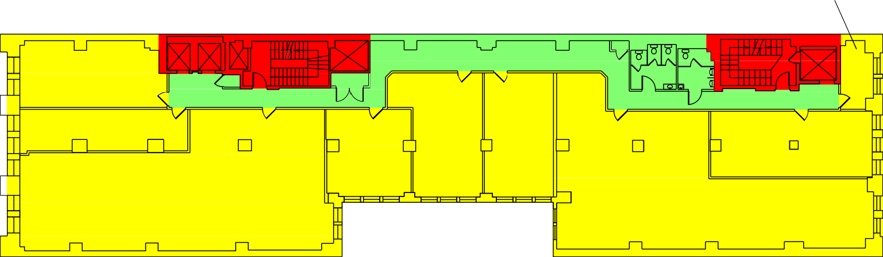
265 RSF
UP
UP
401
950 RSF
WOMEN MEN
DN
DN
404
643 RSF
412
837 RSF
4018
761 RSF
408
659 RSF
420
956 RSF
406
3,278 RSF
418
3,122 RSF
Crosby Street

636 Broadway
Trager LLC 917-763-2200
Floor 4
Prepared by PlanData Systems Corp. Apr 2024
0 10 20 30 40

