SMALLWOOD BUILDING

2670 CRAIN HIGHWAY
WALDORF, MD

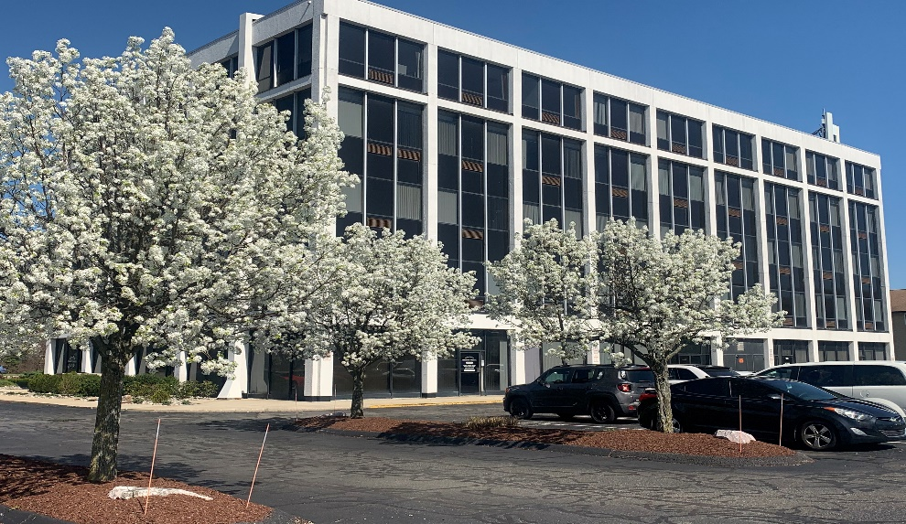
BUILDING DETAILS
Building Location

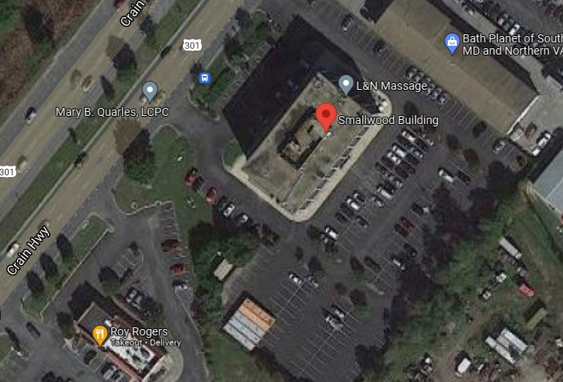
- Located in the heart of Waldorf
- Great visibility

- Five Story Building
- Suites Available from 750-2,700 Sq. ft
- Passenger elevators
- 24/7 Electronic access
- Ample parking

- Cleaning service
- Verizon Fios & Comcast available
- Security cameras

- Rates negotiable
LEASING BY:
Smallwood Family Ltd. partnership

2670 Crain Highway, Suite 302 mandy@smallwoodcompanies.com
Waldorf, MD 20601 Phone: (301)870-9060 Ext. 11
Fax: (301)870-5150

