FOR LEASE
4094 Broadway
Grove City, OH 43123 • Heart of Downtown Grove City

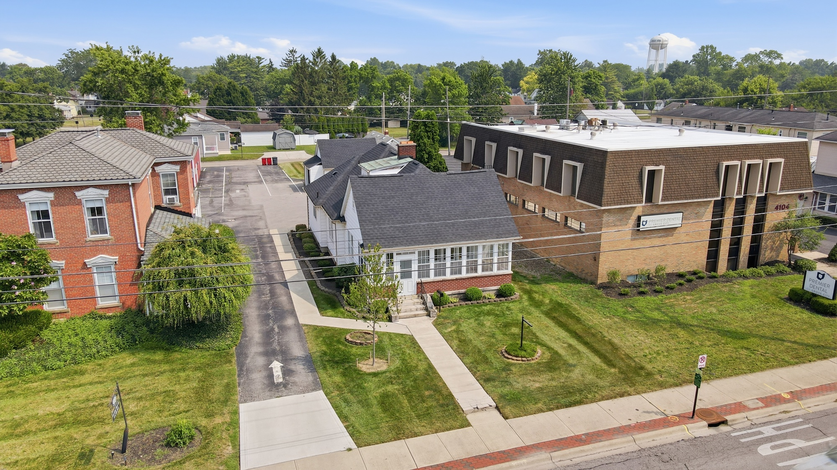
4094 Broadway sits in the heart of Downtown Grove City, steps from the Town Center.
A rare downtown opportunity: a character-filled 1935 brick building, remodeled in 2019, previously home to an apparel showroom and retail shop. Move-in ready now with a brand-new roof, situated in the Downtown Grove City Historic District and inside the Designated Outdoor Refreshment Area (DORA), zoned C-2, this address puts a business right where Grove City's foot traffic, festivals, and small-town charm all come together.
PROPERTY SNAPSHOT
Address | 4094 Broadway, Grove City, OH 43123
Asking Rate | $3,000/month ($36,000/year)
Location | Heart of Downtown Grove City
Year Built / Remodeled | 1935; remodeled 2019
First-Floor Square Footage | 1,263 SF
Additional Space Potential | Attic could be finished to add approx. 300 SF; basement is unfinished but usable, approx. 500 SF (storage/mechanical)
Prior Use | Apparel store / showroom
Zoning | C-2 (Community Commercial)
Special District | Located within the Designated Outdoor Refreshment Area (DORA)
Historic District | Located in the Downtown Grove City Historic District
Parking | 8 dedicated parking spaces plus a 2-car garage with shelving
Lease Type | NN (double net) — landlord covers property taxes and building insurance; tenant responsible for insurance, utilities, and mowing/snow removal; landlord is open to tenant-suited upgrades and improvements (subject to historic-district guidelines and landlord approval)
Lease Term | 2-3 years preferred
Availability | Immediate
Traffic Counts | 15,246+ VPD near Broadway & Park St (see note below)
BUILDING SYSTEMS & CONDITION
Roof | Brand new
Exterior | Siding and gutters scheduled for replacement in January
HVAC | 1 zone
Electrical | Standard residential-grade service (building was a residence prior to rezoning) — may need upgrading for equipment-heavy commercial use
Bathrooms | 1 full bathroom on the main level; a second bathroom is roughed-in and plumbed upstairs

A LOOK INSIDE & OUT
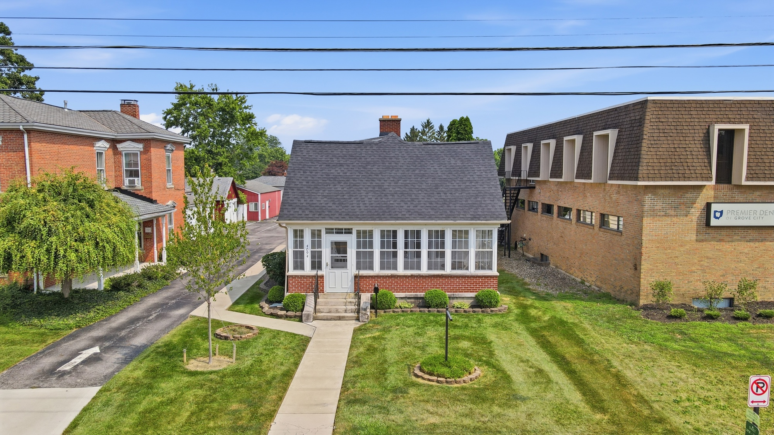  Charming brick exterior with covered entry, downtown Broadway frontage | 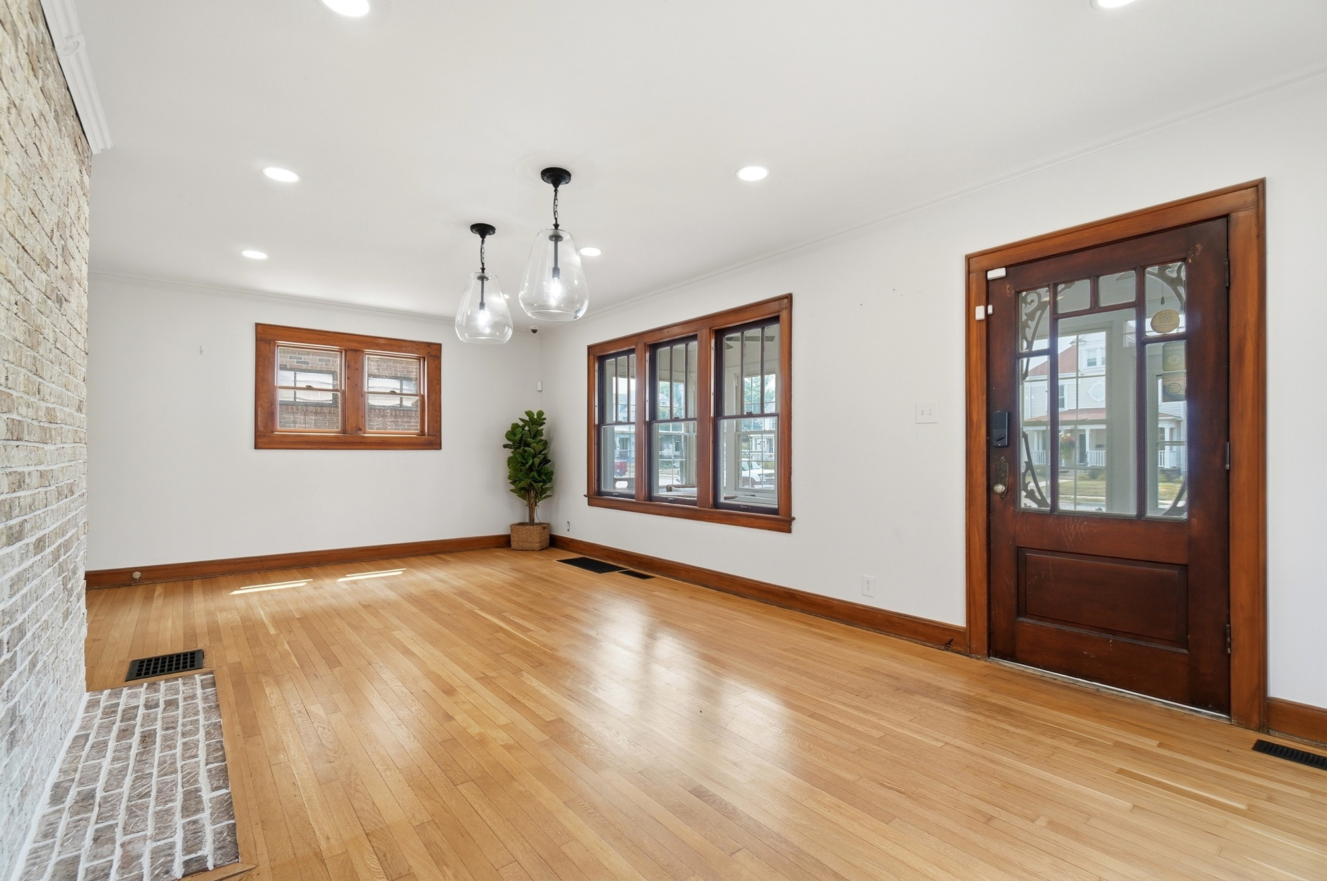  Bright enclosed sunporch / storefront entry overlooking Broadway
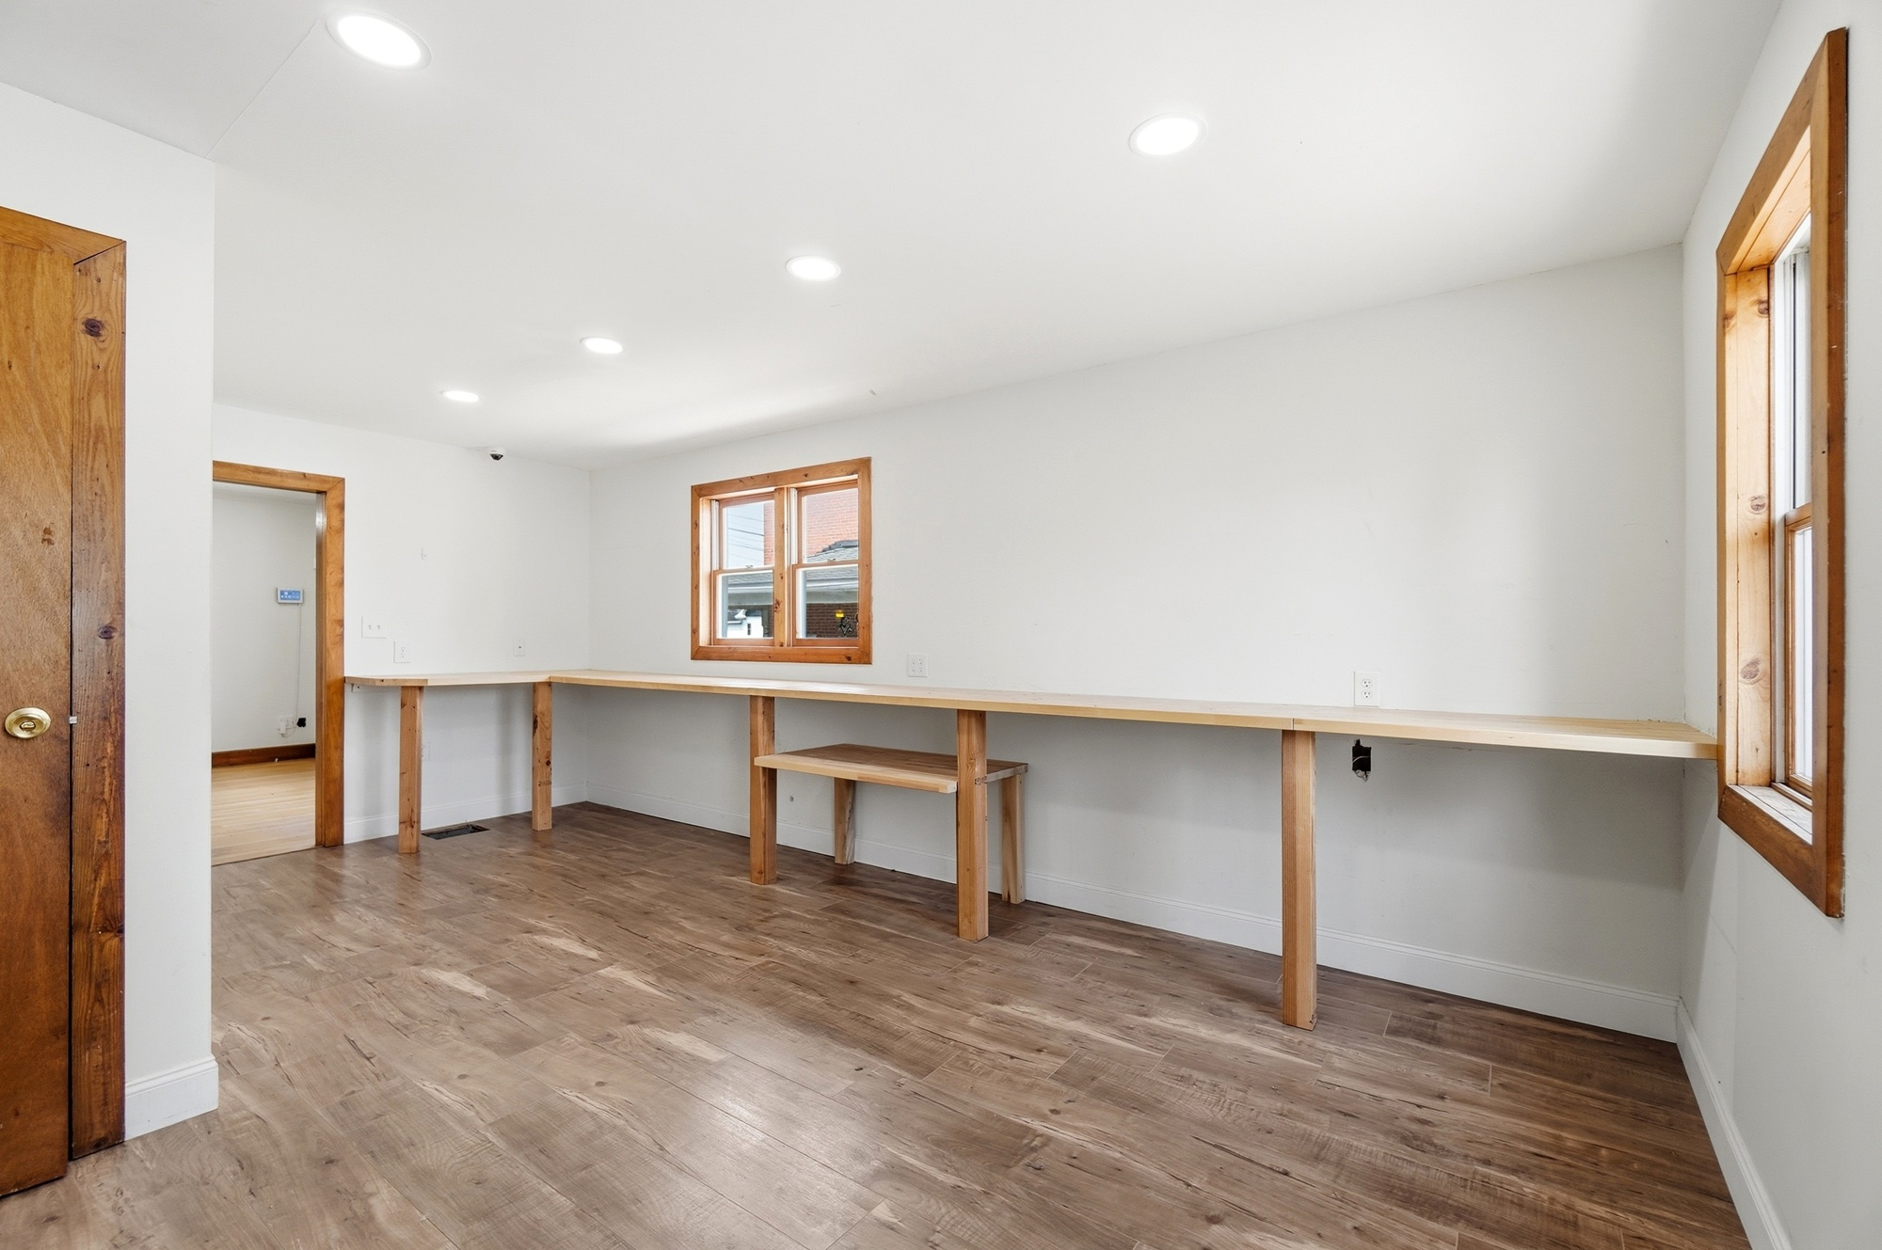  Open interior with original hardwood floors, ready for a new buildout | 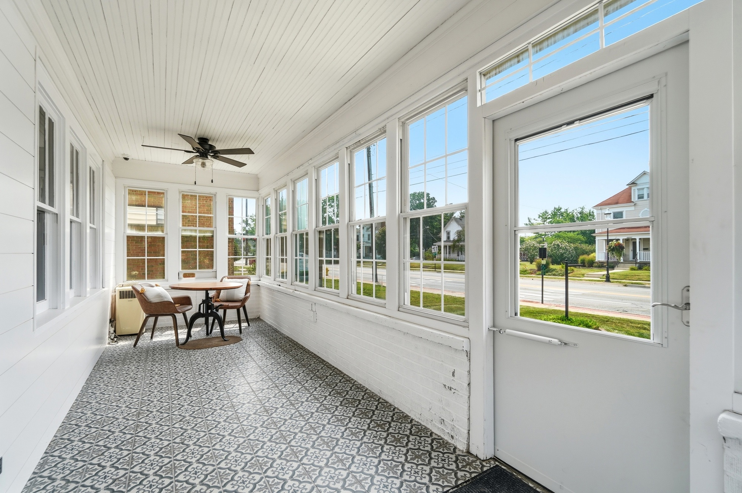  Steps from the DORA district — walkable dining and shopping nearby
WHY DOWNTOWN GROVE CITY
- Walkable core surrounded by locally owned shops, restaurants, and breweries
- Located within the DORA, allowing patrons to carry open containers between participating downtown businesses
- Anchors year-round community draws like the Grove City Farmers Market, Arts in the Alley, and downtown holiday events
- Steady mix of local regulars and visitors drawn to the Town Center's shopping, dining, and entertainment
- Easy access from Broadway, Grove City's main downtown thoroughfare, with I-71 just minutes away
NEIGHBORING BUSINESSES
The official Grove City Town Center map below shows every business in the downtown district — all within easy walking distance of 4094 Broadway. Map courtesy of the Grove City Development Department.
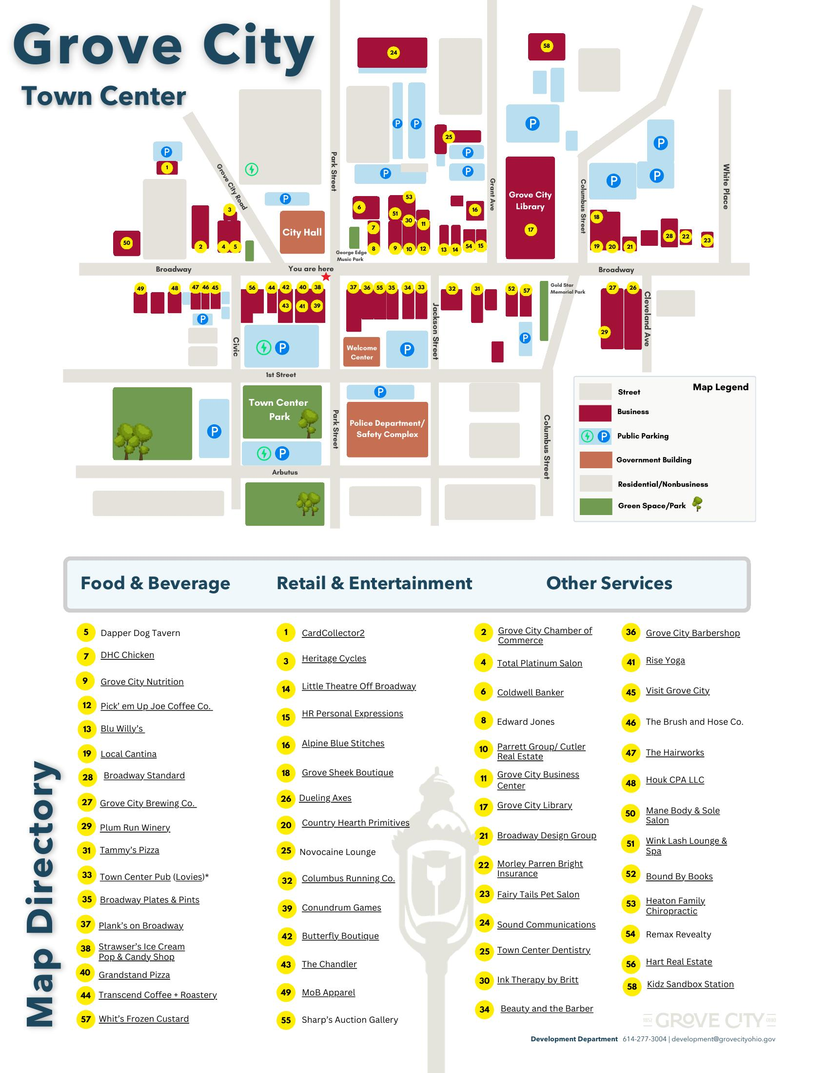
PROPERTY HIGHLIGHTS
- Brand-new roof, with siding and gutters scheduled for replacement in January — move-in ready with major systems addressed
- 1,263 SF first floor, previously operated as an apparel store, plus room to grow: attic could add approx. 300 SF and the basement offers approx. 500 SF of usable storage space
- C-2 commercial zoning supports a wide range of retail, restaurant, service, and office uses
- 8 on-site parking spaces plus a 2-car garage with shelving — a real advantage for a downtown address
- NN lease structure — tenant occupies the entire building with no common areas; landlord covers property taxes, tenant covers insurance, utilities (in their own name), and grounds upkeep (mowing/snow removal)
- Landlord is open to tenant-suited upgrades and improvements to fit your concept, within Downtown Grove City Historic District guidelines, at Tenants expense.
- Flexible 2-3 year lease term, available immediately
- Prime downtown visibility on one of Grove City's most trafficked and photographed streets
TRAFFIC COUNTS
Broadway (US-62) is Grove City's primary downtown corridor and one of the busiest streets in the city. The nearby intersection of Broadway and Park St — just down the block from 4094 Broadway — sees an estimated 15,246+ vehicles per day (VPD). For a verified, site-specific count at this exact address, we recommend pulling the current figure from ODOT's Traffic Count Database (tims.dot.state.oh.us).
IDEAL USES
- Restaurant, café, or bar concept that wants to be part of the DORA experience (note: electrical service is standard residential-grade and may need upgrading for heavier kitchen equipment)
- Boutique retail or specialty shop
- Professional office or service-based business
- Any concept that wants to be seen, walked to, and remembered

Kim Wemlinger
REALTOR® | kwCORE Group Founder | Howard Hanna Broker Partner
kim@kwcore.com • 614-371-5463 • @kwcoregroup (Instagram & Facebook) • www.kwcore.com
All information deemed reliable but not guaranteed. Tenant to verify zoning, permitted uses, square footage, and all measurements.

