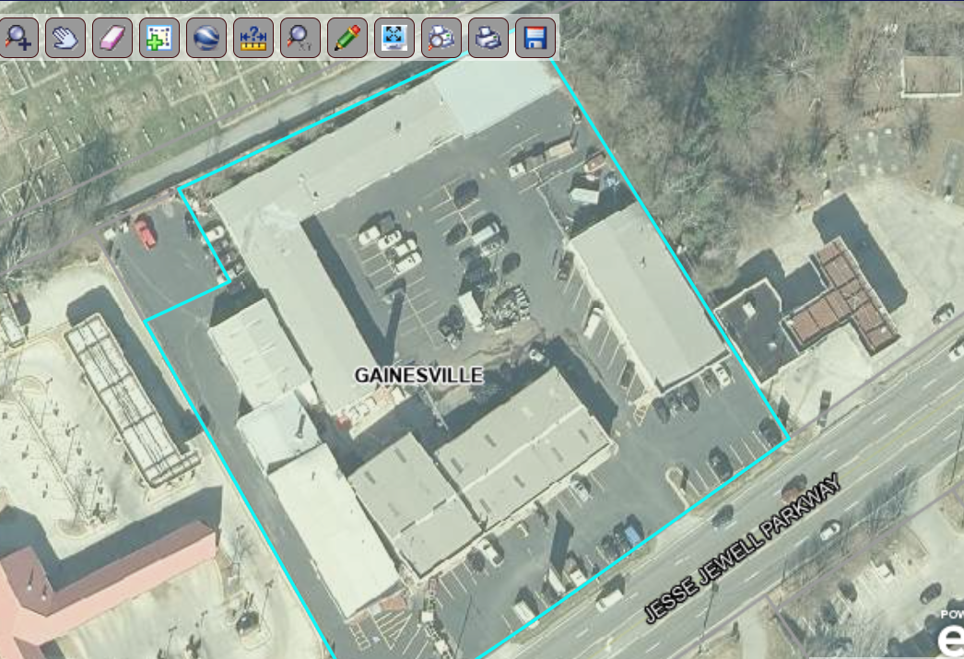
#102
3,200SF
#103
800SF
#104
2,000SF
#105
3,200SF
1190 Jesse Jewell

