56 LOWMOOR ROAD
KIRKBY IN ASHFIELD
NOTTINGHAMSHIRE
NG17 7BG

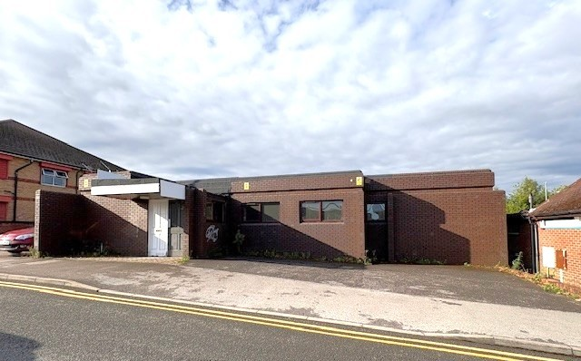

TO LET - £15,000 p.a FRI

- Former dental surgery premises extending to 1600 sq ft or thereabouts
- Located right in the centre of Kirkby in Ashfield on the approach road to Morrisons and having the advantage of on-site car parking
- Situated close to health centres and a pharmacy, this unit is ideally suited to alternative medical or complementary uses
- Having a large reception and waiting area together with 9 rooms all on one ground level
ACCOMMODATION

Entrance porch leading to

Reception Area and Waiting – 536 sq ft with counter

3 separate washrooms all with basin and wc

Store room leading to boiler room with gas Baxi boiler

9 surgery rooms all between 100-110 sq ft and most with range of wall or base fitted cupboards and one or two sinks

OUTSIDE

On site parking for up to 9 cars. Morrisons car park is within 50m

VAT - there is currently no VAT charged on the rent

RATEABLE VALUE - £21,500

EPC – C61, valid until 2028

LEASE – a lease is available for a minimum term of 3 years on a fully repairing and insuring basis

DEPOSIT – 3 months rent

COSTS – the ingoing tenant is responsible for 50% of the legal costs

VIEWING - accompanied viewing. Please contact 01623 721155 or email david.blount@davidblount.co.uk

