FOR SALE — 200 N 1st St, Unit A, Cocoa Beach, FL 32931
Offered at $1,200,752
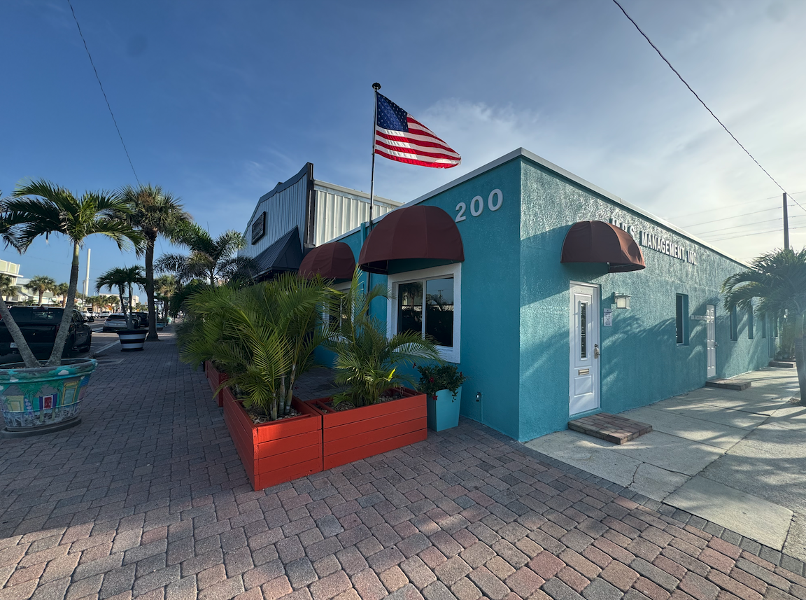

PROPERTY OVERVIEW
Address | 200 N 1st St Unit A, Cocoa Beach, FL 32931-2924
Building Size | ± 1,988 SF
Land Use | Commercial / Office / Retail Condominium
Year Built / Renovated | 2002 (est.) / recent modern upgrades
Zoning | Downtown Commercial District (CBD)
Lot Size | ± 0.03 acres (approx.)
Parcel ID | 25-37-10-DC-00107.0-0015.03
Price/SF | $604 / SF
Condition | Turn-key; modern finishes; ready for occupancy

PROPERTY HIGHLIGHTS
- 🏝️ Downtown location: steps from the beach, shops, and restaurants.
- 🌟 High visibility: signage opportunities in a busy corridor.
- 🛠️ Fully built out: reception, offices, ADA restroom, kitchenette.
- ⚡ Modern systems: HVAC, lighting, plumbing, and security.
- 🏢 Flexible uses: office, boutique retail, salon, or medical space.
- 🚗 Ample parking: shared lot and nearby public parking.
- 🌊 Flood Zone X: outside special hazard area.

LOCATION ADVANTAGES
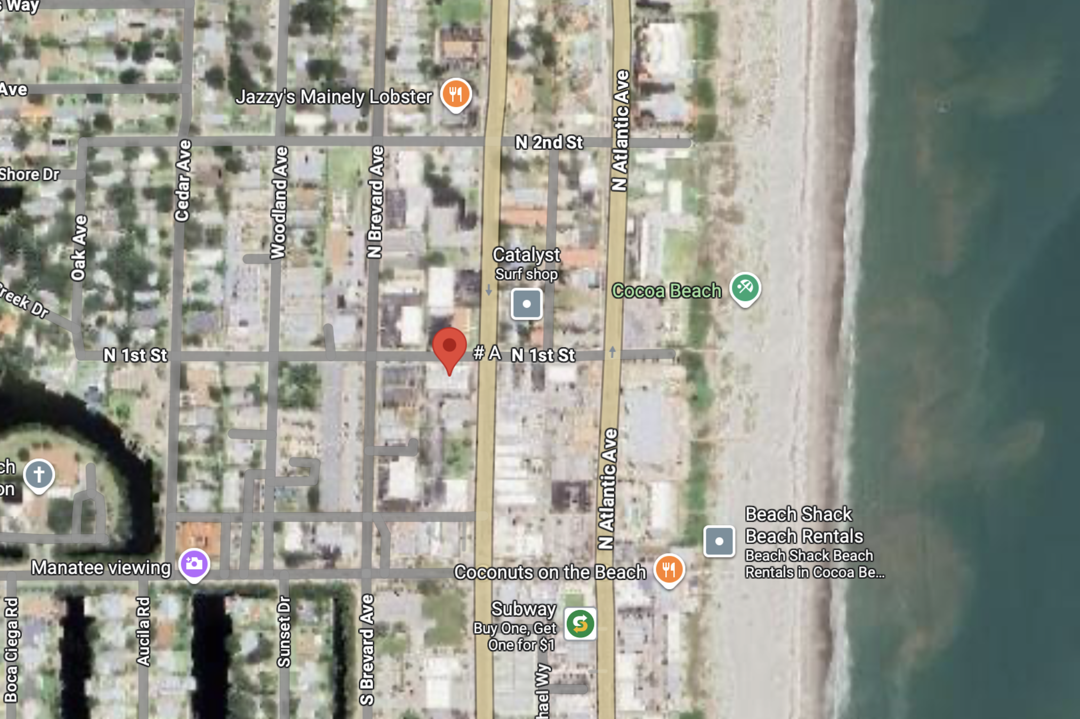
📍 Heart of Downtown Cocoa Beach – walkable to the ocean, hotels, restaurants, and City Hall.
📍 Only 2 blocks from the beach – high local and tourist traffic.
📍 Minutes to A1A and SR-520, direct routes to I‑95 and Orlando.
📍 Surrounded by vibrant retail, cafés, and service businesses.

FINANCIAL SNAPSHOT
List Price | $1,200,752
Building Size | 1,988 SF
Price per SF | $604 / SF
Potential Lease Rate | $20–$25 / SF NNN
Est. Annual Rent Potential | $39,760–$49,700
Ideal Buyer | Investor or owner-user seeking coastal exposure & turnkey space
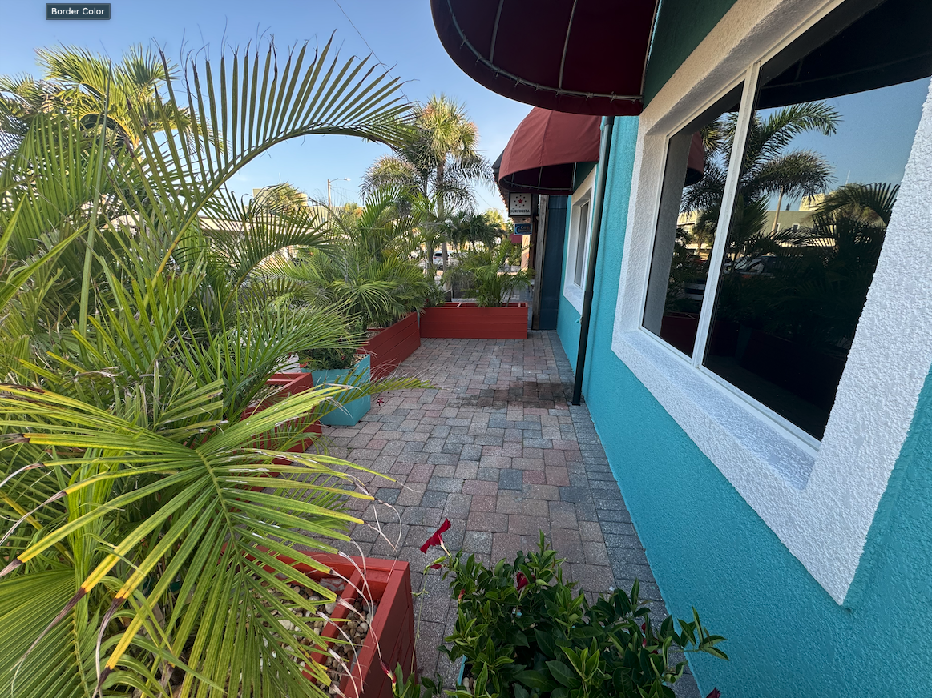

CONTACT INFORMATION
Presented by: Colin Grover — Acquisition Experts, LLC
📞 (772) 285‑5709 ✉️ colin@acquisitionexperts.com

