ACME
Move-In ready Office Space
(Potential Live/Work )

1026 C Atlanta Avenue, Decatur, GA 30030
1400 sq ft

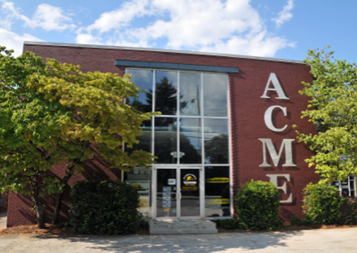

$17.00 psf NNN, approx. $8.02 psf in p/t including CAM TAX INS, and HVAC
Electric and Gas not included

Property/Space Features
- 2 private offices, front entry office area, Restroom w/shower
- Kitchen area
- Industrial look, hardwoods, high exposed ceilings and sky light
- Parking at the immediate front of the building
- Great Location: Walking distance to downtown City of Decatur Restaurants and Shopping

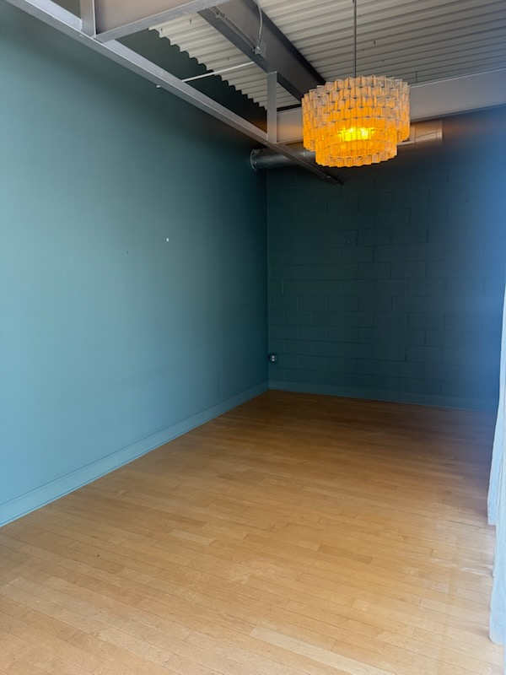
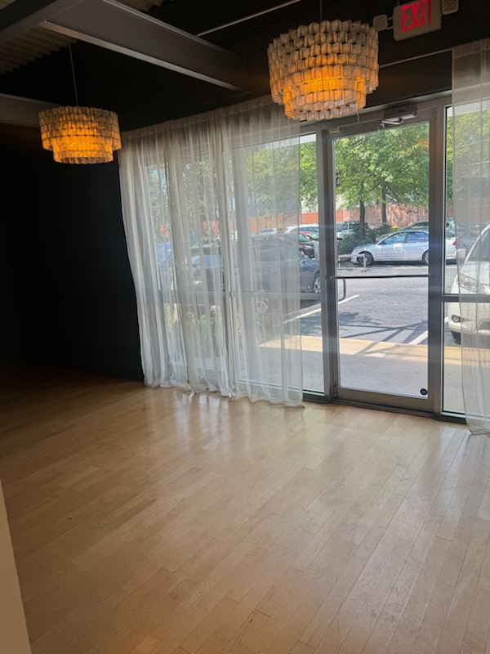

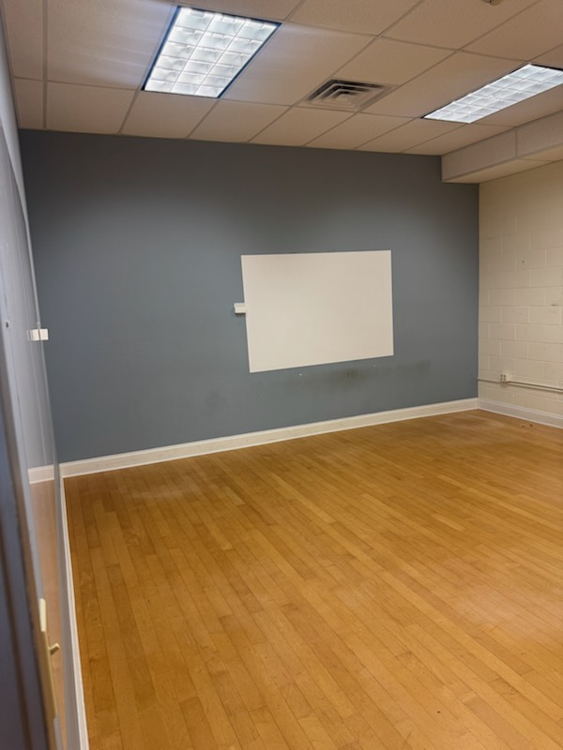
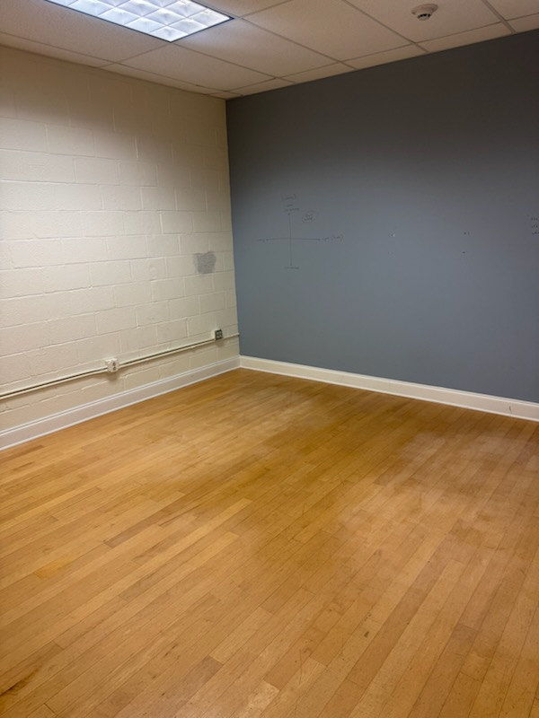

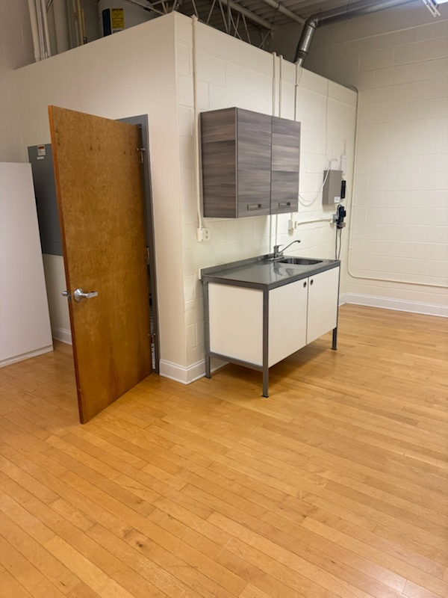

Leasing requirements-
  - Personal guarantee required
  - Personal credit score of 675 or more required
  - First month’s rent and security deposit due at lease signing
  - RENT + CAM + UTIL+ TI + HVAC replacement fee= monthly payment
Broker Commission:
  - Brokers to be paid ½ of first month’s rent with 5% residual.
  - Brokers must make first contact with EDS Leasing office for commission to paid on executed leases by EDS. If EDS shows the tenant the property first, tenant will be responsible for Broker’s commission.

