- WATERWORKS OFFICES & MARINA
1818 WESTLAKE AVENUE NORTH
SEATTLE, WA 98109

SUITE 18-118

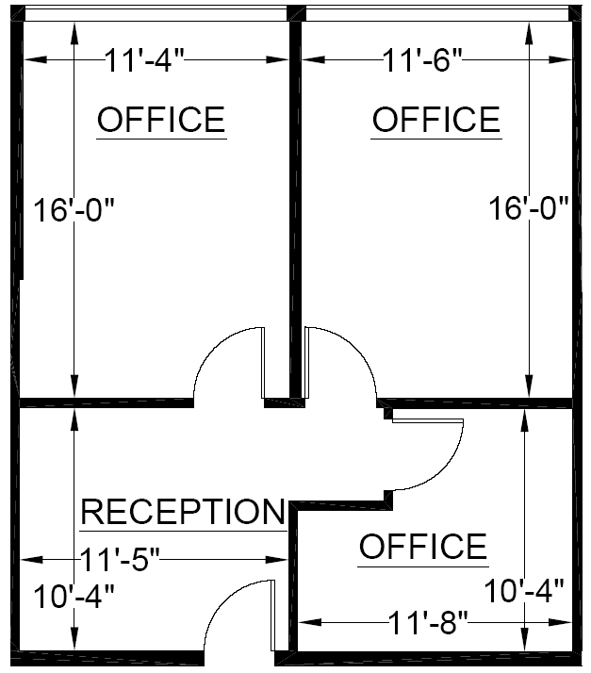

RENTABLE: 794 sq. ft.
(As measured March 2002)

TEMPERATE PARADISE PROPERTIES, LLC 206-851-0036

