Acme
1026 B Atlanta Industrial Avenue, Decatur, GA 30030
1560 sq ft

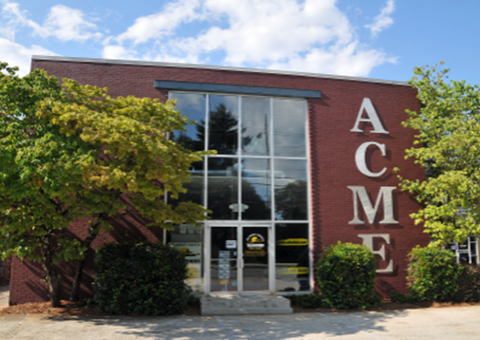

$18.00 psf NNN, approx. $7.55 psf in p/t including CAM TAX INS, and HVAC
Electric and Gas not included
Property/Space Features
- Located near City of Decatur shopping and restaurants
- Parking at immediate front of building
- Industrial look with cement floors and high exposed ceilings
- Conference room
- 3 private offices and 2 built in cubicles, Restroom w/shower
- Kitchen area
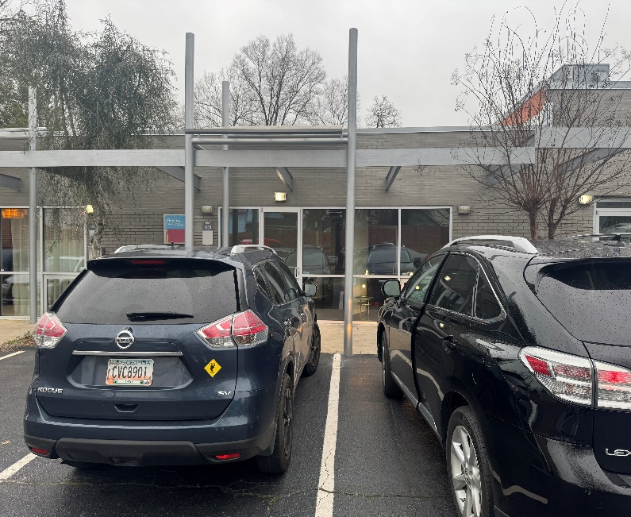
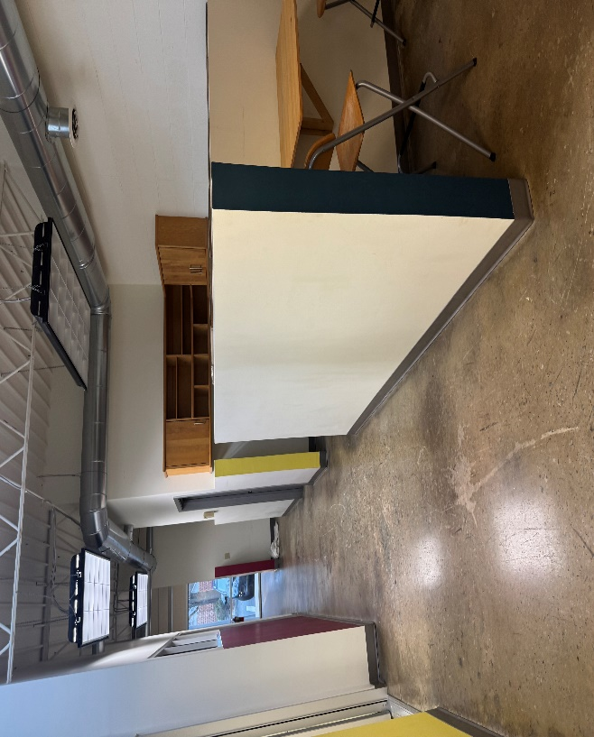

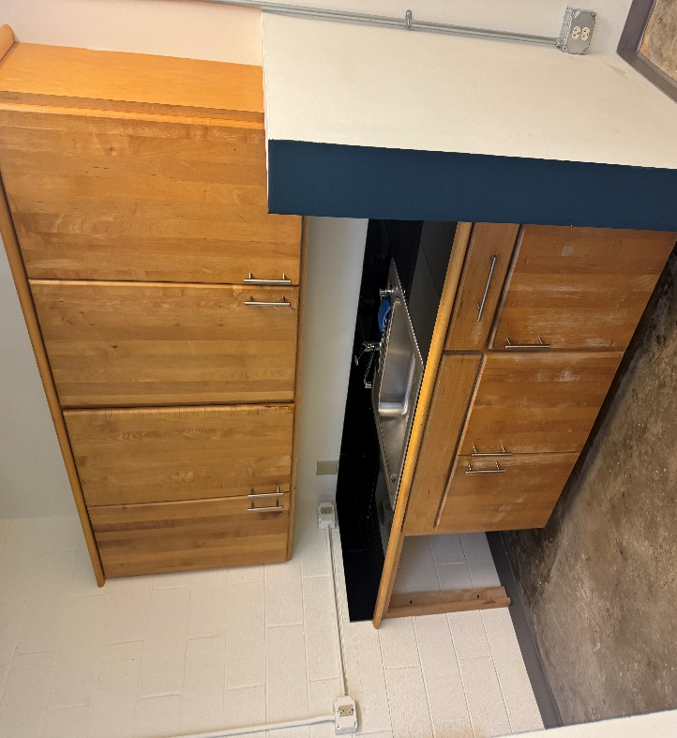
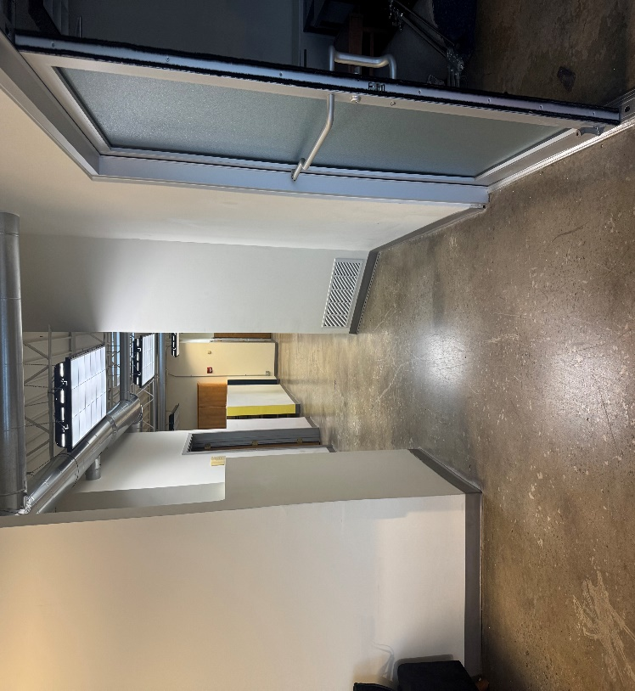

Leasing requirements-
  - Personal guarantee required
  - Personal credit score of 675 or more required
  - First month’s rent and security deposit due at lease signing
  - RENT + CAM + UTIL+ TI + HVAC replacement fee= monthly payment
Broker Commission:
  - Brokers to be paid ½ of first month’s rent with 5% residual.
  - Brokers must make first contact with EDS Leasing office for commission to paid on executed leases by EDS. If EDS shows the tenant the property first, tenant will be responsible for Broker’s commission.

