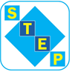

STEP Business Centre
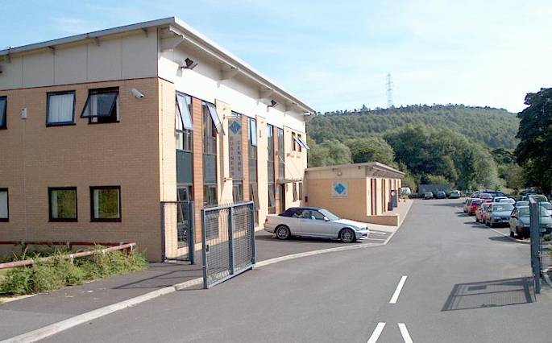

Office & Workshop Space
The Centre provides an ideal setting for small businesses. It comprises 11 large workshops of 548 square feet served by double doors opening onto the front yard, 9 smaller workshops of 301 square feet served from a central corridor and 12 offices ranging in size from 154 to 390 square feet set in a two storey block. Also included in the Centre is a welcoming reception area and a meeting room which can accommodate around 10 people boardroom style.
All units are all fully serviced, ready to move into and let on flexible licence agreements, meaning there’s an easy in easy out option with no long term commitments to worry about.
With only a ten minute drive to the motorway network, the Centre is within easy reach of Sheffield, Barnsley, Leeds, Huddersfield and Manchester.

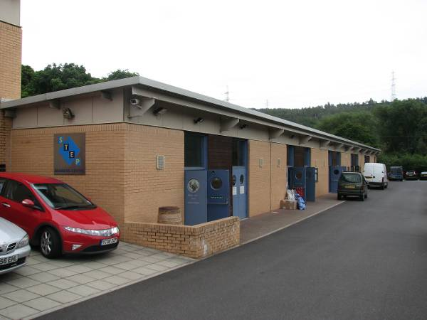
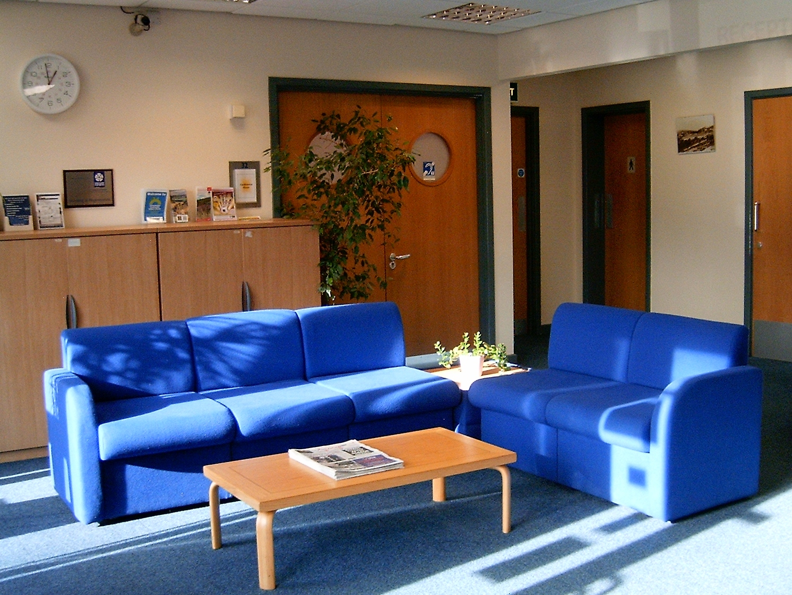

Also available:
Virtual Offices
Running a Business from Home?
If you are not quite ready to rent office space but want to give a professional impression to your client, then our virtual office services are for you. Prices start from £20 per month.

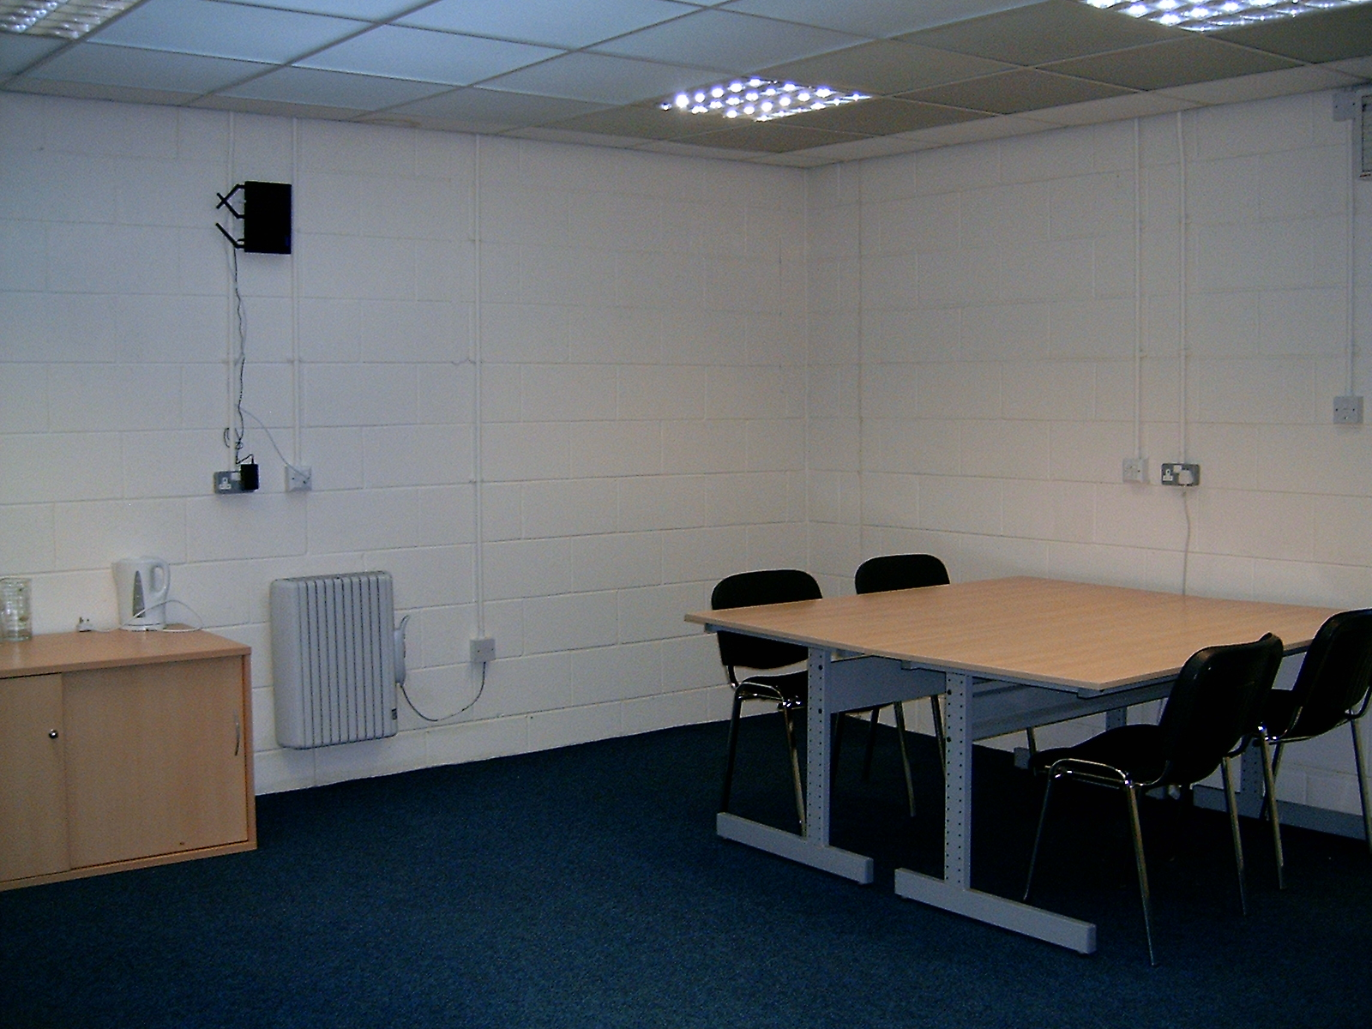
Hot-desking
No commitment work ready office space available from £15 per hour.

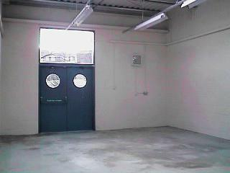
Business Services
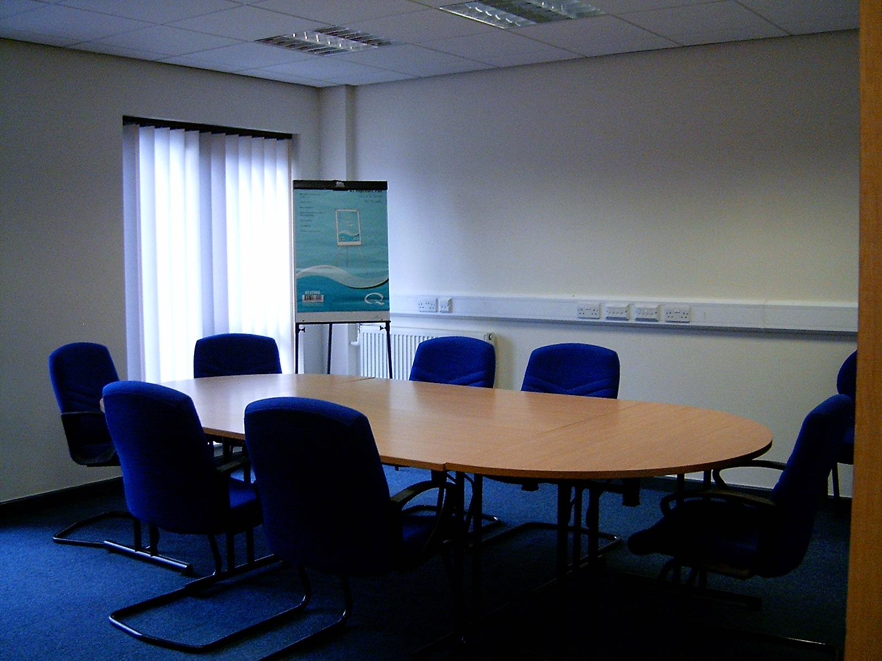
Are available to Tenants and Non-Tenants, these include Meeting Room hire, Telephone and Message taking facilities, Photocopying, Administration services and Virtual Office packages.

Storage Space
Step Business Centre Offer secure storage units from 300sq ft. with no long-term contracts, pay monthly.

For further information please contact:
STEP Business Centre
Wortley Road
Deepcar
SHEFFIELD
S36 2UH
Tel: 0114 2903600
Email – info@stepbusinesscentre.co.uk
Website - www.step-online.org.uk

