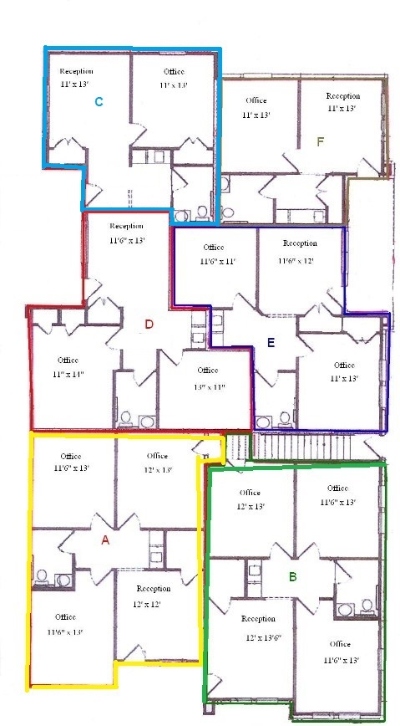
187 Elmhurst, Kyle, TX

