
EVERGREEN LOCATION SERVICES LLC
337 Changebridge Rd , PO Box 180
Pine Brook, NJ 07058-180
973-882-8500(Phone) 973-882-0770 (Fax)
FOR SALE
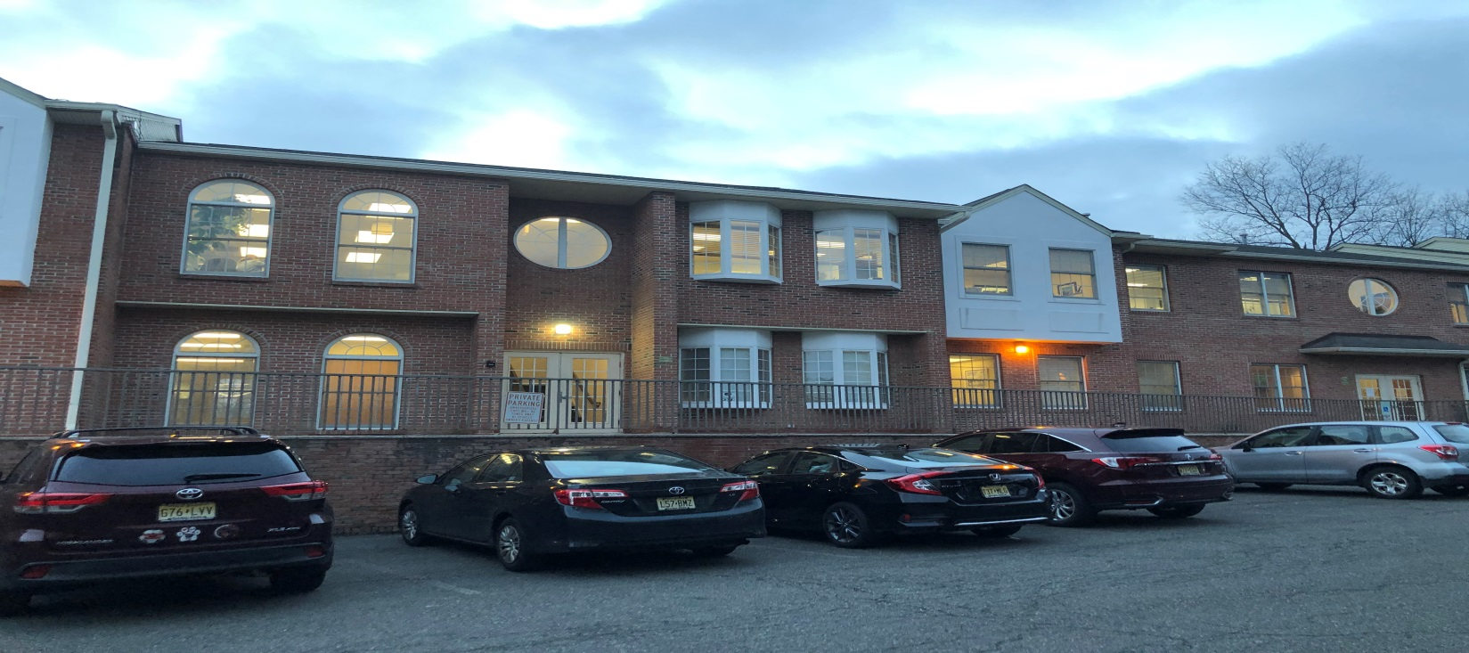
271 Rte 46 W, Fairfield (Essex County)-- Unit G205/206/207

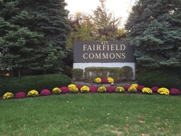
Office Condo

2536+/-sft
2nd floor

Current layout: 2 entrances, reception, 5 offices, open area, conference room, kitchenette, 2 private restrooms

Offered for Sale $415,000
(taxes $ 6000.00 )

Highway location
Ample parking
EZ access to Rte 80/287/23
No elevator

For more information please contact Sal Bellafiore 201-400-8847 salb@evergreencommercial.com
or Cathie Salamone cathies@evergreencommericial.com 201-400-0660

*all information deemed reliable but not guaranteed*

