
Estate Agents – Residential And Commercial
413 St Saviours Road, Leicester, LE5 4HH TEL: (0116) 273 1200 E: info@leoproperties.com

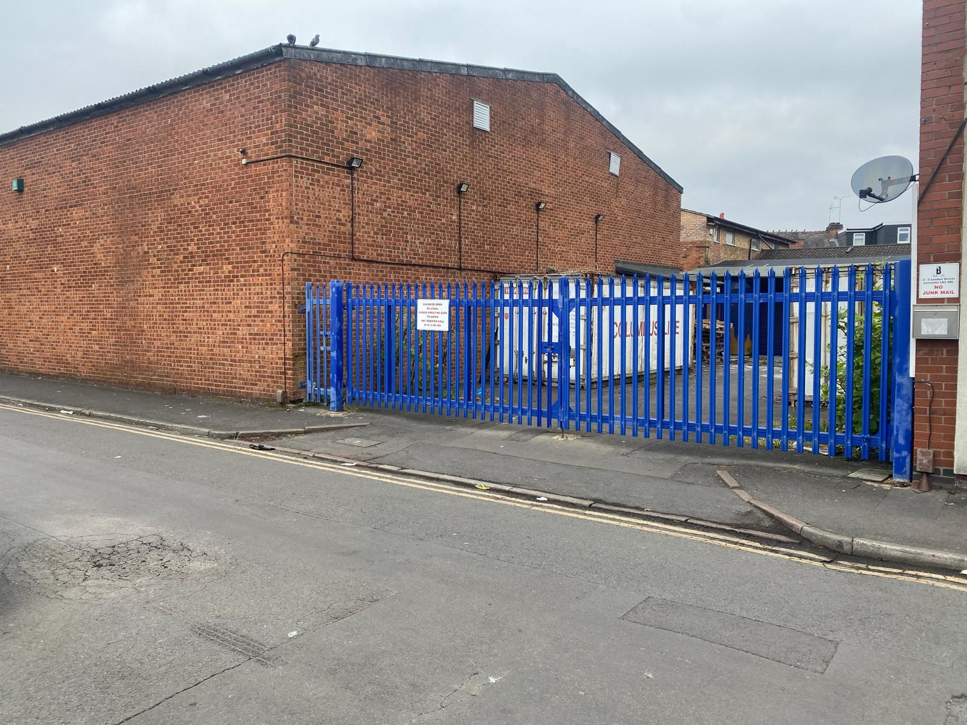
TO LET £36,000 PER ANNUM (£3000 P.C.M)
3-5 LONDON STREET, OFF GREENLANE ROAD, LEICESTER, LE5 3RL
Approximately 4000 SQFT ground floor industrial unit within prime location and good catchment area of local labour/workforce off Greenlane road. The Premises briefly is in excellent condition with suspended ceiling with fitted lights, office, fire exit, goods loading & unloading access, car park space,Wc facilities, 3ph/1ph electric phase supply. Ideal for community centre subject to planning permission or storage or others. Available now.
Approx. 4000 SQFT Ground Floor Excellent condition
Loading / Unloading Car Park space Office
Suspended Ceiling WC Facilities Fire Exit
1 Phase & 3 Phase Electric Viewing recommended
Ideal for Community centre or others

