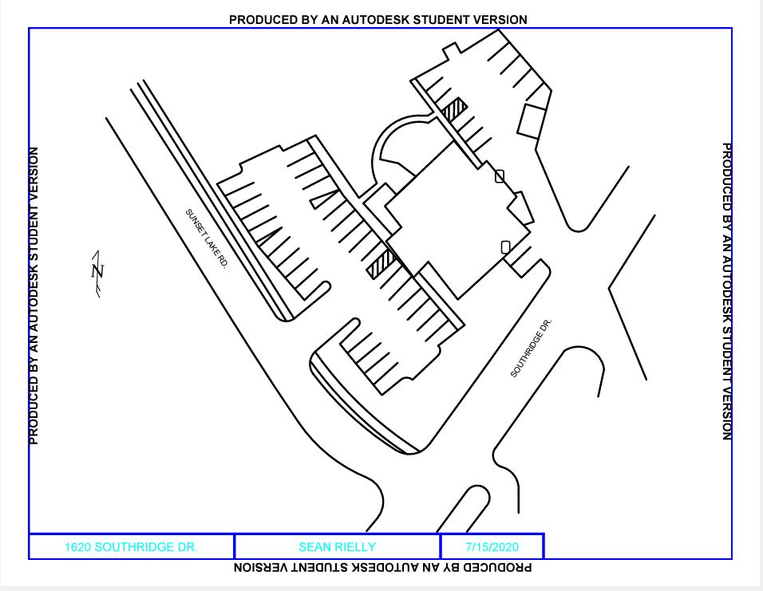
Front Entrance
Side Entrance

