
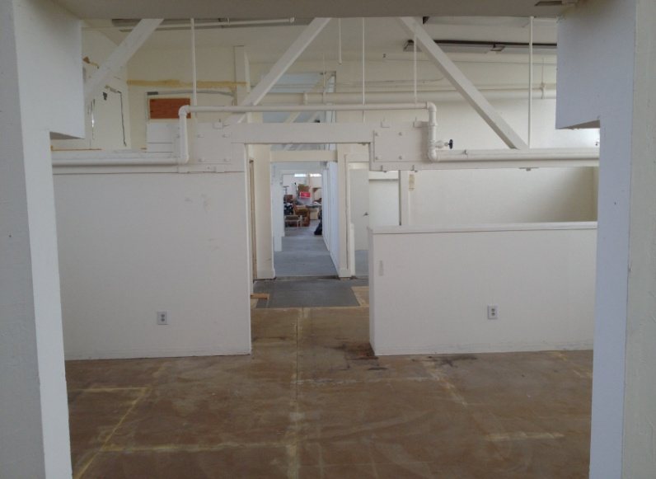
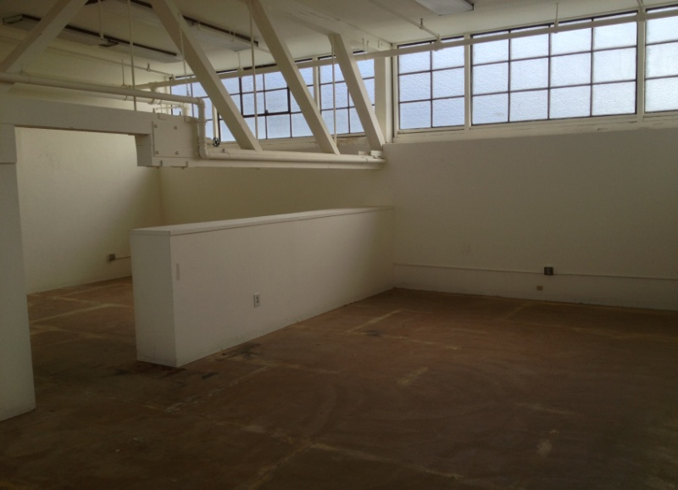

Multiple Work Spaces Terrific Natural Light
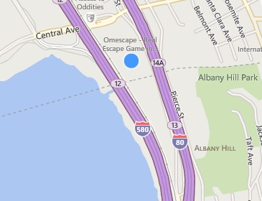
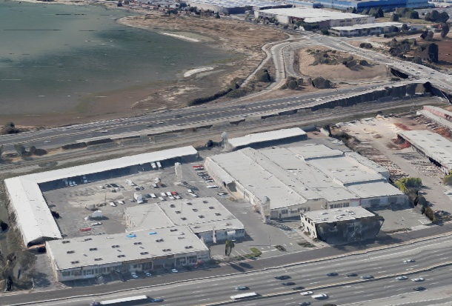

Convenient Location

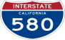
Art Studios Here



Facing 255,000+ Captive Cars/day Convenient Location

ART STUDIO SPACE FOR LEASE

5327 Jacuzzi Street #3-B2: ± 1,060 Sq. Ft.

Art or Office Suites with various sizes featuring:

- Big Windows
- Conference Room
- Off Street Parking
- Slop sink potential
- Open Office & Studio Areas
- Two Restrooms

$1.00/Sq. Ft. NNN Plus + 23¢ CAMs.

FOR FURTHER INFORMATION PLEASE CONTACT Peter McNally 510/848-6007
CITY | Richmond Bayside | LISTING CO. | McNally Realty Advisors
ADDRESS | 5327 Jacuzzi Street | LISTING AGT. | Peter McNally
CROSS ST. | Interstate 80 | PHONE # | 510/848-6007
SPACE AVAIL. | 1,060 Sq. Ft. | LIST DATES | 5/16
PRICE | $1,304/ month all-in | LISTING #
PROP. TYPE | Office- Art Studio | FEE TO S.O. | 3% gross rents
Information Herein Deemed Reliable but not Guaranteed.

