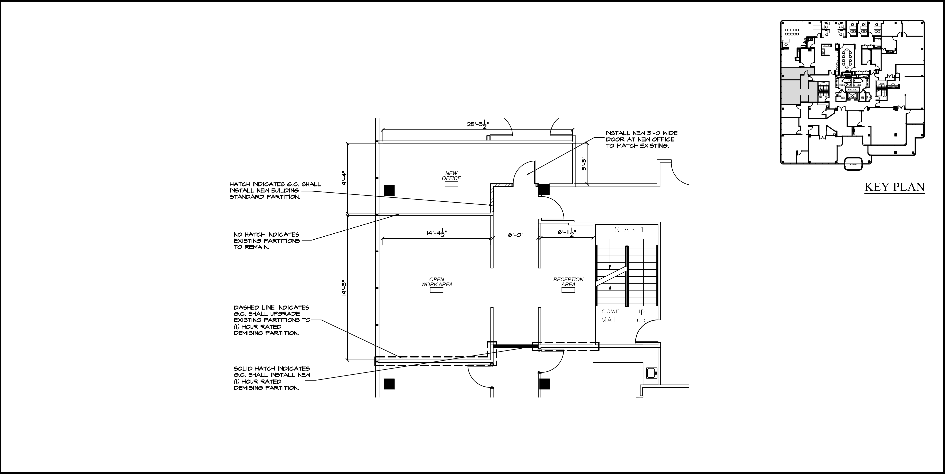
BUCKINGHAM  PROPERTIES | PROJECT TITLE PROPOSED NEW OFFICE ALTERATIONS |  |  |  |   C  CARDARELLI  DESIGN & ARCHITECTURE, P.  Architecture and Planning  297 KNOLLWOOD ROAD, SUITE #202 WHITE PLAINS, NY 10607  Phone: (914) 437-9554 / Fax: (914) 437-9555
BUILDING ADDRESS  118 N BEDFORD ROAD  MOUNT KISCO, NY 10549 | DRAWING TITLE  PROPOSED PLAN  2ND FLOOR  SCALE: 1/8" = 1'-0" |  | DATE: SEPTEMBER 27, 2022 | DWG # SK1
C

