BOUTIQUE OFFICE / MEDICAL OPPORTUNITY  200 NEWPORT CENTER DRIVE  Suite 111 | Newport Beach, California 92660 | FOR  LEASE

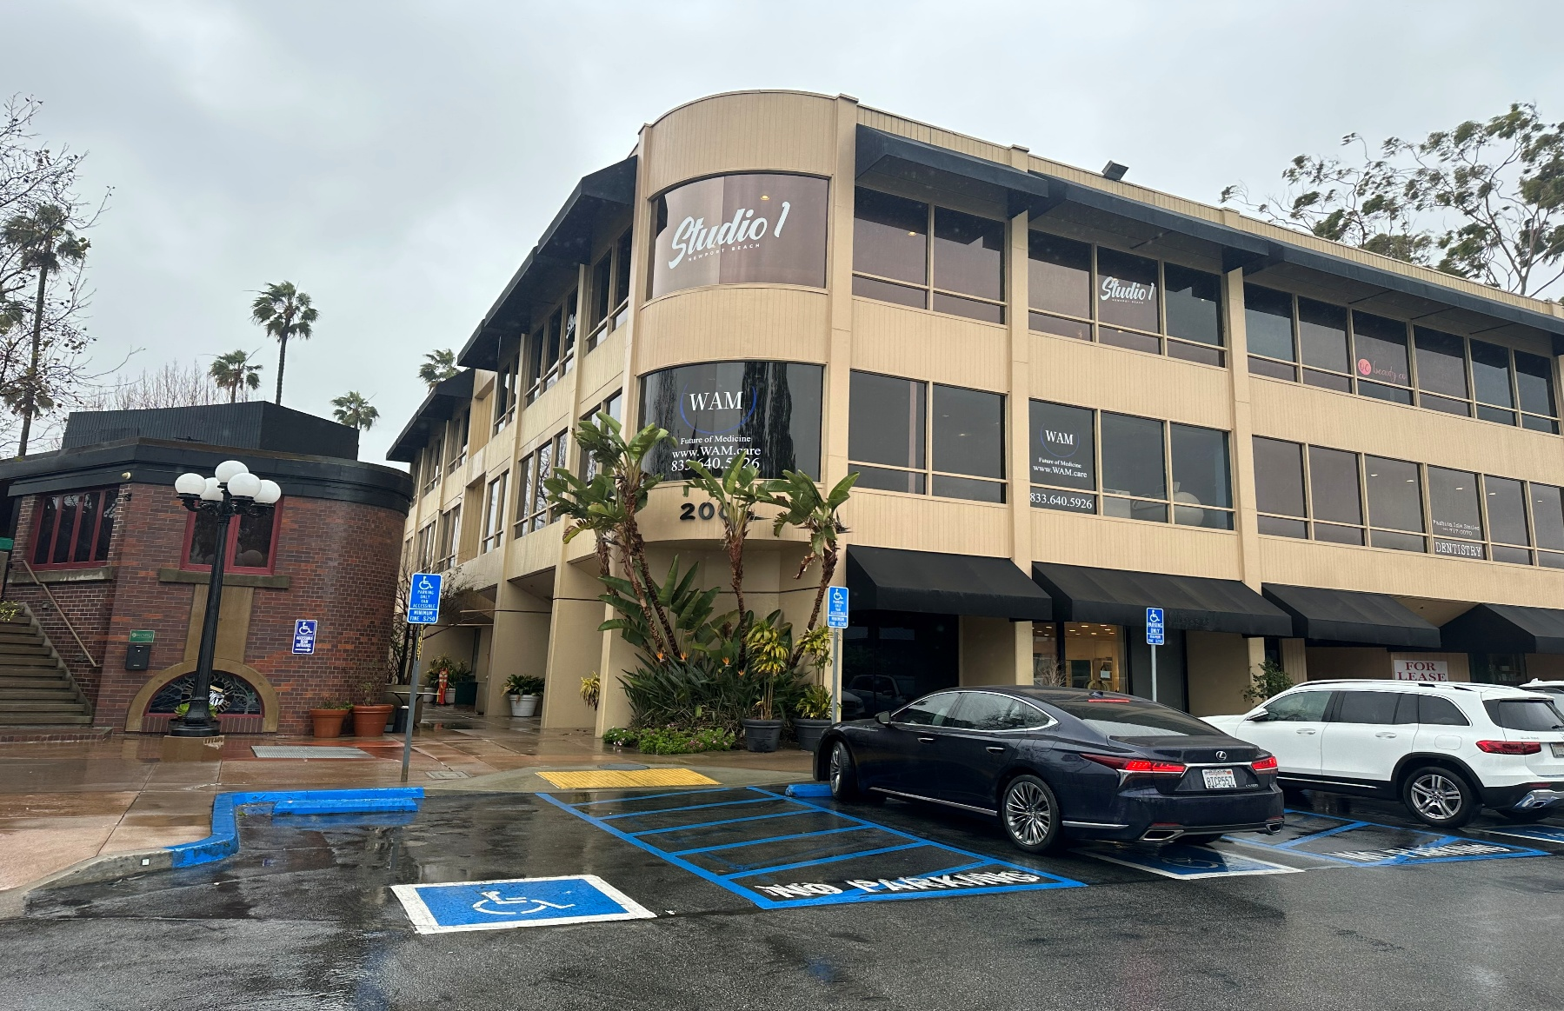 | AVAILABLE IMMEDIATELY  $4.00-$4.50/SF  FULL SERVICE GROSS  - Suite 111 | 1,281 SF  - Office / Medical / Service Retail  - Short- or long-term lease considered  CALL OR TEXT FOR A TOUR / VIDEO
WHY THIS LOCATION STANDS OUT
FREE PARKING  Convenient surface parking for staff and clients | NEWPORT CENTER  Prestigious address adjacent to Fashion Island | OCEAN VIEWS  Window offices and prominent exterior exposure | EASY ACCESS  Elevator served; ground-floor Suite 111 access
AVAILABLE SUITE
SUITE 111 | 1,281 SF
- Ground floor with two entry doors
- Reception, 3 private offices, storage and open area
- Corner position; potential sink installation
- Landlord may consider tenant improvements or free rent, subject to negotiated terms

 | KAREN A. SUNDAY  Karen A. Sunday & Associates, Inc. | Commercial Real Estate Broker  CA DRE Broker License #01883124 | (949) 632-7727  Karen@karensunday.com  23 Corporate Plaza Drive, Suite 150 | Newport Beach, CA 92660

NEWPORT BEACH MARKET PROFILE  AFFLUENT CLIENT BASE. PREMIER BUSINESS ADDRESS.  A compelling setting for professional, medical, wellness and boutique service users | FOR  LEASE

SUITE 111 FLOOR PLAN  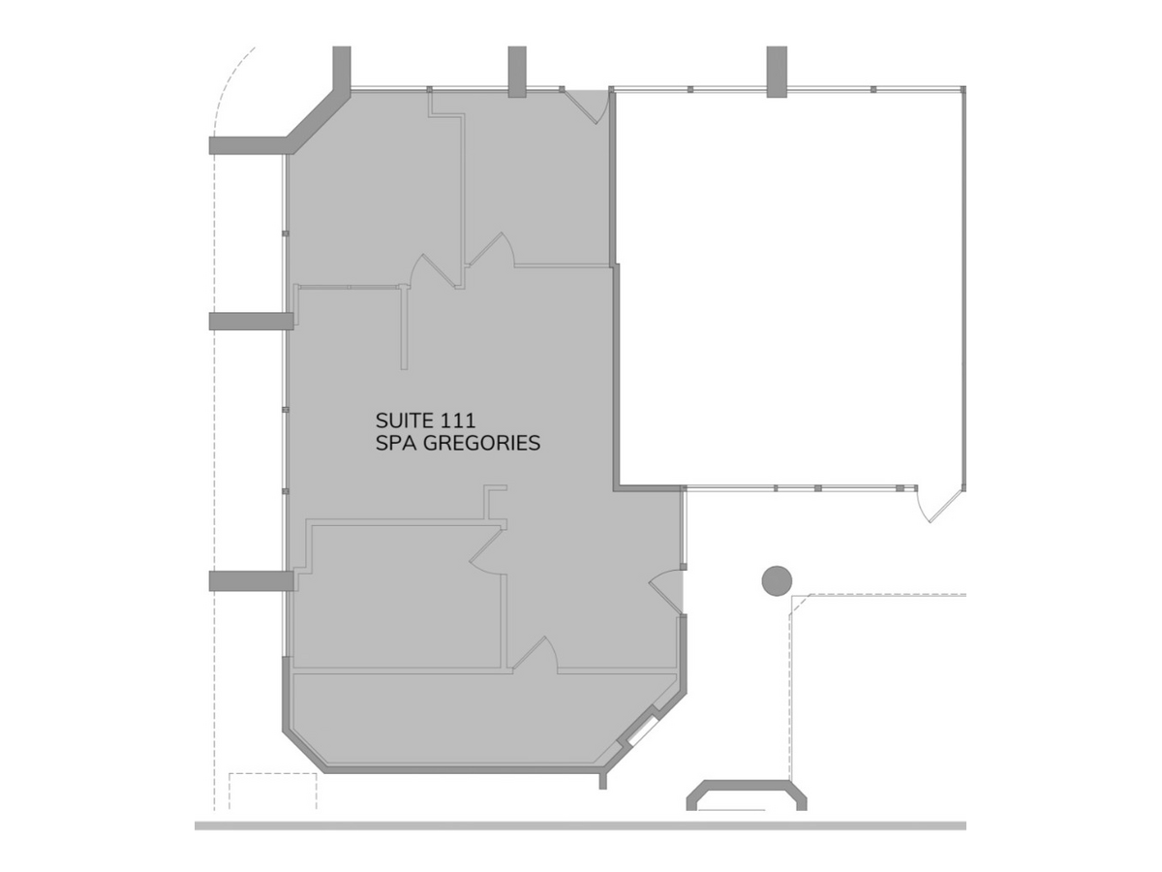  Conceptual plan shown for orientation; tenant to verify dimensions and suitability. | NEWPORT BEACH DEMOGRAPHICS  Sources: U.S. Census Bureau QuickFacts and ACS 2024 estimates.  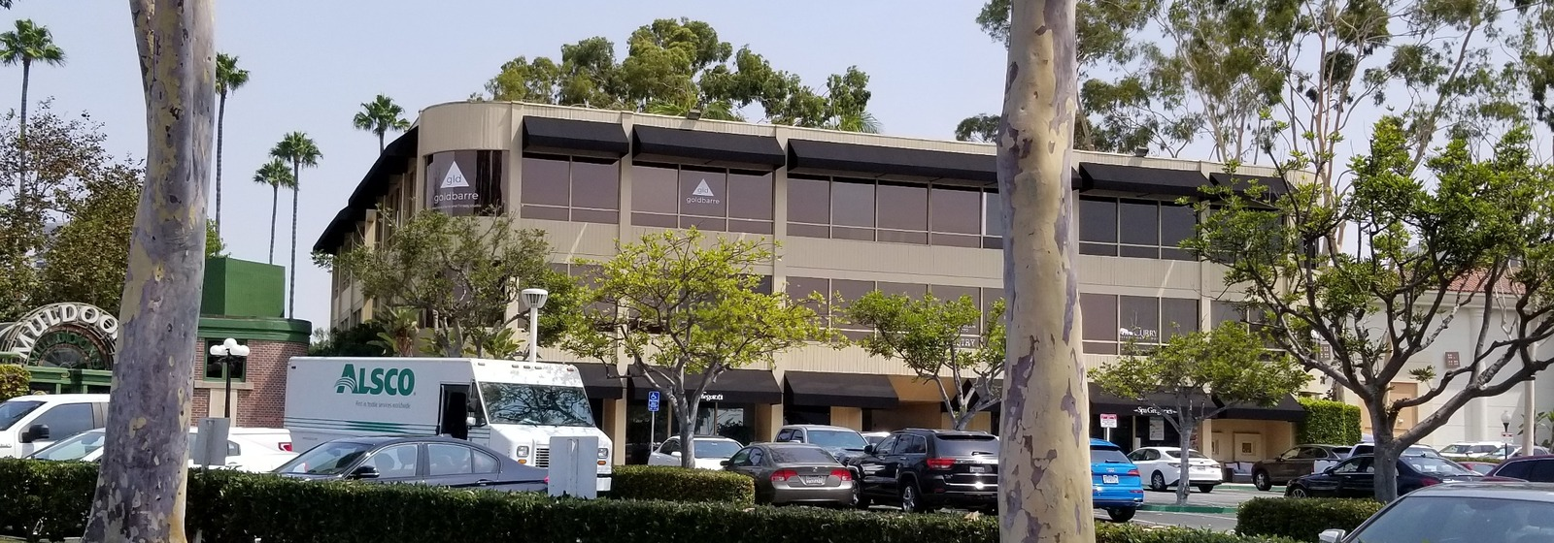
  $156,867  MEDIAN HOUSEHOLD INCOME | $112,622  PER-CAPITA INCOME
  69.6%  BACHELOR'S DEGREE OR HIGHER | $2.0M+  MEDIAN OWNER-OCCUPIED HOME VALUE
  $47,919  ANNUAL RETAIL SALES PER CAPITA | 22.9 min  MEAN COMMUTE TIME
TENANT-FOCUSED SELLING POINTS
CLIENT CONVENIENCE  - Free surface parking  - Elevator service  - Wheelchair-accessible building  - Immediate availability | BRAND VISIBILITY  - Newport Center Drive address  - Exterior signage opportunity, subject to approval  - Corner and window-office options  - Boutique, easy-to-find building | AMENITY-RICH SETTING  - Walkable to Fashion Island shopping and dining  - Convenient to PCH, MacArthur Boulevard and SR-73  - Minutes to coastal communities and John Wayne Airport  - Strong professional and medical referral base
IDEAL FOR
Medical & wellness • Therapy & counseling • Professional office • Beauty & aesthetics • Boutique service retail
 | KAREN A. SUNDAY  Karen A. Sunday & Associates, Inc. | Commercial Real Estate Broker  CA DRE Broker License #01883124 | (949) 632-7727  Karen@karensunday.com  23 Corporate Plaza Drive, Suite 150 | Newport Beach, CA 92660
Information is from sources believed reliable but is not guaranteed. Tenant must verify zoning, permitted use, dimensions, parking, signage and lease terms. Availability and economics are subject to change.

