RETAIL OPPURTUNITY NOW LEASING SPRINGFIELD, NJ
5000 SF END -CAP

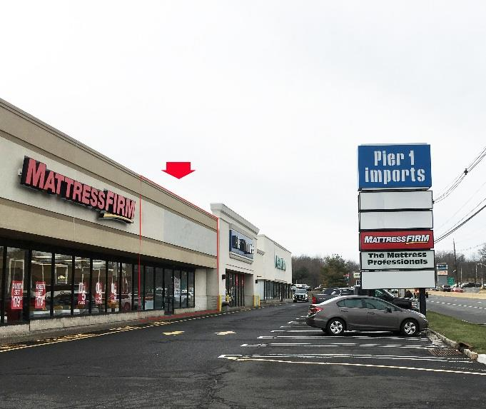

275 ROUTE 22 E. NOW LEASING

Major highway location NOW Leasing!!!! Located on Route 22 East. High visibility with pylon sign and direct access off Route 22. FORMER Mattress Firm; PLYLON SIGNAGE

LEASE | AVAILABLE Former Mattress Firm
STORES AVAILABLE | 5,000 SF
GLA | +/- 100,000 SF
AVAILABILITY | NOW
RENTAL RATE from; | $35.00 psf nnn
CAM NNN CHARGE | $6.50 +/-
TRAFFIC COUNT | 85,000 CARS DAILY
PARKING | 249
ADJOINING  TENANTS | Goldfish, Olive Garden, Leslie Pools  NJ Motor Vehicles, Soho Design

Demographics | 1 Mile | 2 Miles | 3 Miles
Population | 25,552 | 141,298 | 295,298
Average HH Income | $92,020 | $71,600 | $66,604

EXCLUSIVE BROKER
J.P. REALTY GROUP
330 ROUTE 661 - BLAIRSTOWN, NEW JERSEY 07825
(908) 813-0987 jponczek@msn.com FAX (908) 813-0987

