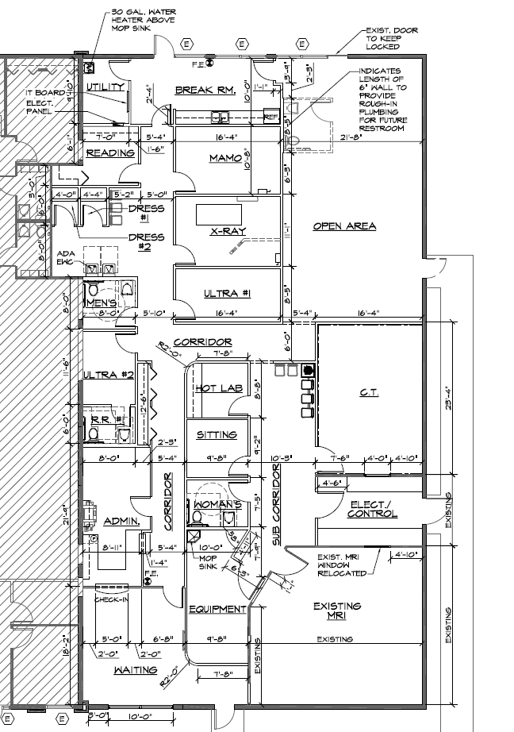
600 W. North Blvd., Leesburg, FL
Suite E (5,396 RSF)

