EXHIBIT A
Suite 132

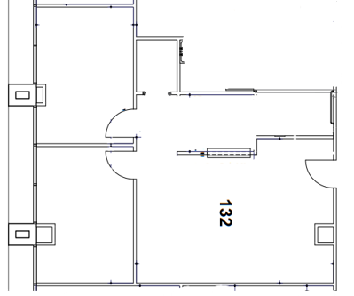
Approximately 925 SF

