Drakeley Real Estate 256 Main Street South Woodbury, CT 06798 203.263.4336

Award Winning Mixed Use Development

One Available Unit left!
$18/sf
Second Floor, 9,441sf or divide to 4500sf
Permitted Uses: Office, Retail, Medical

Ample parking, On-site Owner
Proximity to Heritage Hotel & 18-hole Heritage Club Golf Course
1 mile from I-84 interstate highway
Contact Tim Drakeley (203-510-9184) or Katherine Parlato (203-592-0443) for a showing or more information!

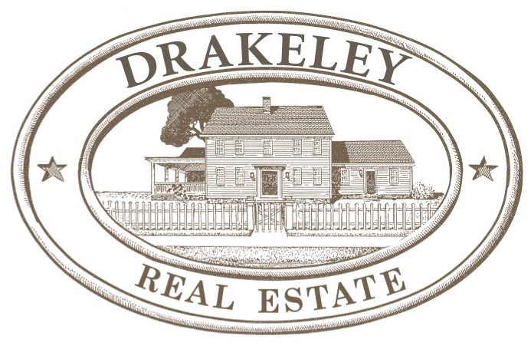
466 Heritage Road Southbury
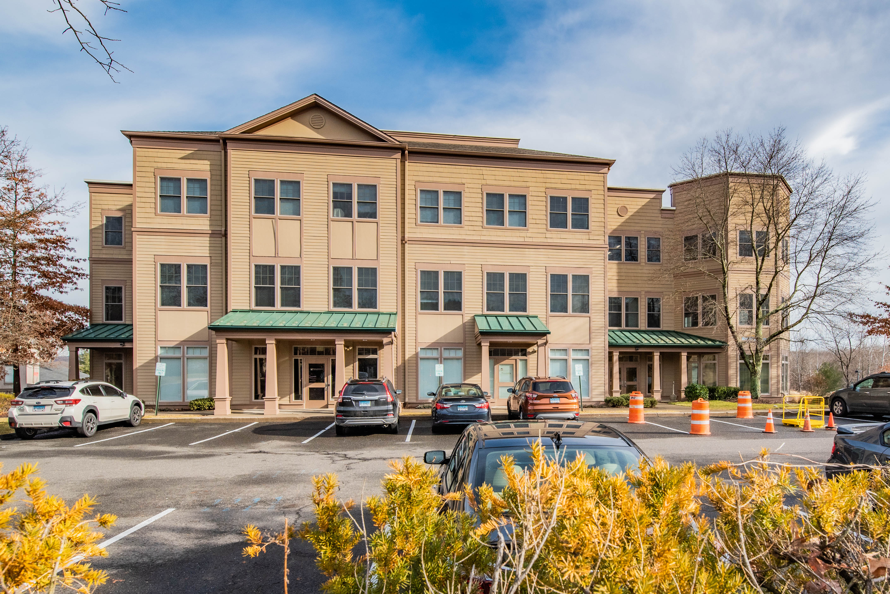
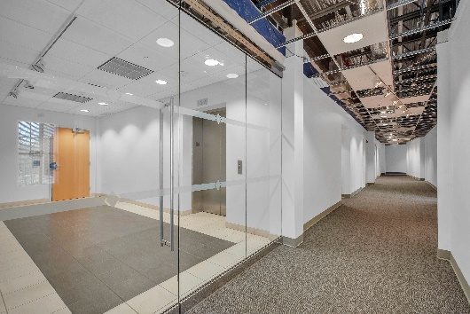
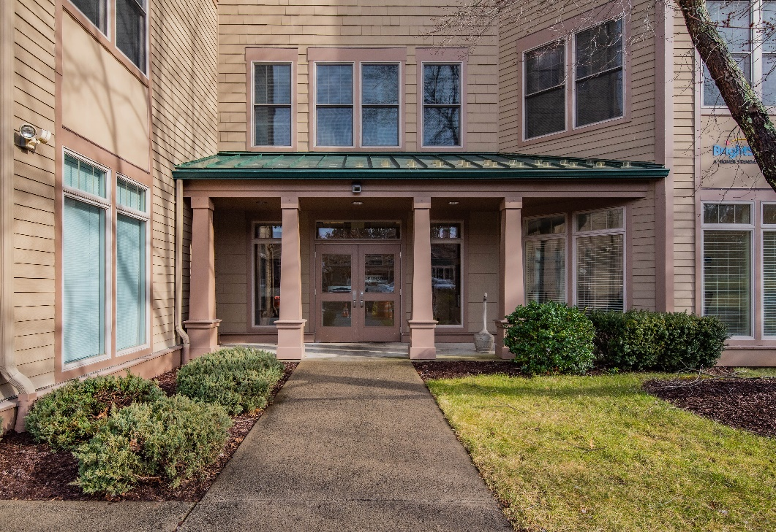
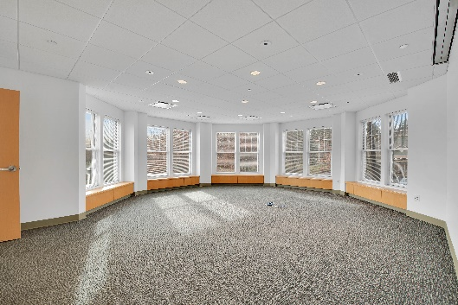
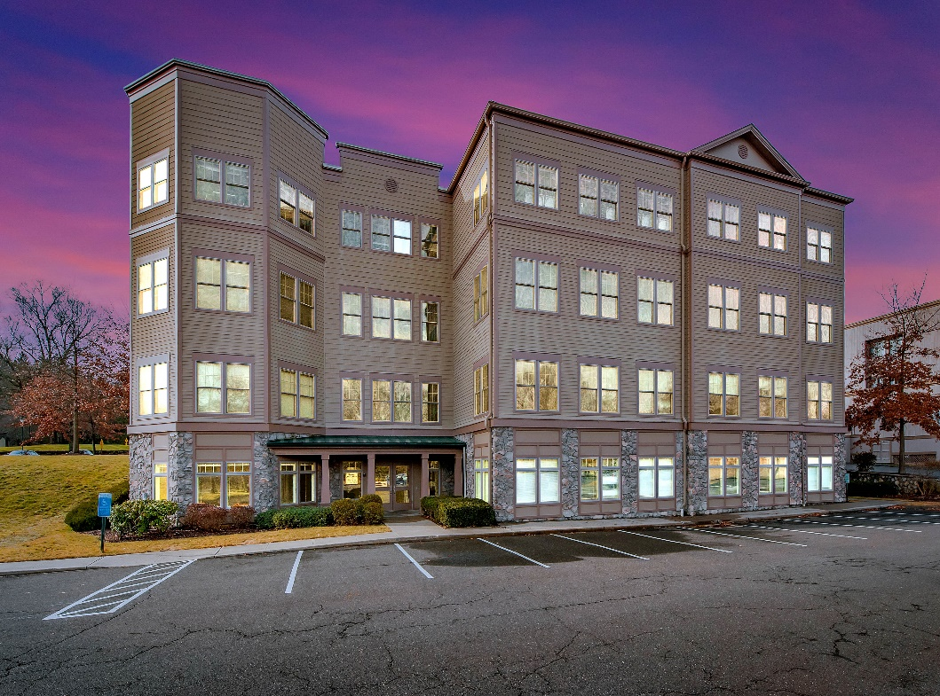
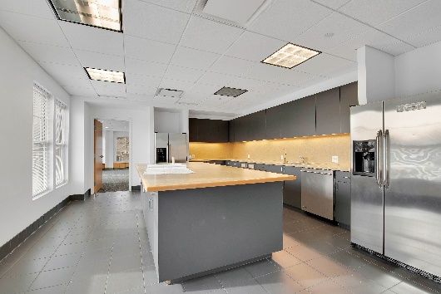
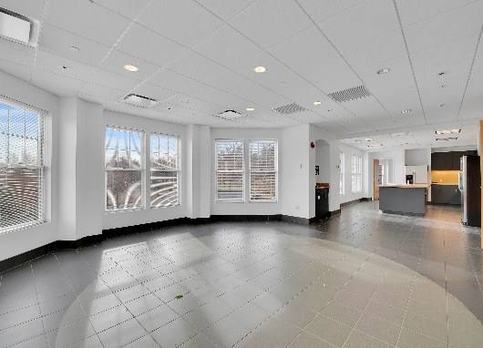

Timothy Drakeley
Broker/Owner
203-510-9184
Katherine Parlato
Realtor®
203-592-0443

Generations of Trust & Integrity

Drakeley Real Estate 256 Main Street South Woodbury, CT 06798 203.263.4336

