JWH Business Suites
Coming to Marysville, OH FALL 2025
On Columbus Ave minutes from historic Uptown
Contact Matt Homan for details: (937)-673-7502
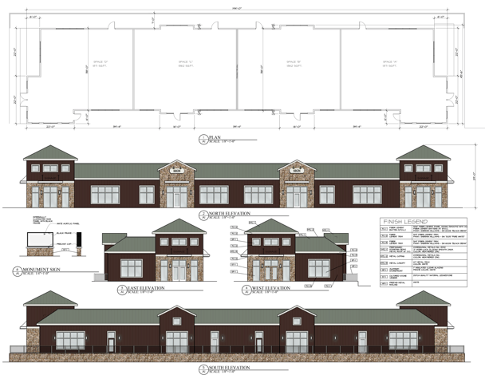

- Competitive cost per square foot for new build retail starting at $32.
- Build to suite. Bring your own GC or get a bid from ours.
- 3-10 year triple net leases available.
- Multi use retail/commercial zoning.
- All units available. Will divide down to 1,500 square feet.
- Plenty of parking and green space amidst some of Marysville’s most prime residential and commercial real estate growth just down from Benny’s Pizza.

