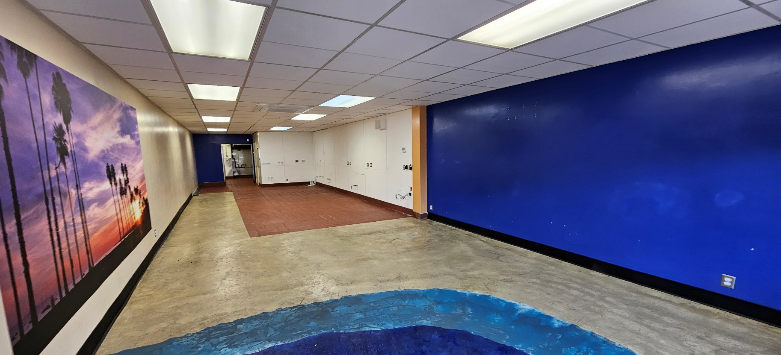
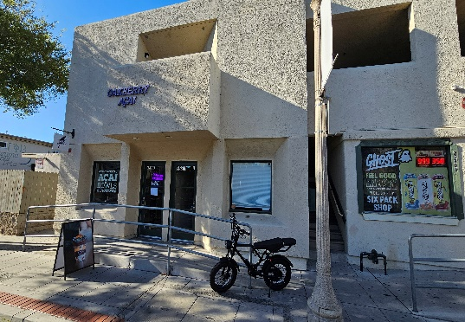
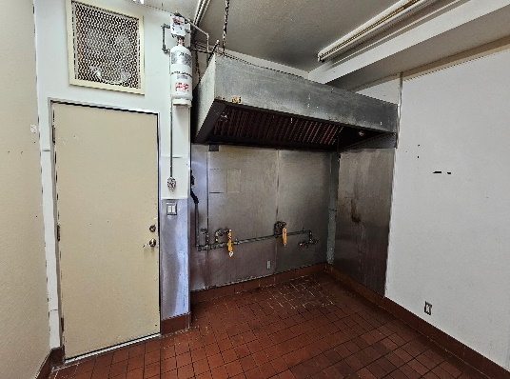
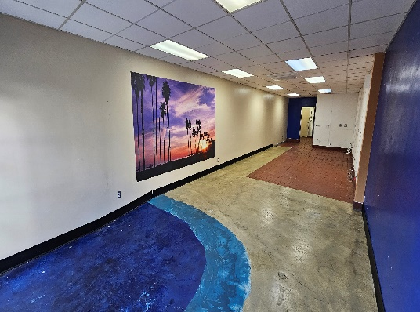
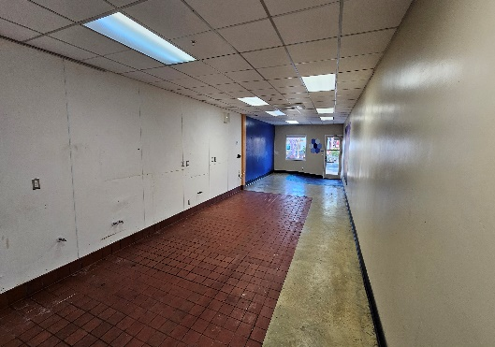

I.V. RESTAURANT SPACE ON PARDALL FOR LEASE
Remodeled Space with Hood, Grease Interceptor, Drains. & HVAC
6580 Pardall Suite B, Isla Vista, CA 93117 Asking $3.50 / S.F. NNN

Remodeled 910 s.f. restaurant space is ready for your concept with dual HVAC units, an 8’ hood, fire suppression system, grease interceptor (approved by Goleta West Sanitary), mop sink, floor drains, new exhaust fan, and commercial hot water heater.

This space is centrally located on Pardall right by Embarcadero Del Mar and benefits from a high volume of students biking and walking on their way to and from school.

Recently remodeled with upgraded HVAC, lighting, and a functional layout with the kitchen in the back, service area in the middle, and a modest seating area toward the front of the space. It has great signage and visibility and, overall, just needs basic restaurant equipment such as a stove, refrigerator, freezer, and P.O.S. system to start operating. The space was recently approved by the County Health Department, so approving a new concept should be straightforward. The space has handicap accessibility and should be ADA compliant.

HIGHLIGHTS AND LEASE DETAILS:
* 910 S.F. remodeled space is competitively priced at $3.50 / S.F. + NNN (~$0.44).
* Potential for brisk sales from high bicycle and pedestrian traffic to and from school.
* Recent health inspection, so approving a new concept should be straightforward
* Newer HVAC, ceiling tiles, electrical, plumbing, paint. Space is sprinklered too!
* High visibility and good signage add to the overall desirability of this location.
* 2 nearby, offsite parking spaces are available on the corner of Cordoba and EDM.
* Call today to schedule a private showing-space is move-in ready & currently vacant.

CONTACT:
Andrew “Andy” Adler, Broker-Associate 01162080
Century 21 Masters Commercial
1635 State St., Santa Barbara, CA 93101
805-722-2640 / z97andy@gmail.com

