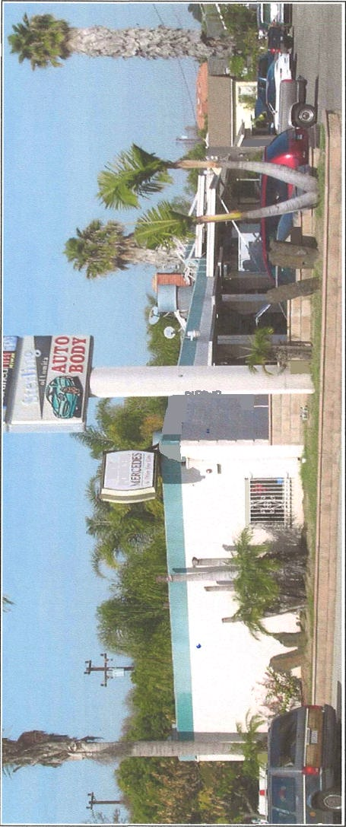
FOR LEASE
7,733 SQ. FT.
2075 W. Lomita Blvd., Lomita

Existing Auto Body

- 2 AQMD Spray Paint Booths

- Major Street Frontage
$11,595.00 Per Month
Gross

- Auto Building Masonry Block – 3,493 Sq. Ft.

- Residential / Office Frame Stucco – 3,340 Sq. Ft.

- Garage / Repair – 900 Sq. Ft.

- Covered Work Area

- Signage Available

- Immediately Available

The Auto Body space and spray paint booths are located in the rear of the Property.
Please do not disturb the front auto mechanic Tenant.

SITE PLAN ON REVERSE

Sojka-Nikkel Commercial Realty Group, Inc. Joseph J. Sojka, Broker
(310-534-8000

(310) 534-8000

