EXECUTIVE PROPERTY MANAGEMENT GROUP
_______________________________________________________________________
1751 MOUND STREET, SUITE 206 SARASOTA, FL 34236
OFFICE- 941-365-0200 CELL- 941-809-7027 FAX- 941-365-0290
GARYLANDSMAN@COMCAST.NET

2701 14th, at the corner of 14th and 27th,
One acre, with curb cuts, cleared, no buildings on it! just fenced it in.
Extremely visible to the huge # cars on 14th Street
Rent- $65,000 yr.; Sales price- $595,000
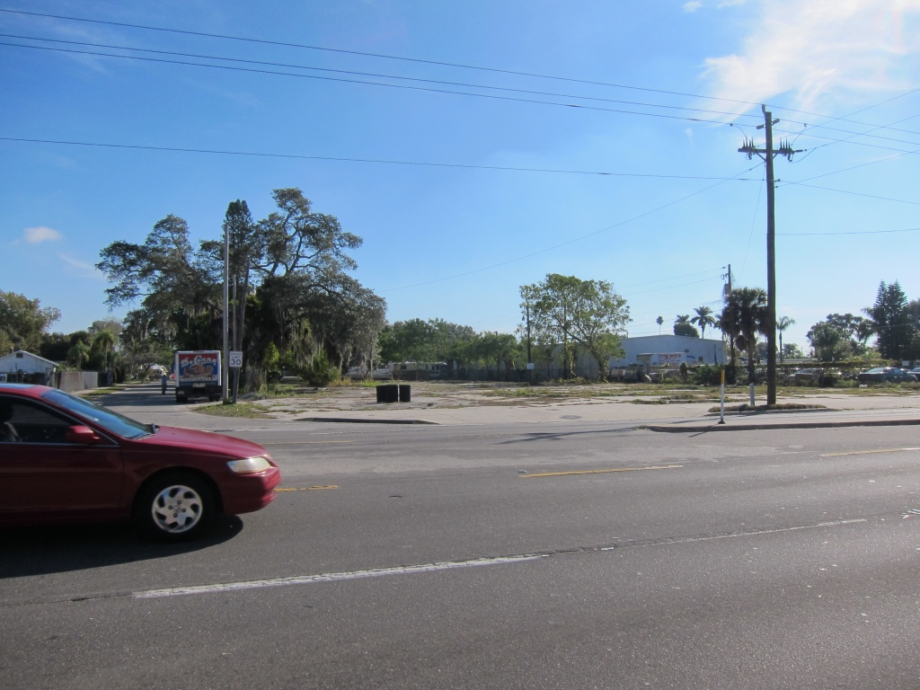
In re: 2701 14th Street corner property

11/28/18

Vincent,
The site does not need to be rezoned to allow for retail or restaurant. The HC zoning allows both uses. When the LDC code is updated next year, the maximum FAR may increase to 0.35.
Rachel W. Layton, AICP | Assistant Vice President Director of Planning
201 5th Avenue Drive East | Bradenton, FL 34208 941.748.8080 x 120 Work | 941.748.3316 Fax | www.znseng.com
￼
The property is located in the jurisdiction of Manatee County. I was able to confirm the Future Land Use is Retail Office Residential (ROR). The property is zoned Heavy Commercial (HC). The maximum square footage for the HC zoning district is 0.23 Floor Area Ratio. For this site, the maximum building size would be 10,450 square feet with a maximum height of 35 feet.
In the permitted use table, the AP note means the County will review the proposed use with the Administrative Site Plan (or Final Site Plan) application. The Land Development Code allows a wide range of commercial uses to include: car wash, child care, drive-through facilities, equipment sales, rental and leasing, flea markets, funeral home, gas pumps, lodging, self-storage, offices, banking, outdoor storage, personal service establishments, recovery homes, retail sales, schools, vehicle repair and vehicle sales, veterinary clinic, and warehouse.
Because the HC zoning district allows for so many uses, I do not see another zoning category to recommend.
I agree that this is an area in need of redevelopment. The best use for the Bradenton area would be retail or restaurant. These uses would be allowed with the approval of a Final Site Plan (engineering plan). The site will be able to receive credits toward the existing pavement when it’s time for a drainage permit from the Southwest Florida Water Management District. The open space requirement would be 15 percent and would include buffers and stormwater. This would leave more room for parking, which would average 1 space per 200 square feet.
Please let me know if you have any other questions. Rachel Whitcomb Layton, AICP

