For
LEASE
Asking rate:
$4.50 per sq. ft.
Full service gross
Suite 208-1,824 ft
200 Newport Center Drive, Suite 208
Newport Beach, CA 92660 – CALL TO SHOW


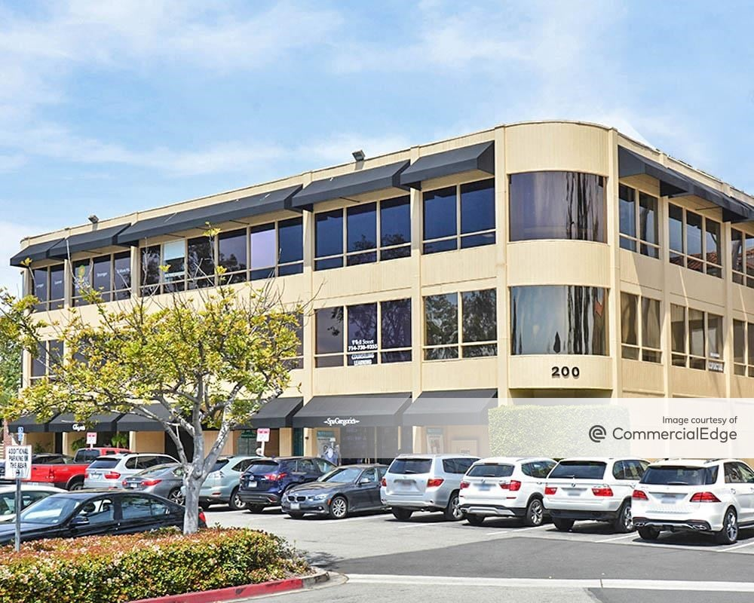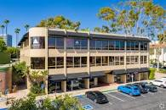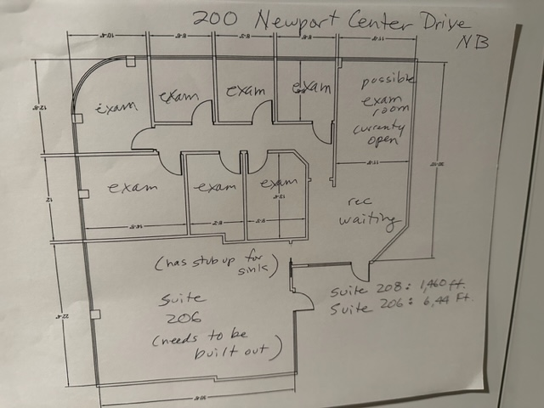

Suite Availability
Suite 208 configuration :
Reception, waiting room, 7 exam rooms, suite has a lot of light corner suite in the bldg., has sinks
Free Parking in the surface parking lot for tenant anvisitors. Common area restrooms- no restroom in the suite.
Elevator served

.

AVAILABLE IMMEDIATELY- BUILDING SIGNAGE AVAILABLE
On the exterior window, ocean view – great location
Medical space for Lease in Newport Center – Fashion Island Newport Beach
NEW LEASE WILL BE IN PLACE- call to view- plug and play
ASKING RENT: $4.50 FT FULL SERVICE GROSS- flexible terms
CALL

Hoag Hospital
HHospitFashion Island-Newport Center Office Suites

Suite 208- 1,824 ft

