RETAIL FOR LEASE
Former Subway Restaurant
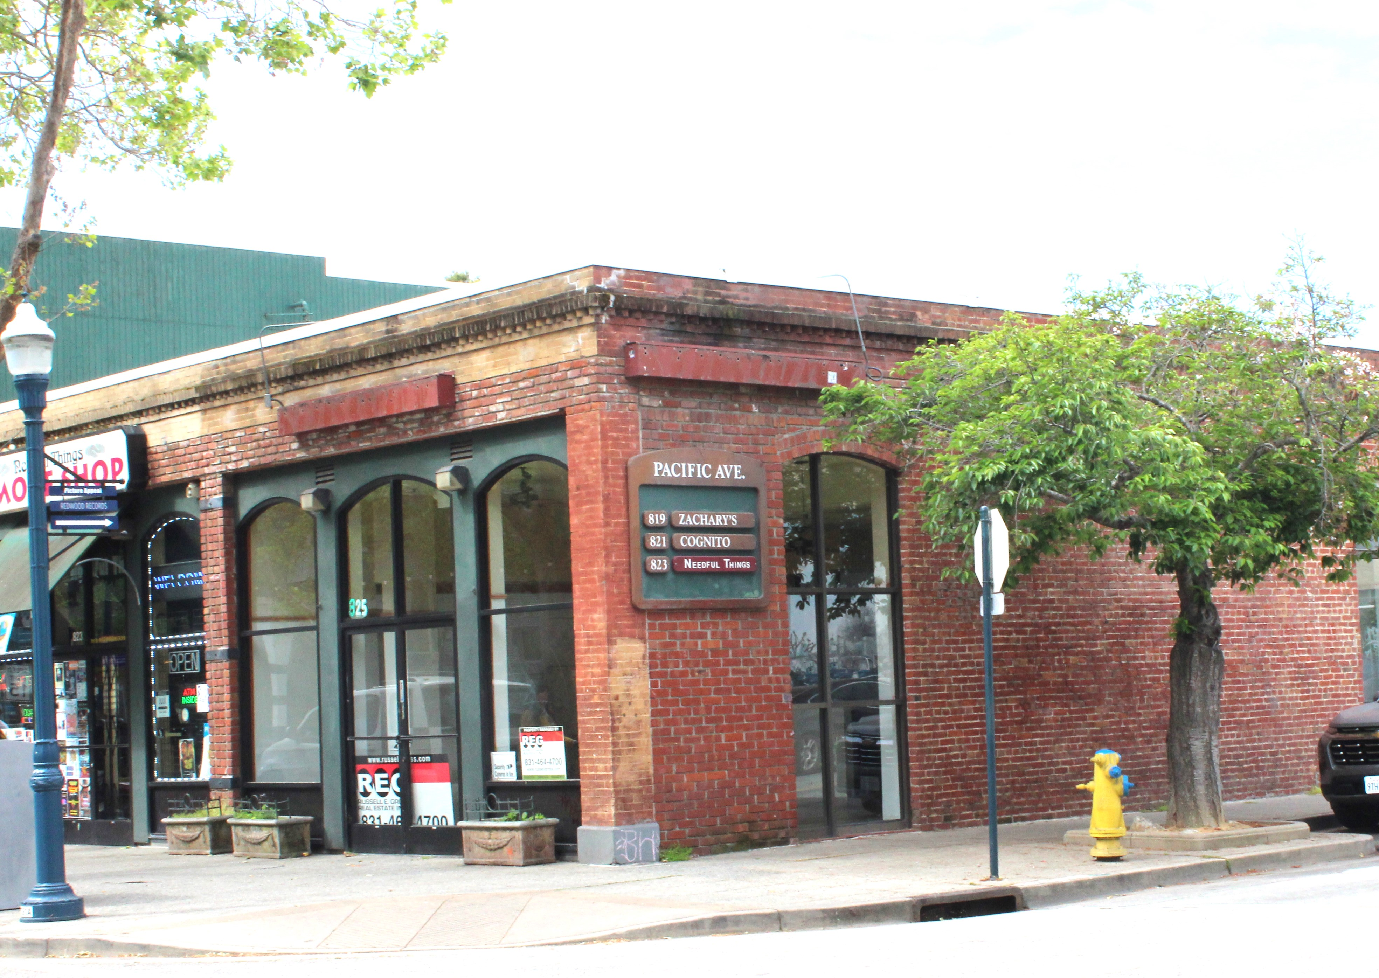

Property Address: 825 Pacific Avenue, Santa Cruz, Ca. 95060

Description: *1,650 Sq. Ft. Former Subway Restaurant location
*Downtown Santa Cruz on corner of Pacific & Maple
*Directly across major Residential/Commercial Development.
*Walk in Refrigerator/Freezer, sandwich line cases, required sinks, fountain lines, handicap restroom, etc.
*Private, shared back parking lot w/ 4 reserved spaces.

Rental Rate: $2.00/sf NNN (est. $0.53/sf)

PRESENTED EXCLUSIVELY BY:

DRE #01270957
Russell E. Gross Real Estate, Inc. 3140 Porter St, Soquel, Ca. 95073
Office # 831-464-4700 CELL # 831-246-0202 russell@russellgross.com

