2800 ECR 147

MIDLAND, TX 79706
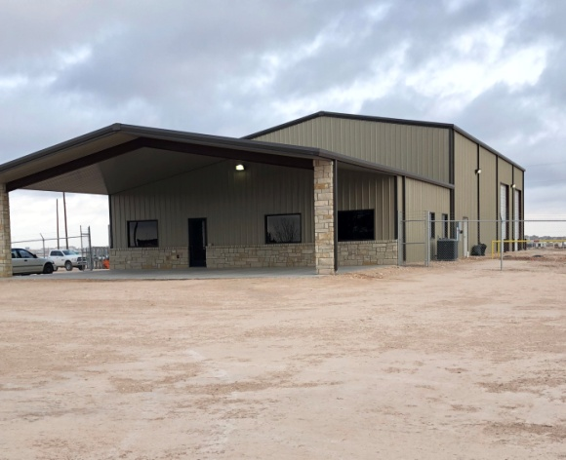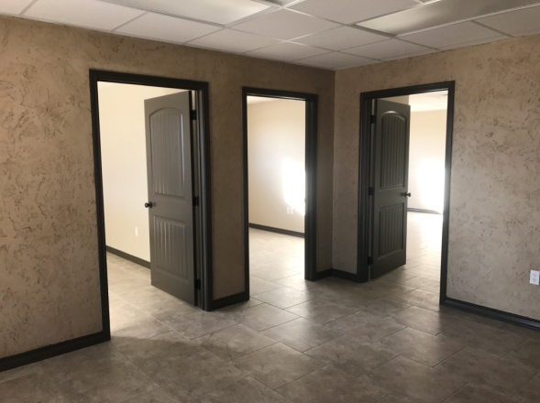
PROPERTY DESCRIPTION:
OFFICE/SHOP ON 5.33 ACRES
TOTAL SQUARE FOOTAGE IS 6,750
THE OFFICE PORTION OF THE BUILDING CONSIST OF 1,750 SQUARE FEET AND INCLUDES THE FOLLOWING
6 OFFICES THAT ARE PREWIRED WITH CAT 5 DATA CABLE
CONFERENCE ROOM
DATA ROOM
KITCHENETTE
3 BATHROOMS
1,500 SQUARE FOOT OF COVERED PARKING
THE SHOP PORTION OF THE BUILDING CONSIST OF 5,000 SQUARE FEET
SALE PRICE: $1,350,000.00
LEASE PRICE: $12,500.00 /MONTH 60MONTH NNN

