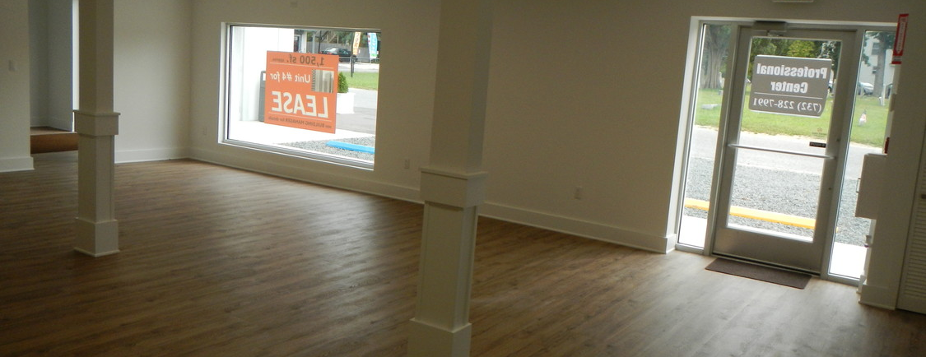
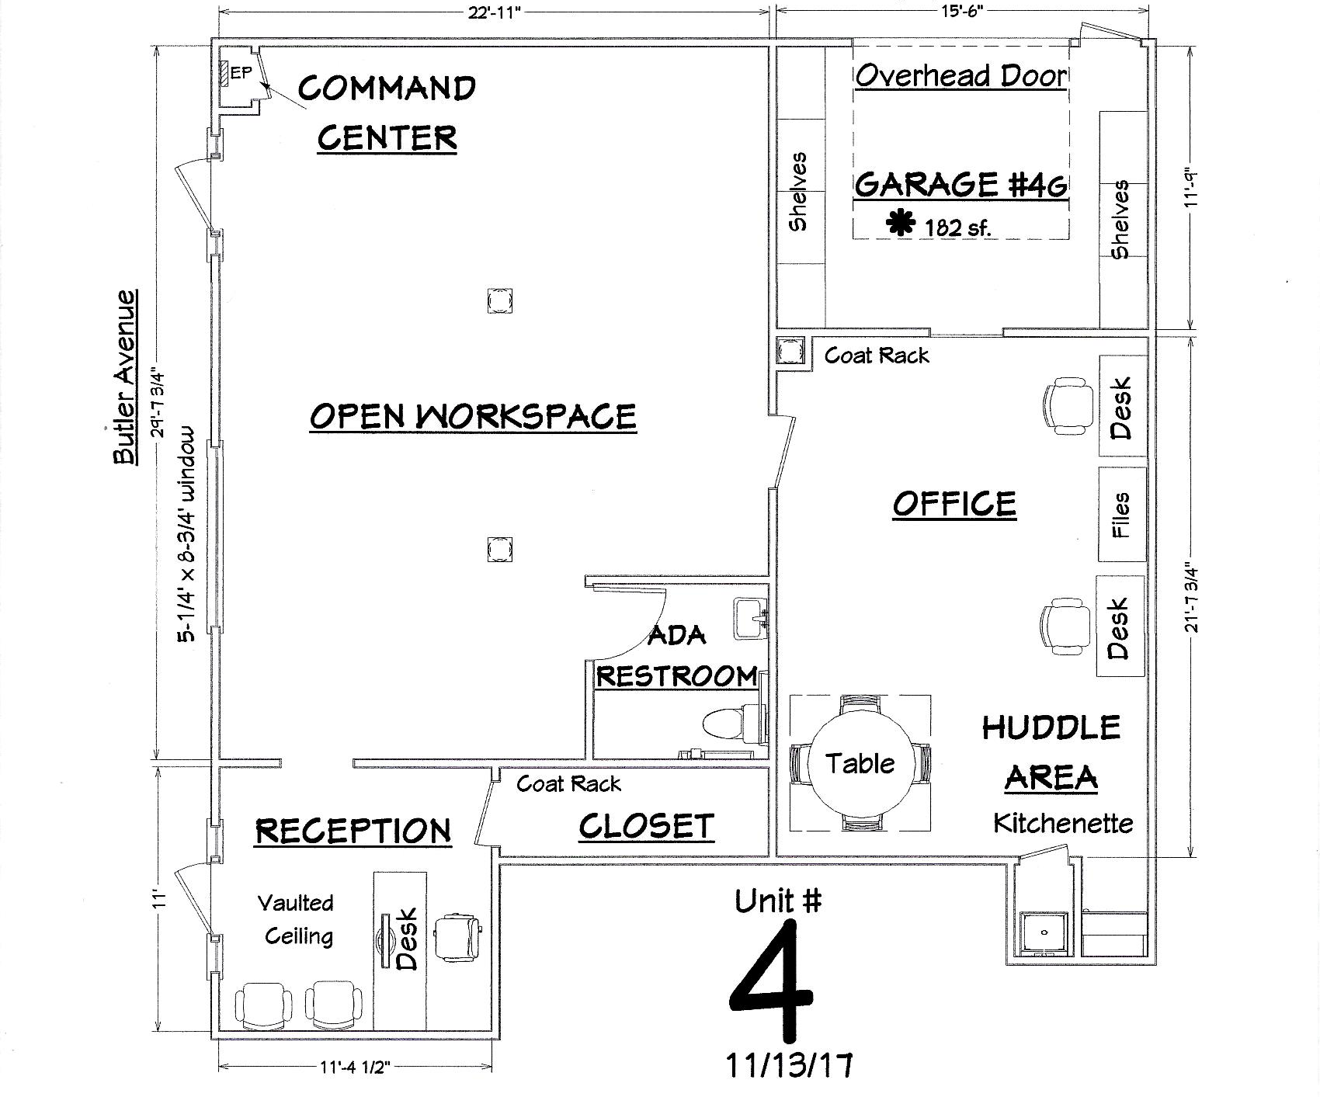



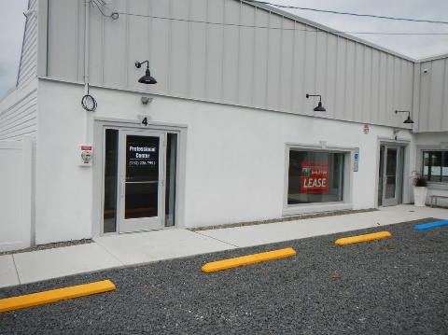
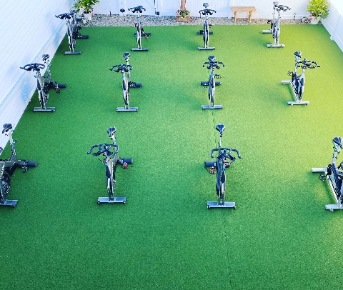

Unique Rt. 9 Space for Lease
Unit #4 510 Rt. 9 Bayville, NJ 08721
Call (732) 503-9098 for a Private Showing
Unit #4 for Lease

Mo. + Electric

Security is $5,711.
3.25% increase every January 1st
1,500 square feet approx.
Rt. 9 Easy Access
Ample Parking Lot
Vaulted Reception Area
Large ADA Restroom
Well-appointed Sales Floor
Back Room with 3 Bay Sink
Side Garage with separate entry

High Efficiency:
LED Light Fixtures
Spray Foam Insulated
5/8” Thick Fire X Drywall
High Efficient 240v HVACR

Fully Updated:
Glass Storefronts by Old Castle
Commercial LVT Floors
Detail Molding & Tegular Ceilings

Rent Includes:
Bi-Annual Preventive Maintenance
US Post Box and Address
Property Taxes
24/7 Security Lighting & Cameras
Security System & Panic Button
Sewer & Water Consumed (basic)
Dumpster (basic)
Snow Removal (basic)

Optional:
Adjacent 1,000 sf. Fenced in Turf
$2,877

