

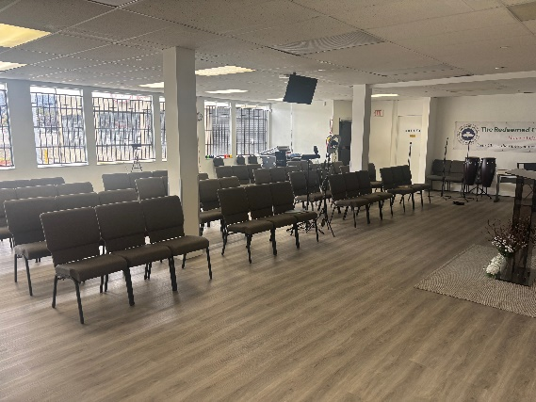
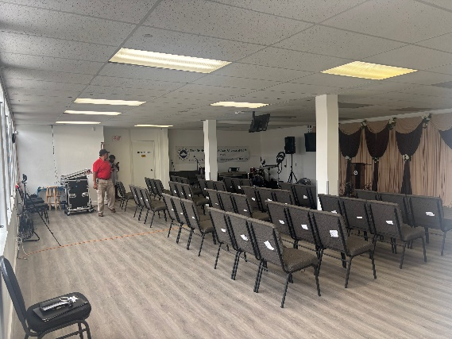
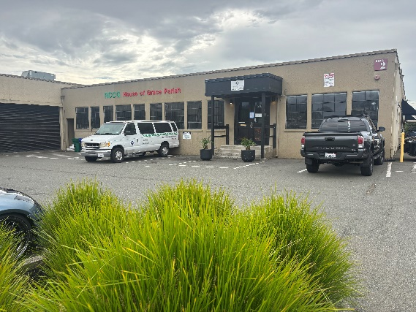

Parking at the Door Main Church Space for 60 Bright Setting
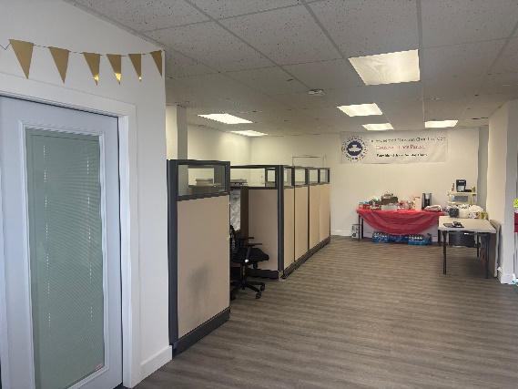
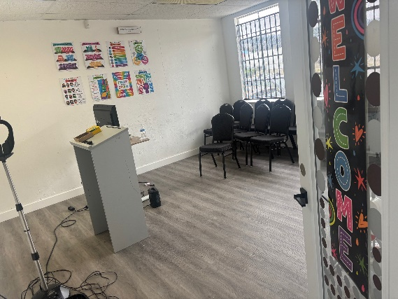
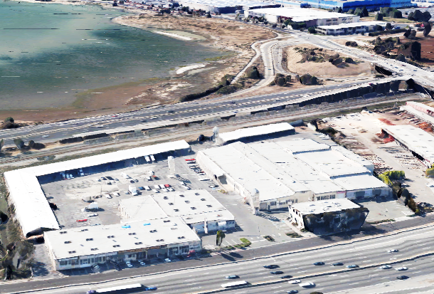
S.F. Bay
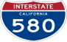
Space Here
Open Flow

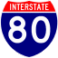

Office/Admin area Kids Chapel for 19 Facing 255,000+ Captive Cars/day

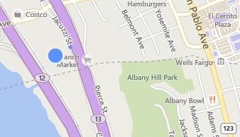
I-80 CHURCH or SHOWROOM FOR LEASE

5327 Jacuzzi Street #2-D: ±2,467 Sq. Ft.
BART

Open Office, Retail, Church, or Craft Space featuring:
- Retail Fixtures - Delicious On Site Cafe
Site!
- Natural Light - Security Bars
- Off Street Parking - Two Restrooms in Space
- Three-Phase Power - Reasonable T.I’s (paint/carpet)

…& Commanding Exposure to I-80 Freeway! Please see plan on page two. Only Half-mile from BART!

$1.50/Sq. Ft. Monthly Net + 40¢ CAMs.
FOR FURTHER INFORMATION PLEASE CONTACT Peter McNally 510/848-6007
CITY | Richmond Bayside | LISTING CO. | McNally Realty Advisors
ADDRESS | 5327 Jacuzzi Street#3-C2 | LISTING AGT. | Peter McNally
CROSS ST. | Interstate 80/Central Ave. | PHONE # | 510/848-6007
SPACE AVAIL. | 2,467 Sq. Ft. | LIST DATES | 1/26
PRICE | $4,700 / month all-in | DRE # | 982919
PROP. TYPE | Retail - Activity Space | FEE TO S.O. | 3% gross rents
Information Herein Deemed Reliable but Not Guaranteed.


