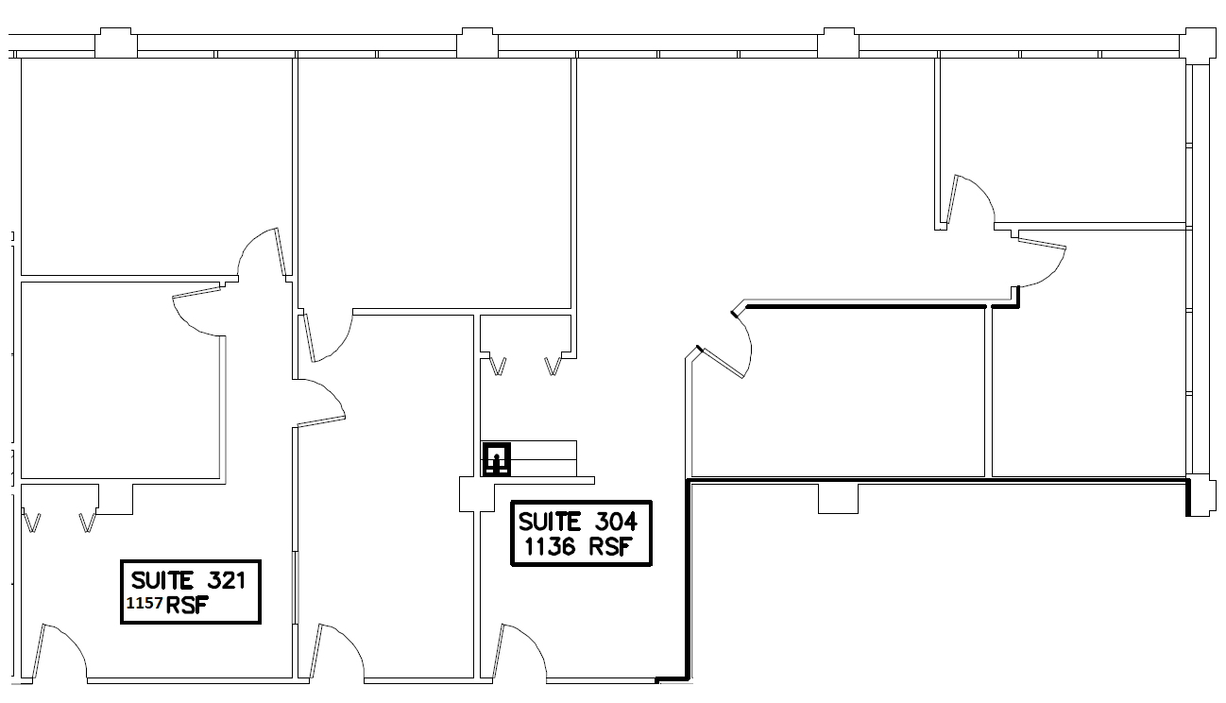
800

E. NW HWY
PALATINE, IL

SUITE 304 & 321
RSF AS NOTED
IMPERIAL REALTY COMPANY

4747 W. PETERSON AVENUE
CHICAGO, ILLINOIS 60646
SUITE 200
T 773.736.4100
F 773.736.4541
www.imperialrealtyco.com

