RESTAURANT/BAR

East Decatur Station
627 D East College Avenue, Decatur, GA 30030
2200 sq ft

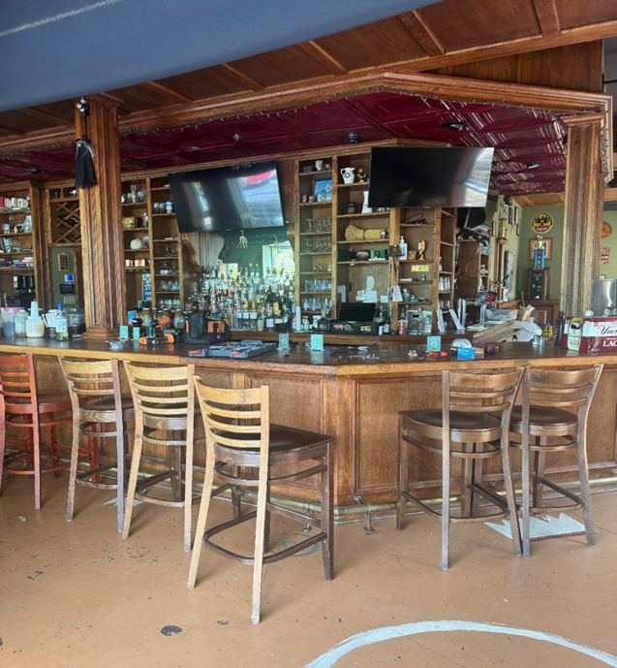

$28.00 psf NNN, approx. 7.30 psf in p/t including CAM TAX INS, TRASH, and ELECTRIC. Water and Gas not included
Property Features
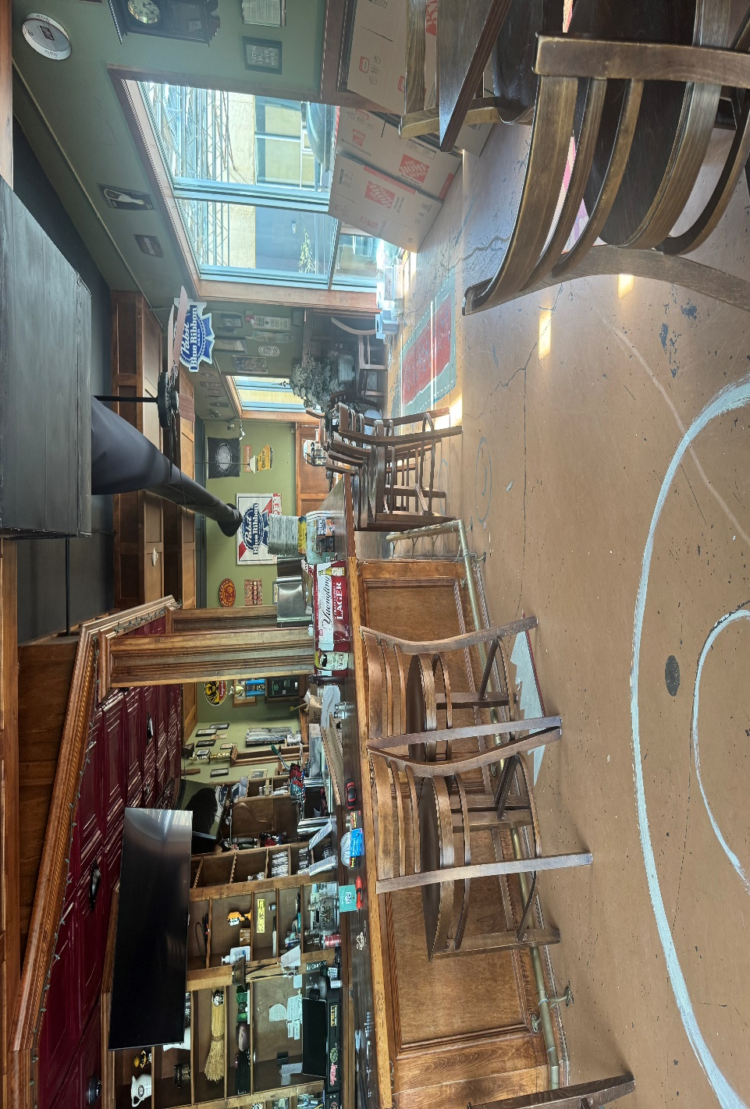
- Great Restaurant Space located near City of Decatur shopping and restaurants and adjacent to Upcoming Pedestrian Friendly Mixed-Use residential apartment building
- Parking at the immediate front of the building
- One Block from Avondale Marta Train Station

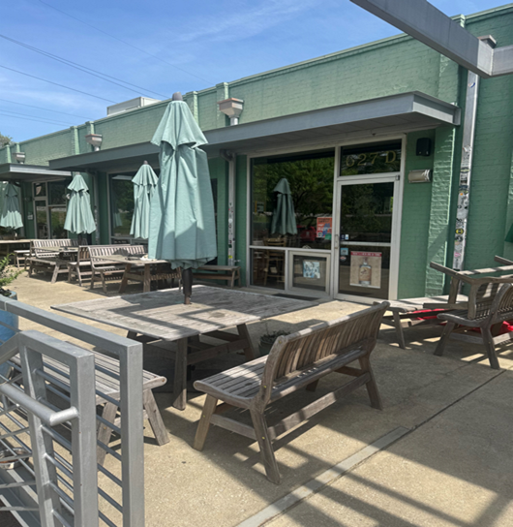

Leasing requirements-
  - Personal guarantee required
  - Personal credit score of 675 or more required
  - First month’s rent and security deposit due at lease signing
  - RENT + CAM + UTIL+ Trash = monthly payment

Broker Commission:
  - Brokers to be paid ½ of first month’s rent with 5% residual.
  - Brokers must make first contact with EDS Leasing office for commission to paid on executed leases by EDS. If EDS shows the tenant the property first, tenant will be responsible for Broker’s commission.

