regions bank building
5401 S. Kirkman Road, Orlando, FL 32819

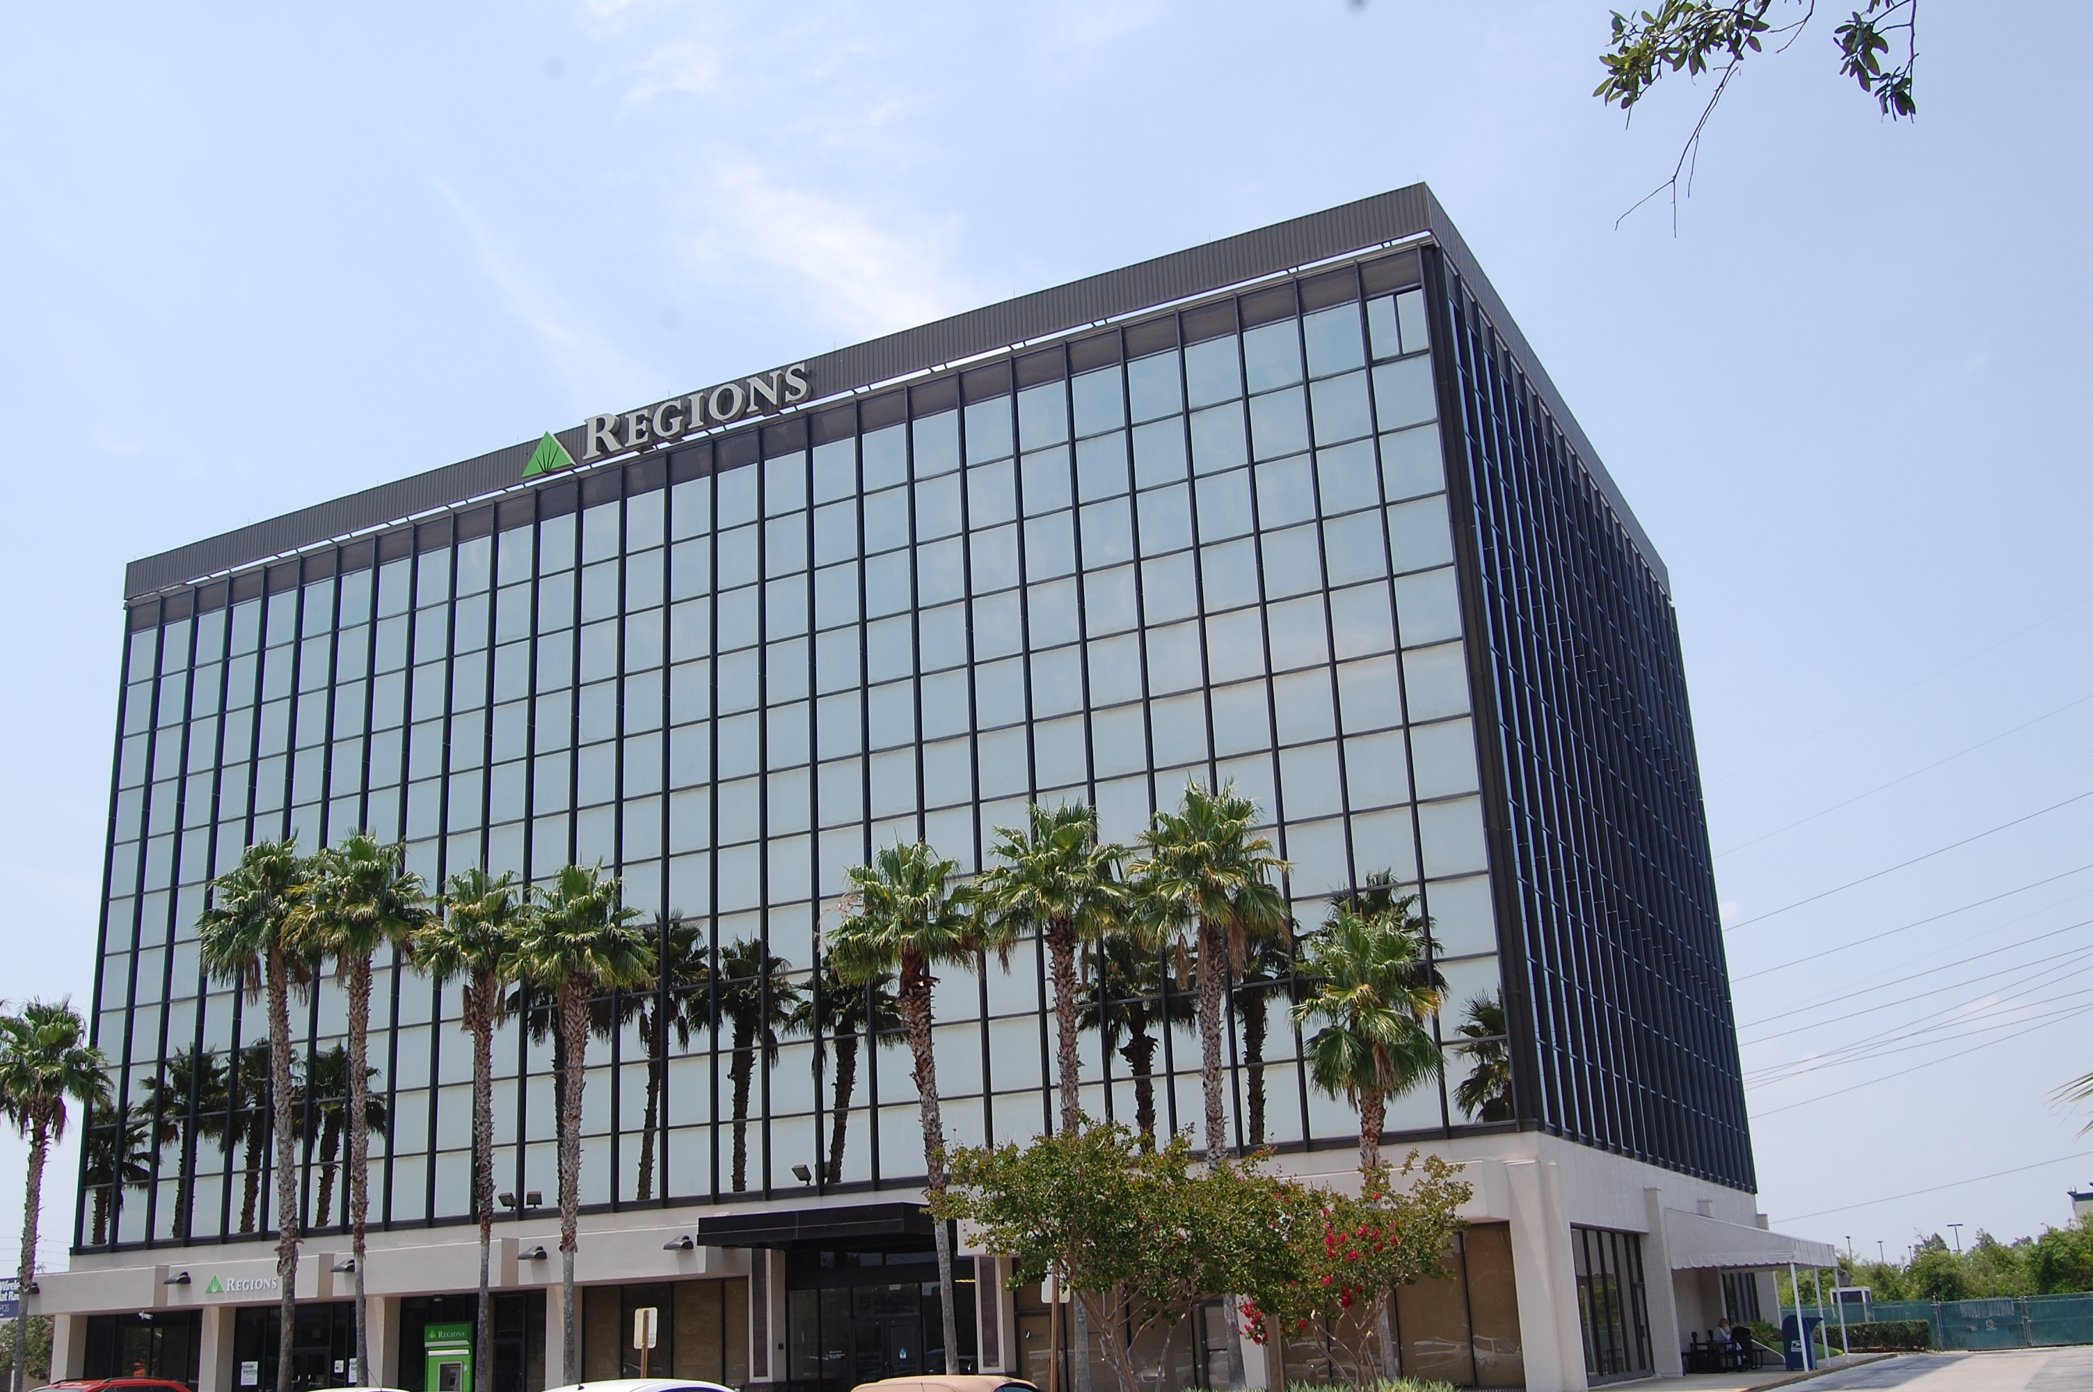

FOR LEASE
Specifications:
- 92,781± SF.
- 7 Floors
- Parking Ratio: 3.1/1,000 RSF.
- ATTRACTIVE LEASE RATES: $29.00/RSF. FULL SERVICE
ON - SITE

PROPERTY MANAGER
Strategically Located in Southwest/Tourist Corridor
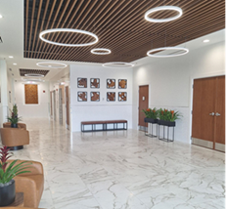

DAY PORTER & NIGHTLY JANITORIAL SERVICE

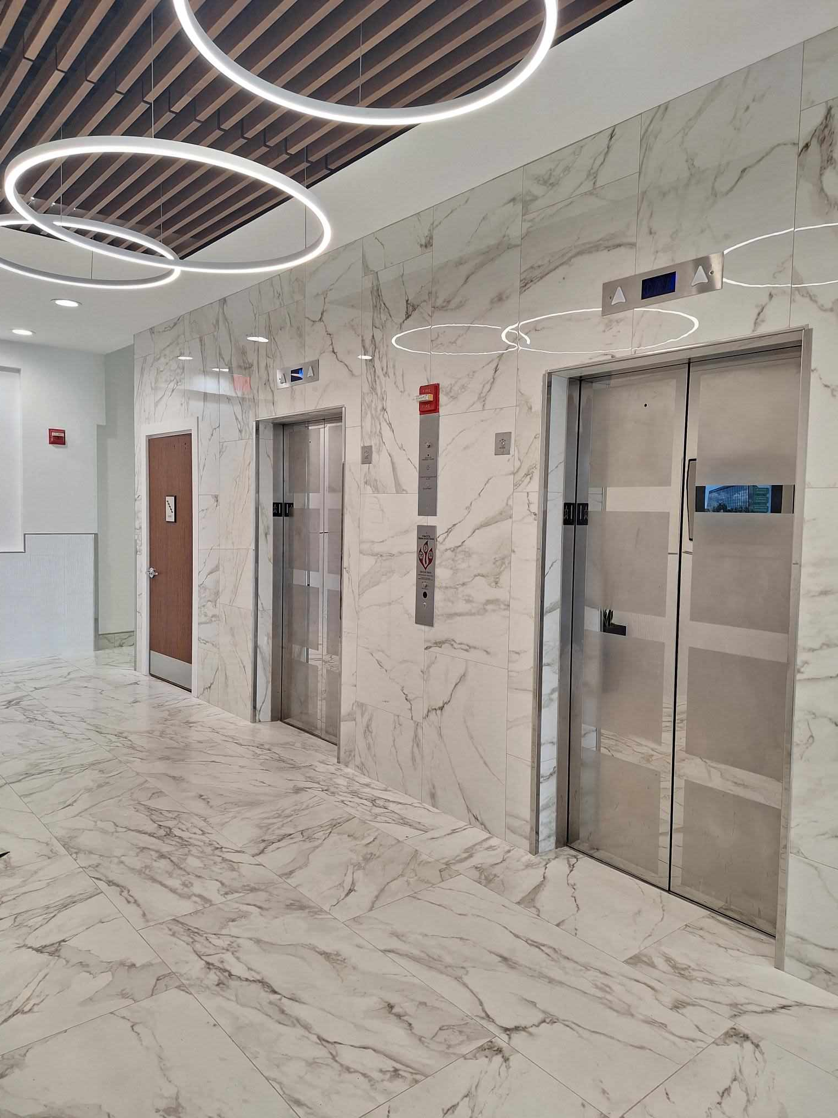
BUILDING ENGINEER

Amenities:
- Class A lobby with touch screen directory
- Easy access to I-4, the Florida Turnpike, John Young Parkway and the East/West Expressway
- Close to Universal Studios and Island of Adventures, Restaurant row, and the Millenia mall.
- Variety of hotels within walking distance



Contact: isabel lantry
| (407) 351-6006 | ilantry@marcent.us |
AREA MAP
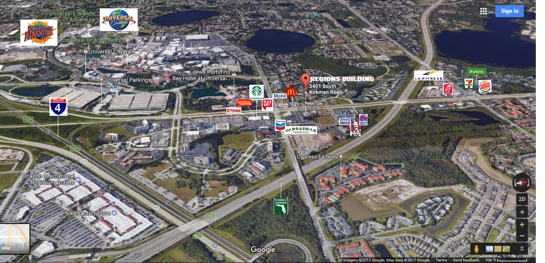
Mall of Millenia &
Orlando Premium Outlets
3 MINUTES
Downtown Orlando
18 MINUTES
Orlando Int’l Airport
15 MINUTES
Restaurant Row
8 MINUTES


IDEAL FOR:
- Insurance Companies
- Real Estate Companies
- Engineers
- Accounting Firms
- Law offices
- Healthcare Firms
- Other Professional Services



