Sackville Place Business Centre, 44-48 Magdalen Street, Norwich NR3 1JU
Contact: Shiv: 07308752533
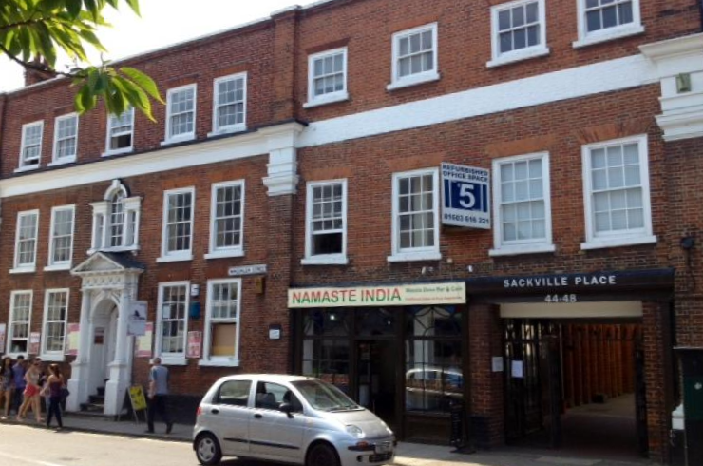
Available Space | Approx. size (sq ft) | Desk Recommendation | Price Per Month
Ground Floor
Suite 2 | 135 | 2 | £220
Suite 18 | 135 | 2 | £220
First Floor
Suite 111 | 283 | 5 | £450
Suite 112 | 283 | 5 | £450
Suite 113 | 283 | 5 | £450
Suite 114 | 283 | 5 | £450
Suite 117 | 630 | 10 | £1200
Second Floor
Suite 206 | 270 | 5 | £450
Suite 209 | 270 | 5 | £450
Suite 210 | 270 | 5 - NEEDS REPAIR | £450
Suite 211 | 245 | 3 - NEEDS REPAIR | £380
Suite 213 | 270 | 5 - NEEDS REPAIR | £450
Suite 218E | 285 | 4 – NEEDS REPAIR | £ 380
Suite 221 | 630 | 10 – NEEDS REPAIR | £1200
Suite 222 | 670 | 15-20 – NEEDS REPAIR | £1600
Third Floor
Suite 305 | 120 | 1-2 – NEEDS REPAIR | £220
Suite 310 | 120 | 1-2 – NEEDS REPAIR | £220
Suite 316 | 245 | 3 – NEEDS REPAIR | £375
Suite 311-312 | 295 | 5 – NEEDS REPAIRE | £480

Description:
Sackville Place is a small period property located in the north of the City Center.

Transport:
The bus station is 10 minutes away by foot and the railway station less than 15.

What does the above price include?
- Rent
- Service & Maintenance Charges
- Communal cleaning
- Basic furniture

Additional Costs
- Parking if available (£50.00 per month)
- Business rates are not included although many offices should qualify for 100% rates relief but please rely on your own enquiries
- Super-fast fiber Internet as per requirement and choice of provider
- Extra furniture can be arranged at a cost

