

“NEIGHBORHOOD” RESTAURANT/BAR
627 D East College Avenue, Decatur, GA 30030
2200 sq ft

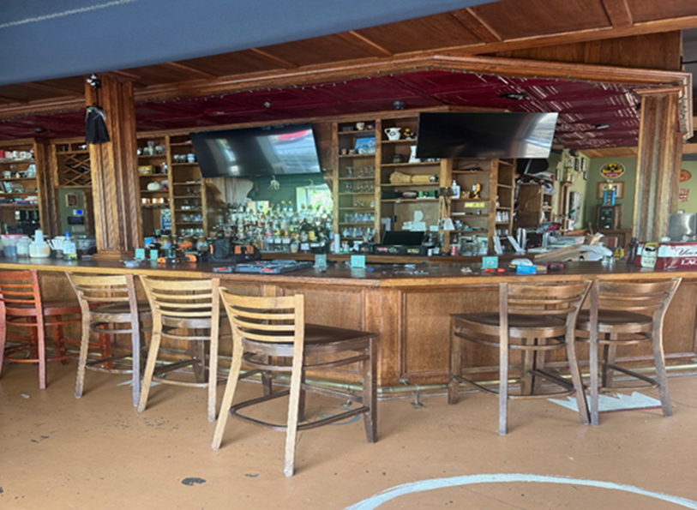

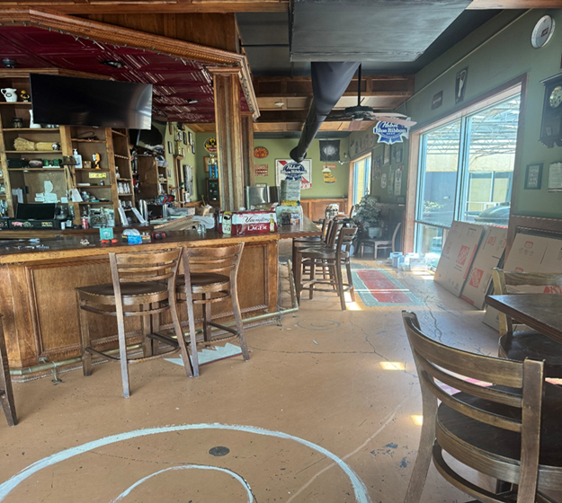

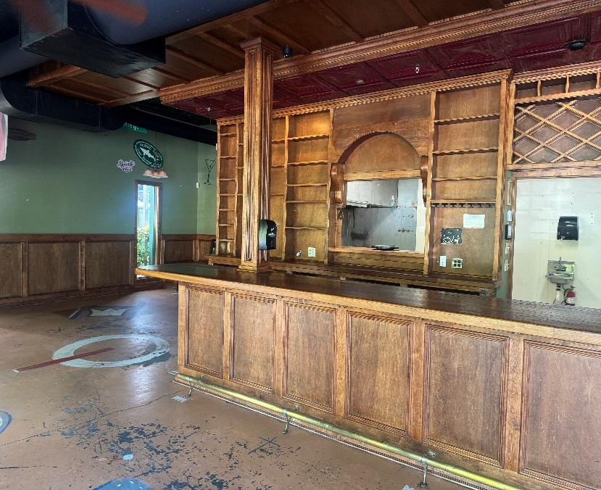
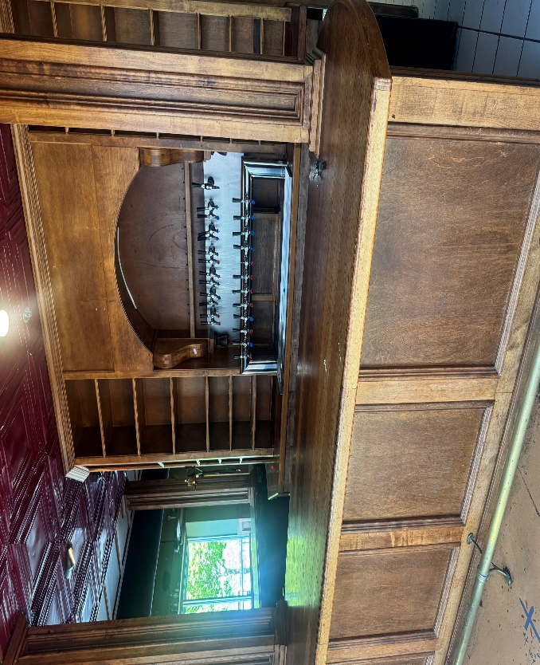

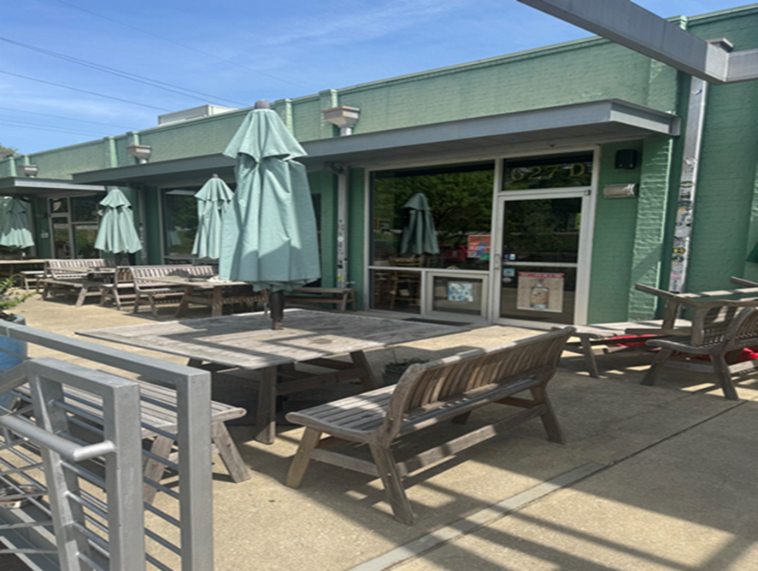

$25.00 psf NNN, approx. 7.30 psf in p/t including CAM TAX INS, TRASH, and ELECTRIC. Water and Gas not included
Property Features
- Join the City of Decatur Restaurant Scene with fabulous location and welcoming “vibe”
- 50 linear ft beautiful custom-built bar, lots of tabletop space, billiard area and beer tap system
- 9 ft. Vent hood, 1500 gal grease trap, walk-in refrigerator
- Two Restrooms
- Great outdoor patio seating overlooking the courtyard
- Abundant Parking as well as immediate parking in front of the building
- Over 1000 apartments within walking distance, including 370 Mixed-Use residential apartment building under construction next door
- One Block from Avondale MARTA Train Station
Leasing requirements-
  - Personal guarantee required
  - Personal credit score of 675 or more required
  - First month’s rent and security deposit due at lease signing
  - RENT + CAM + UTIL+ Trash = monthly payment

Broker Commission:
  - Brokers to be paid ½ of first month’s rent with 5% residual.
  - Brokers must make first contact with EDS Leasing office for commission to paid on executed leases by EDS. If EDS shows the tenant the property first, tenant will be responsible for Broker’s commission.

