- WATERWORKS MARINA & OFFICES
1818 WESTLAKE AVENUE NORTH
SEATTLE, WA 98109

SUITE 18-232

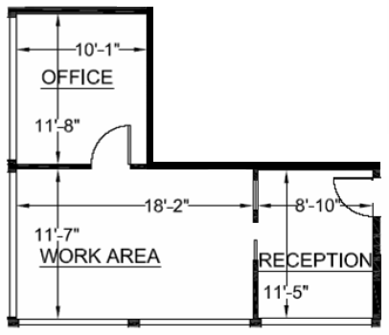

RENTABLE: 622 sq.
TEMPERATE PARADISE PROPERTIES, LLC
206-851-0036

