Unique Residential Rental Opportunity
Park Hill, Yonkers, NY 10701
Two “Sponsor Exempt” Garden Co-Op Apartments
(Essentially compatible to a 2-Family House)
OFFERED FOR SALE:
Two 2nd Floor, 1BR, 1Bth, “sponsor-exempt,” apartments, leased with annual increases, currently totaling over $30,000 net yearly income.
These co-op apartments avoid the usual negative effects of having a Co-Op Board having any negative influences on the new owners, such as Board Approval of tenants, or subsequent buyers, renovation or modification of the units. As long as no buyer ever occupies the apartment(s), this exemption virtually converts the value of these apartments to that of condominium units, thereby increasing their value.
SEE PROPRIETARY LEASE and BYLAWS excerpts below.
Photos and plans are attached below. No access to apartments will be allowed until prospective buyers show adequate credit (700+), proof of finance, and bank approval documents.
Each apartment has a ground floor entrance with stairs to a 2nd Floor landing. Above the landing is a trap door to a tenant-controlled, private attic storage space. The attic has been furnished with a plywood floor making it suitable as a “crawl space” storage area with pull-chain light. According to the exemption, this space may be converted to living space by way of an internal stairway.
At the top of the stairs, an additional locked entry opens into a living room with open-plan dining area, and access to the kitchen with breakfast counter. Adjacent to the entry, there is a small hallway with a closet, access to the bath with full size tub and shower, and access to a bedroom with two closets. Views of parklike settings on three sides and proximity to a children’s playground. The apartments are adjacent to the Yonkers Middle High School property.
The cooperative provides daily door front garbage pickup. There is a childrens’ playground within feet of both apartments. Unit 94-A provides two windows looking out onto the playground.
Within the perimeter of the greenspace courtyard of the two-story structures is a convenient laundry room with cashless, card-access machines that are well maintained.
A recycling area adjoining the laundry provides a means for residents to dispose of small appliances and other unwanted household items.
Apartment 90-2A currently has one parking space assigned to it with the monthly fee included in the rent. Parking is renewable yearly.
Bus transportation is available within 100 yards, and the complex is walking distance to Tibbet’s Brook Park, with mini golf, a large lazy-river pool complex, exterior gyms and access to the Northway bike and jogging trail.
The complex offers easy access to all major highways, Yonkers waterfront, houses of worship, downtown shopping and entertainment and two MTA stations with 32 min. commute to NYC.
Address 1: 90 Spruce Street, Apt. 2A: Completely painted Aug. 2025, recently leased for 1 year at $2,000 per month, with an annual increase in rent expected at renewal.
50 feet away is:
Address 2: 94 Spruce Street, Apt. 2A: Repainted Jan. 2025, currently occupied on a 1-year lease since Nov. 2024, expiring yearly. Current includes a one-year renewable private parking space.
See below for 2024 and 2025 P/L spreadsheets.
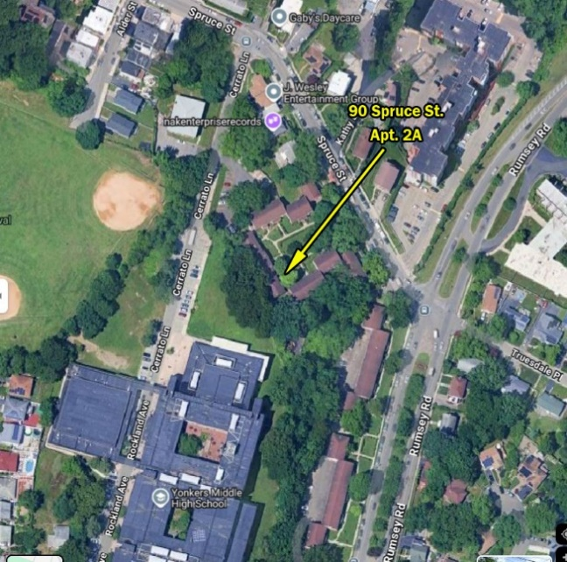
Aerial View at Intersection of Rumsey Rd, and Spruce Street, Yonkers, NY

INSPECTIONS
Since the properties are currently occupied, interested parties should express their interest with either an all-cash proof of funds (POF), or a POF, proof of income (IRS documents) and with a bank approval letter for adequate financing. Contracts of Sale based on financing may not include a “failure to finance” escape clause.
Upon receipt of appropriate documentation, owner will arrange for a mutually agreeable date and time for an examination of the interiors.
Exterior and physical plant examinations may be scheduled at any mutual time between management and potential buyers.
A view from the living room window of  90 Spruce Street, Apt. 2A, showing the well-  maintained courtyard. The couple is walking  toward the recycling and laundry room at  the end of the sidewalk. | 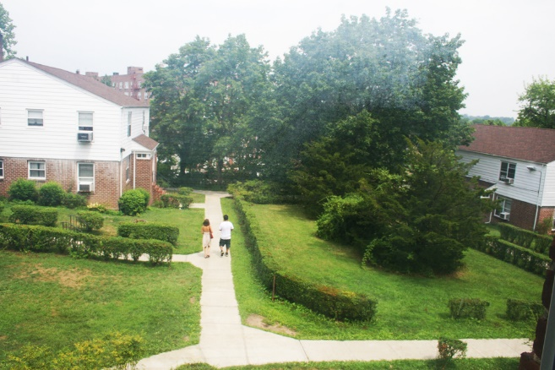
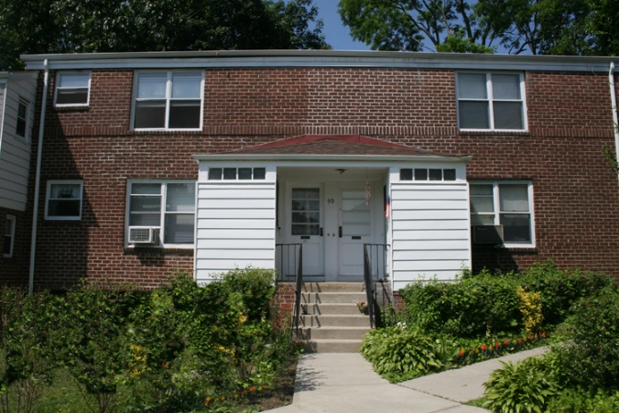  The living room of 94 Spruce St. 2A,  Featuring the open-plan dining area to  The right, and the entrance to the  kitchen. | The entrance of 94 Spruce Street, Apt 2A (left  side door).  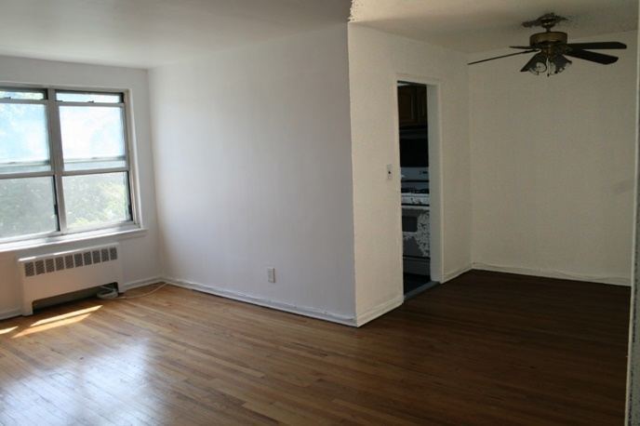
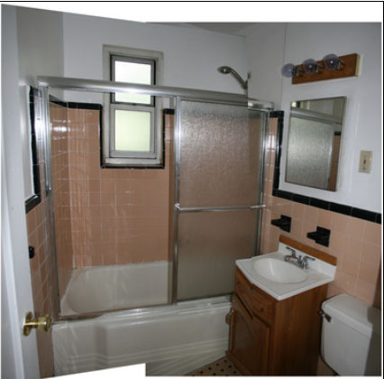  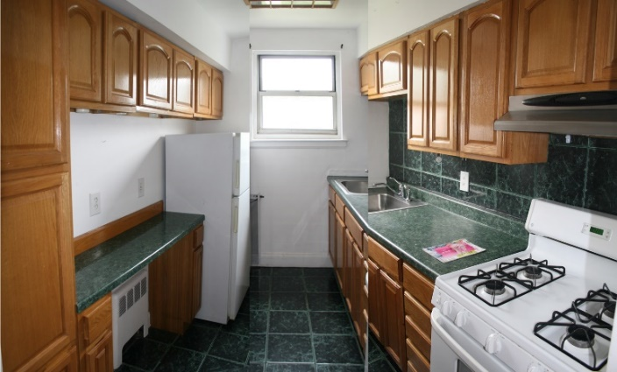  An example of the kitchens in each apartment. | 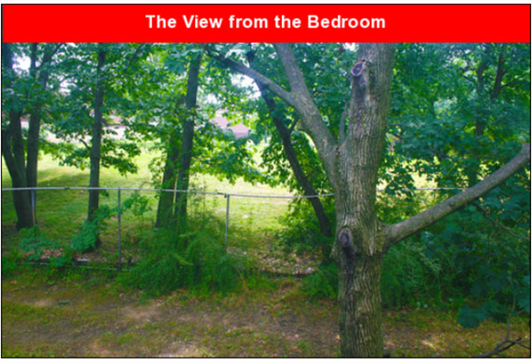  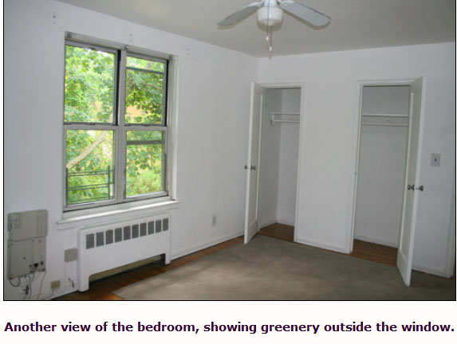
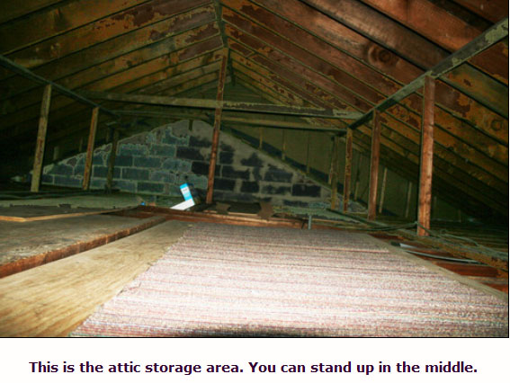 | 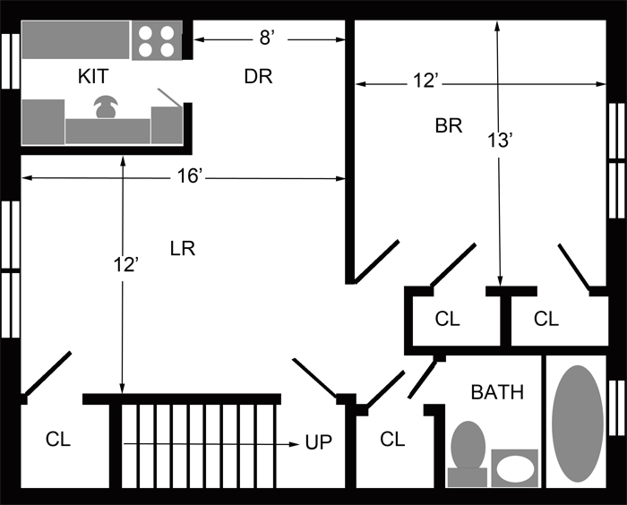

Financial Spreadsheets
Income and Expenses
2024 Historical

Tax Year 2024 | Income | Expenses | Tax Deductable | P/L
90 Spruce St. - Apt. 2A
Income (Rent) | $19,800
Income (Security Deposit)
Used Security Deposit
Expenses
Return Security Deposit
Repairs |  | $350
Supplies |  | 75
Appliances
Co-op maintenance |  | 10,069
Taxes |  |  | 1,407 | 1,407
Interest |  |  | 844 | 844
Total | $19,800 | $12,745 | $2,251 | $9,306
94 Spruce St. - Apt. 2A | Income | Expenses | Tax Deductible | P/L
Income (Rent) | 15,850
Income (Security Deposit)
Return Security Deposit |  | 1,750
Expenses
Return Security Deposit
Repairs |  | 400
Appliances
Supplies |  | 222
Co-op maintenance |  | 10,069
Office |  | 94
Taxes |  |  | 1,407 | 1,407
Interest |  |  | 844 | 844
Total | $15,850 | $14,786 | $2,251 | $3,315
Grand Total Net Profit |  |  |  | $12,621
Income and Expenses: 2025 To Date

Current P&L 9/2025 | Income | Expenses | Tax Deductible | P/L
90 Spruce St. - Apt. 2A
Income (Rent) | $24,000
Income (Security Deposit)
Used Security Deposit
Expenses
Return Security Deposit
Repairs
Supplies
Appliances
Co-op maintenance |  | 10,069
Taxes |  |  | 1,407 | 1,407
Interest |  |  | 844 | 844
Total | $24,000 | $10,069 | $2,251 | $16,182
94 Spruce St. - Apt. 2A | Income | Expenses | Tax Deductible | P/L
Income (Rent) | 22,200
Income (Security Deposit)
Return Security Deposit
Expenses
Return Security Deposit
Repairs
Appliances
Supplies
Co-op maintenance |  | 10,069
Office
Taxes |  |  | 1,407 | 1,407
Interest |  |  | 844 | 844
Total | $22,200 | $10,069 | $2,251 | $14,382
Grand Total Net Profit |  |  |  | $30,564
CAP RATES | SalePrice | Gross Inc. | CAP Rate
Gross Income/Sale Price | $500,000 | $30,564 | 6.1%
Gross Income/Sale Price | $450,000 | $30,564 | 6.8%
Gross Income/Sale Price | $400,000 | $30,564 | 7.6%

Sept. 9, 2025: Market Analysis from ChatGPT:
Yonkers / Westchester County Cap Rate Insights
1. Apartment Loan Store – Yonkers (June 2025)
Provides cap rates for multifamily properties in Yonkers by class:
- Suburban A Class (likely well-maintained properties): 5.75%
- Suburban B Class: 5.88%
- Suburban C Class (probably older or needing updates): 6.25%
Apartment Loan Store
2. Admiral Real Estate – Westchester County Multifamily
Over the last 2–3 years:
- Prime locations (e.g., near Metro-North stations): cap rates around 5%
- Walk-ups or less vibrant areas: significantly higher, between 7% – 8.5%, depending on size, condition, maintenance issues admiralrealestate.com
3. Showcase Listings – Westchester Multifamily for Sale
Current listings show a range of actual asking cap rates:
- Lower end: ~4.9% – 6.0% (e.g., 50 Highland Ave at 4.9%; Sleepy Hollow at 6.0%)
- Mid-range: 6.3% – 7.0% (e.g., Rollins St Yonkers at 6.31%; Stanley Pl Yonkers at 7.0%)
- Higher end: 8% – 9.5% (e.g., some Yonkers and Mount Vernon properties) Showcase+1
4. Hudson Valley Benchmark
A broader regional metric (includes parts of Westchester):
- Multifamily properties: generally yield 5.5% – 6.5%
Birchwood Property & Ventures

Summary Table: Cap Rate Ranges
Location / Source | Estimated Cap Rate Range
Suburban Yonkers A-Class (Apartment Loan Store) | 5.75%
Suburban B-Class (Yonkers) | 5.88%
Suburban C-Class (Yonkers) | 6.25%
Prime Westchester multifamily | ~5%
Walk-up / secondary locations (Westchester) | 7.0% – 8.5%
Current listing prices (Yonkers area) | 4.9% – 9.5%
General Hudson Valley multifamily | 5.5% – 6.5%

Interpretation for 2-Family, 1-Bedroom Buildings
Your property type (two-family, each unit 1 BR) likely falls into the suburban B or C category—unless it's in a high-demand downtown or transit corridor (which could push it toward A-Class characteristics).
- If well-maintained and in decent suburban location: cap rate may hover around 5.8% – 6.2%
- If prime location or exceptional asset: you might see ~5%
- If older or in less desirable spot: cap rate could climb to 7% or more

Final Thoughts
- Average cap rates for such properties in Yonkers / Westchester typically range between ~5% to 6.5%.
- Listings demonstrate variability—some exceptional cases yield as low as 4.9%, while others approach 8-9% depending on condition and location.
- Regional benchmarks (Hudson Valley) support this range, pointing to 5.5% – 6.5% as standard for multifamily assets.

Excerpts from Rumsey Gardens Co-Op
Proprietary Lease and Bylaws
Supporting the “Sponsor Exempt” Status

RUMSEY GARDENOWNERS, Inc.,
Lessor,
TO
(Name Witheld)
Lessee.
PROPRIETARY LEASE
(EXCERPT)
37. Continuance of Cooperative Management of Building After All leases Terminated No later than 30 days äfter the termination of all' propri— etazy leases for space in the Building, whether by expiration of their terms or otherwise, a special meeting of shareholders of the Lessor shall take place to determine whether (a) to continue to operate the Building as a residential apartment Building, (b) to alter, demlish or rebuild the Building or any part thereof, or (c) to sell the Building and liqui— date the assets of the Lessor, and the Directors shall carry out the detemination made by the holders of a majority of the shares of the Lessor then issued arß outstanding at said Iteeting of shareholders of the lessor, ard all of the holders of the then issued and outstanding shares of the Lessor shall have such rights as enure to shareholers of corporations having the title to real estate.
38. (a) Unsold Shares The term "Unsold Shares" means and refers to shares of the Lessor which have been issued or transferred either to the Sponsor or individual designee(s) of the Sponsor pursuant to the Plan of cooperative organization of Lessor and all shares which are Unsold Shares retain their character as such (regardless of transfer) until an individual purchases same actually occupies (by hinuself or a person related to him by blood or marriage) the apartrnent to which shares are allocated. Holders of unsöld shares may not cancel their proprietary leases unless (i) share—holders owning a majority of the apartment corporation's outstanding shares (other than unsold shares) shall have given notice of intent to cancel or (ii) all unsold shares constitute fifteen (15%) percent or less of the apartment corporation's outstarding shares, at least five (5) years have elapsed since the apartment corporation acquired title to the building and, on the effective date of cancellation, holders of unsold shares shall pay to the apartment corporation a sum equal to the product of the then current mnthly maintenance chargés payable under the proprietary lease multiplied by twenty—four.
- Subletting Apartment and Sale of Shares: Neither the subletting of the apartment from time to time nor the sale ot assignment of this lease or any shares of the Lessor by the holder of Unsold Shares allocated to the apartment shall require the consent of the Lessor, Directors, shareholders or any other person or entity. At the request of the holder of Unsold Shares, the Lessor shall consent in writing to any such subletting, sale or assignment and shall execute a recognition agreement in connection there— with, but such consent shall not be required in order for any such subletting, sale or assignment to be effective.
- Change in Form of Lease: Without the Lessee's consent, to change in the form; terms or conditions of this lease, as permitted by Paragraph 6, shall (1) affect the rights of the holder of Unsold Shares allocated to the apartment leased hereby to sublet the apartment or to assign this lease, as hereinbefore provided in this Paragraph 38, or (2) eliminate or modify any other rights, privileges or obligations of such holder of Unsold Shares.
P—22

RUMSEY GARDENOWNERS, Inc.,
BYLAWS
(EXCERPT)

Section 6. Regrouping the Space: the Board of Directors, upon the written request of the owner or owners of the shares appurtenant to one or more proprietary leases covering one or more apartments in the apartment building may, in its discretion, at any time permit such owner or owners, at his or their own expense, as determined or approved by the Board of Directors:
- to subdivide any apartment into any desired number of apartments, (i i) canbine all or any portions of any such apartments into one or any desired number of apartments and (iii) to relocate the shares issued to accompany the proprietary lease or leases, but, subject to subsection (b) of this Section, the total number of the shares so reallocated shall not be more or less than the number of shares previously allocated to the apartment or apartments involved; or
- to incorporate one or more servant’s rooms or other space in the building not covered by any proprietary lease* into one or more apartments covered by a proprietary lease, whether in connection with any regrouping of space pursuant to subsection (a) of this Section or otherwise, arE in allocating shares to any such resulting apartment or apartments r shall determine the number of theretofore unissued shares to be issued and allocated in connection with the appropriation of such additional space, in accordance with the principle set forth in Section 3 of this Article V.
Upon any regrouping pursuant to subsections (a) or (b) above, the proprietary leases so affected, and the accompanying certificates of shares, shall be surrendered and there shall be executed and delivered in place thereof respectively, a new proprietary lease for each separate apartment involved, and a new certificate of shares for the number of shares so reallocated to each new proprietary lease,
The holders of Unsold Shares, however, shall have the absolute right, without payment of any fee or charge, to change the size and layout of any apartment including the right to subdivide any apartment owned by any of them into two or more apartments, or to combine all or any portion of such apartments into any desired number of apartments, provided such alterations do not unreasonably encroach on public areas commonly used as such.
BL - 11

