9521 Folsom blvd. unit k sacramento 95827

available  now | 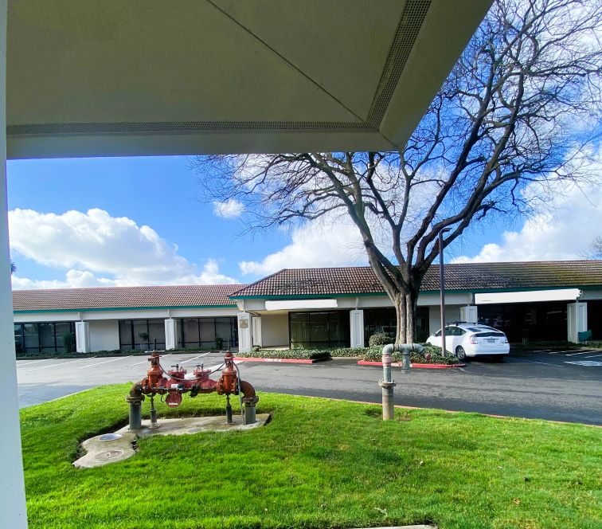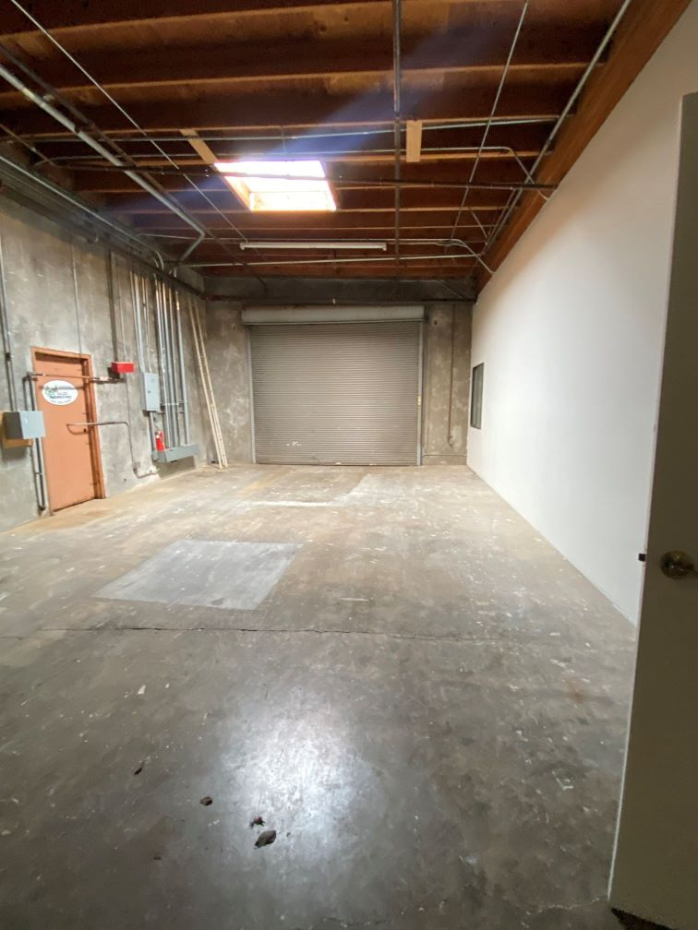
warehouse space
1600 SQ. FT Warehouse Space
1920 Attached Offices
Located Within Butterfield Plaza
Anchor Tenants -Woodcraft/Dominos
Well Maintained Retail Shopping Center
On- Site Management
Near the Butterfield Light Rail Station
HWY 50 – 15 min to Midtown/Folsom
Monument Signage
DINA CALVERT  916-363-4600  dina@lindaflood.com |  | 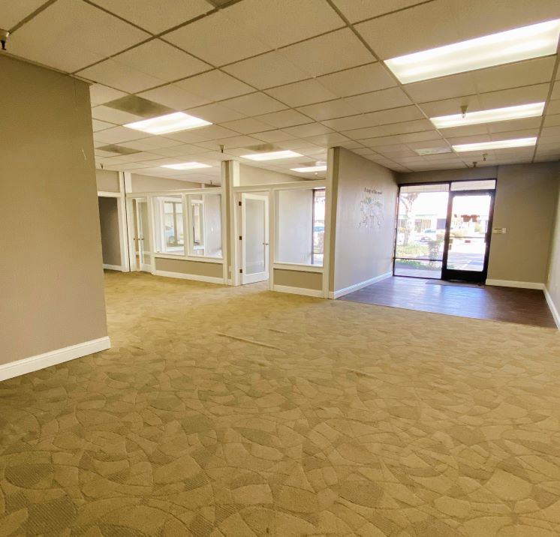
www.butterfield-plaza.com

