- WATERWORKS OFFICES & MARINA FIRE PLAN
1800 WESTLAKE AVENUE NORTH
SEATTLE, WA 98109

SUITE 00-104

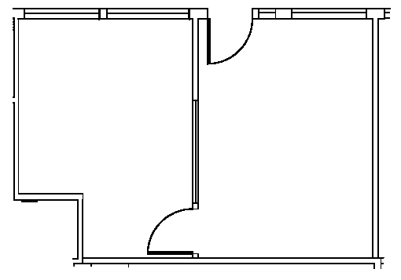

Rentable: 423 sq. ft.
(As measured March 2002)

