

4600 HWY 6 N
EXECUTIVE SUITES: #378 - #383

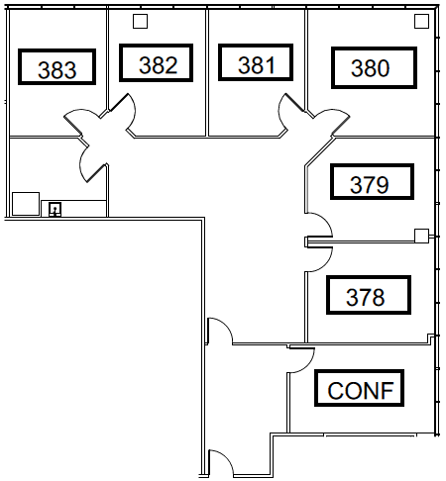

LEASING INFORMATION
MATT EVANS
713-627-1100
MEVANS@ROCKWELLMGMT.COM

