
For further information please contact:
01582 957591
9 Compton Avenue,
Luton, LU4 9AX
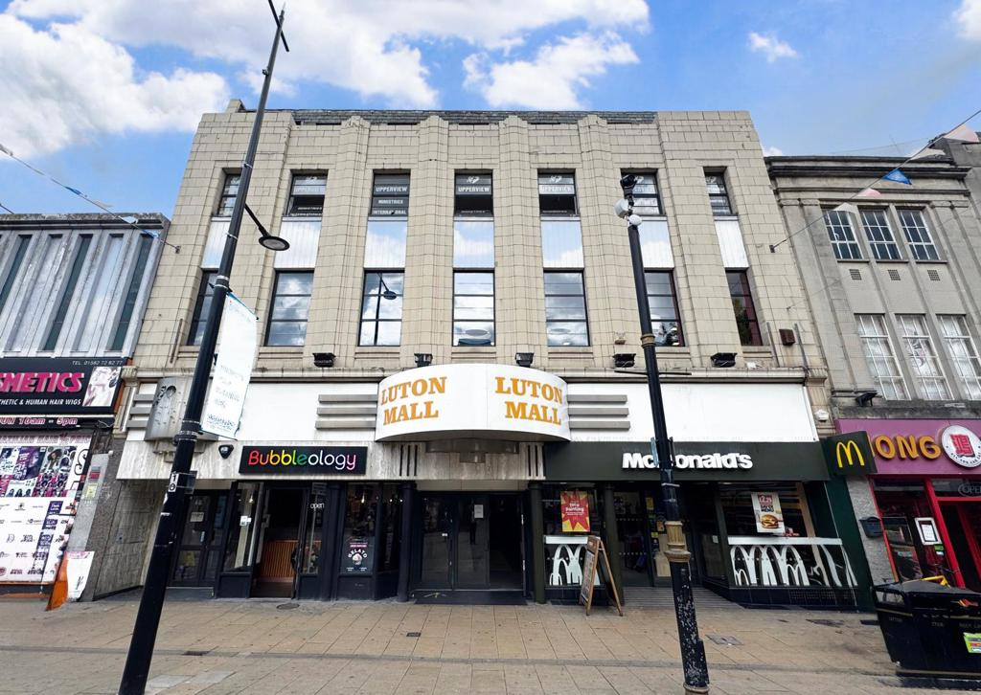
To Let

3rd Floor, 46 George Street, Luton, LU1 2AZ

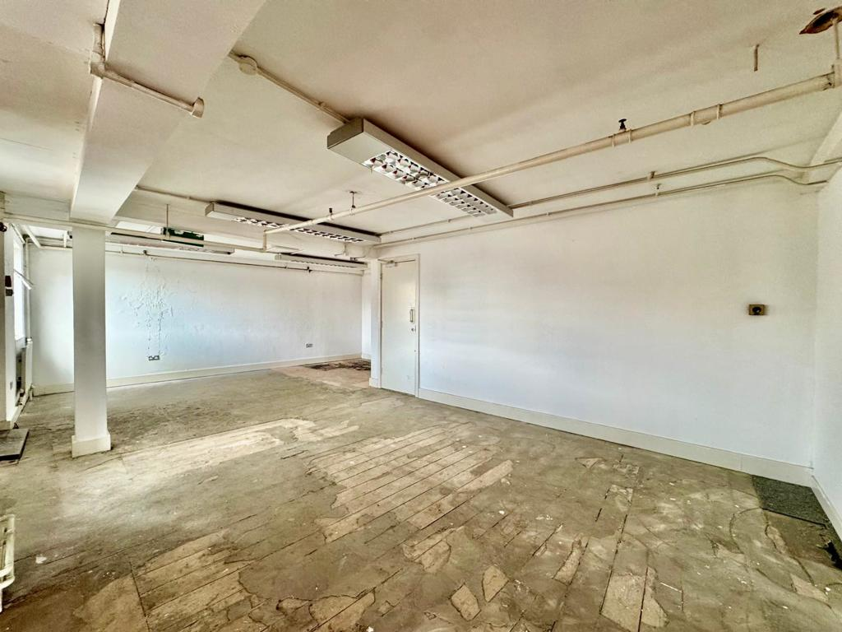
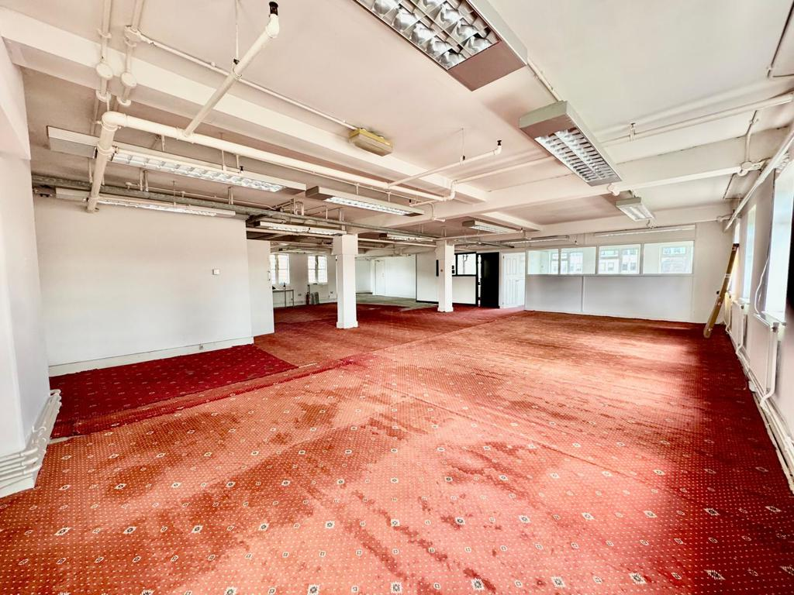




2,055 Sq Ft / 190.91 Sq M
£20,000 Per Annum
Third floor office suite which comprises of large open plan main room with 2 ancillary offices with natural light throughout.
The office is accessed from the ground floor on George Street with stairs rising to the third floor with own access to the office suite, this space would be ideal for a company looking for a spacious office in a vibrant town centre location.
For further information please contact:
Stimpsons Eves is the trading name of Stimpsons Eves Limited Registered in England & Wales. Company Reg. no; 6512125 whose registered address is 138 Bromham Road, Bedford, MK40 2QW. Note: Messrs. Stimpsons Eves for themselves and for vendors or lessons of this property whose agents they are given notice that: (i) the particulars are set out as a general outline only for the guidance of intended purchases or lessees, and do not constitute, nor constitute part of, an offer or contract;(ii) all descriptions, dimensions, reference to condition and necessary permissions for use and occupation, and other details are given without responsibility and any intending purchases or tenants should not rely on them as statements or representations of fact but must satisfy themselves by inspection or otherwise as to the correctness of each of them; (iii) no person in the employment of Messrs. Stimpsons Eves has any authority to make or give any representation or warranty whatever in relation to this property.
01582 957591
9 Compton Avenue,
Luton, LU4 9AX

3rd Floor, 46 George Street, Luton, LU1 2AZ

Situated within Luton town centre the property benefits from being within a bustling town with a range of shops and amenities, The property is also located within walking distance to Luton main train station with access links to London in under 35 minutes.Luton also benefits from excellent road links including the A6 and a short drive to Junctions 10 & 11 of the M1 with road links to London and The North.
Location
Costs

Rateable Value TBC. The rates payable may be affected by transitional arrangements. Interested parties should call the local Rating Authority for further advice.
Rates
All figures are quoted exclusive of VAT, purchasers and lessees must satisfy themselves as to the applicable VAT position, seeking appropriate professional advice.
VAT
The premises are to be let by way of a new lease at a rental of £20,000 per annum exclusive.
Terms & Tenure
Third Floor Office Suite 2,055 sq ft (190 sq m)
Accommodation
The EPC rating for the property is 75 - Band C.
EPC
Each party is to be responsible for their own legal costs.
Strictly by appointment only please contact:
Sean Sumbillo sean.sumbillo@stimpsonseves.co.uk
Joanne McGirl joanne.mcgirl@stimpsonseves.co.uk
Viewing

