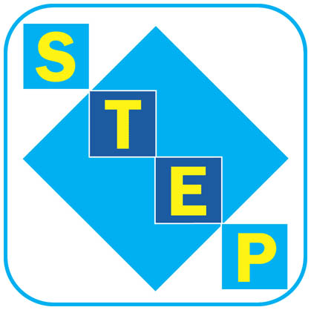
BUSINESS CENTRE
Unit Size

OFFICES | Size
Small Offices | 154 sq ft
Medium Offices | 230 – 266 sq ft
Large Offices | 307 - 391 sq ft

WORKSHOPS | Size
Small Workshops | 301 sq ft
Small Converted Business Units | 301 sq ft
Large Workshops | 548 sq ft
Large Converted Business Units | 548 sq ft

Workshops monthly licence fee includes heating and services.
Electricity is metered in workshops and will be charged monthly, in arrears, on actual usage.
Business Rates are payable directly to the Sheffield City Council.

Services provided at no additional cost include heating, reception facilities, general maintenance of building and grounds, cleaning of public areas, CCTV and alarm systems. Additional charges are payable for additional services e.g. cleaning of unit.

Rent is payable in advance, services are payable in arrears.

A bond equal to one month’s rent plus one month’s rent in advance is required before occupation.
All charges are to be paid by monthly direct debit, cheque or cash.

