
Estate Agents – Residential And Commercial
413 St Saviours Road, Leicester, LE5 4HH TEL: (0116) 273 1200 E: info@leoproperties.com

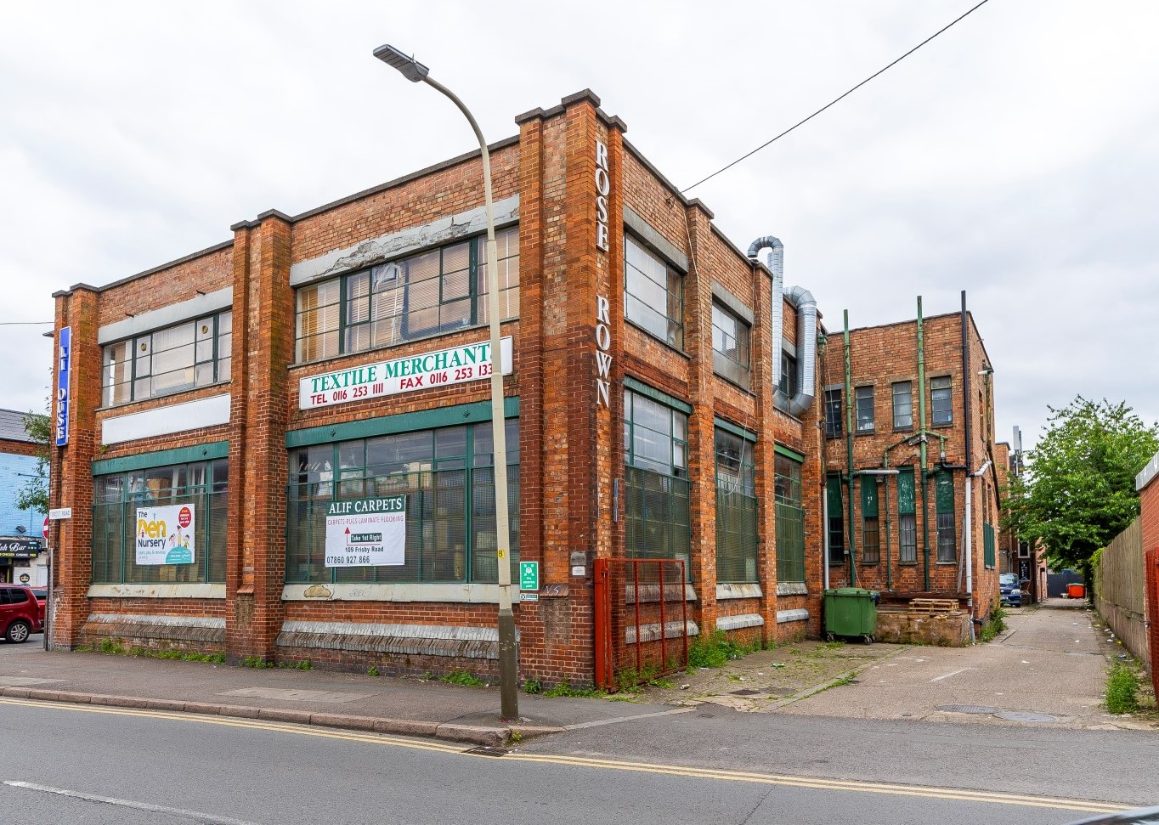
41 FOREST ROAD/FRISBY ROAD, Leicester, LE5 0DW
TO LET £25,000 P.A (£2083.33 P.C.M)
Approximately 8,000 SQFT industrial unit on ground & 1st floor within prime location and good catchment area of local labour/workforce on Main Road. The Premises briefly is in good condition, high ceiling, car park space, office, fire exit, goods loading & unloading access, Wc facilities, 3ph/1ph electric phase supply.
* Over 2 floors *Total Approximately 8,000 SQFT
*Ground Floor Approx 4000SQFT *First Floor Approx 4000SQFT
*Car Park *High Ceiling
*First Floor Office *Fire Exit
*Goods Loading / Unloading *Shutter
*WC facilities *3ph/1ph Electric Phase supply
*Good catchment area *Available Immediately

