SUITE 616 & 606 SHADEDAAEA 6,842.24 NUA
8,1n.85NRA
Add on Faclor 1.1952

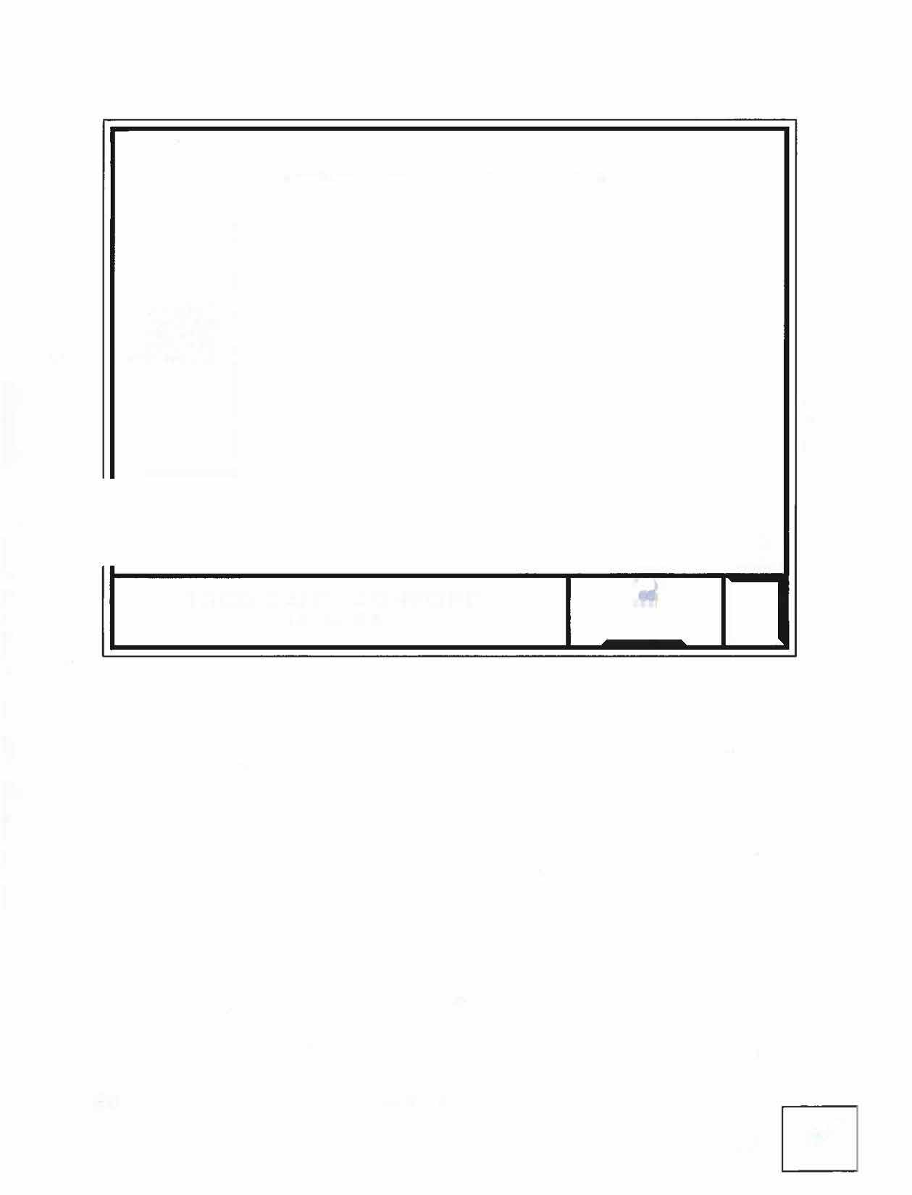
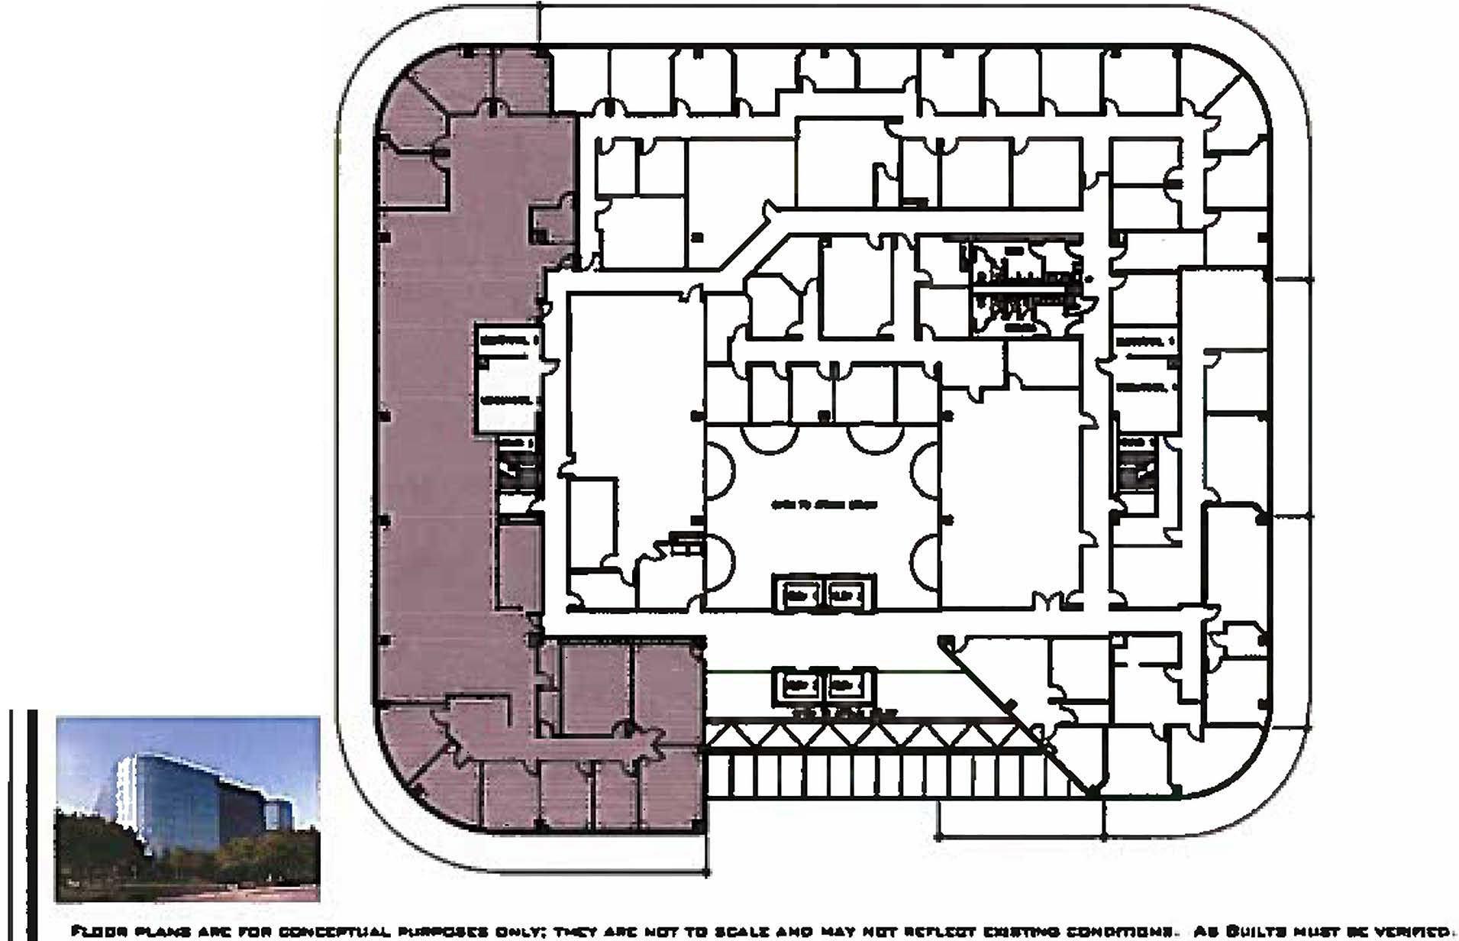
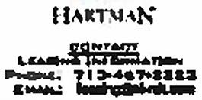
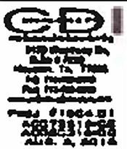

916

1880 DAIRY ASHFORD
LEVEL 06

Exhibit "A"
m :-,-c-,.t

Initials
VK fit

