News Story Submission Template

Story Headline: | Ohio Retail Centers Receive Financing for $43.65M
Story Subhead: | JLL Capital Markets represented DLC Management Corp. in securing financing for two Ohio shopping centers
Story Body: | On January 21, 2025, JLL announced that financing had been secured for Taylor Square in Reynoldsburg and Tuttle Crossing in Dublin, Ohio. The financing consists of $30 million and $13.65 million. JLL represented the borrower, DLC Management Corp. They were able to secure a five-year, fixed rate loan through Tristate Capital Bank.  Tuttle Crossing consists of 276,718 square feet and is located at 5700-5830 Britton Parkway in Dublin. The property was built in 1996 and sits on 18.66 acres. There are 1,200 parking spaces and the center is between Britton Parkway and I-270. The center includes many major tenants including Best Buy, Ross Dress for Less, Golf Galaxy, and World Market.  Taylor Square consists of 378,102 square feet and was built in 2000. The center recently underwent renovations in 2023. Major tenants at the site include Marshalls, JOANN Fabric and Crafts, Avis, and Walmart.  Scott Aiese, Claudia Steeb, and Alex Staikos of JLL Capital Market’s team based in New York represented the borrower.
Property ID(s): | PID: 766238  PID: 713121
Contact ID(s): | CID: 5654370  CID: 2163587  CID: 12913641  Loc: 28753 (DLC Management Corp)  Loc: 22338688 (TriState Capital Holdings)
Name and CID of Person who verified Comp (if applicable): | Press release from JLL
Transaction ID(s): | N/A
Research Market | Columbus
Broker(s) Notified  [Y/N] | No- Press release  $43.65M financing secured for Ohio retail centers

Reminders:
- Please attach an image of the PID or CID (if a people story) below.
Photo on next page
- Please indicate who you called and or emailed to notify of news story in internal note of comp.
Both sides, emailed

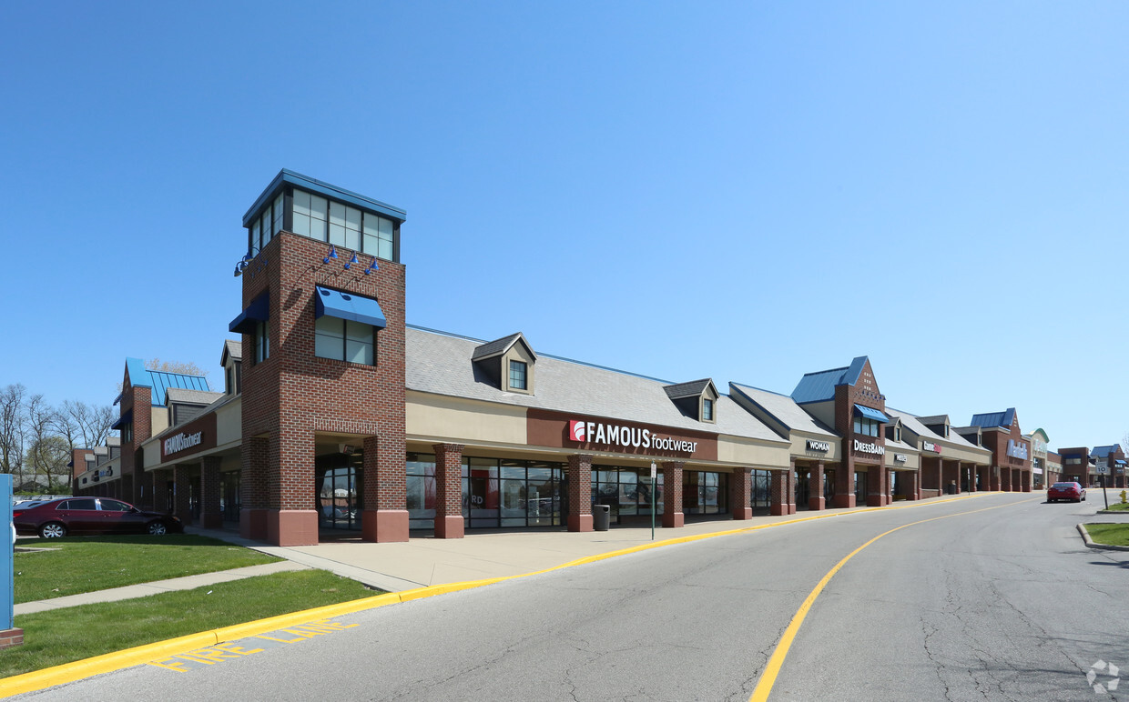
Taylor Square

