SHOP TO LET

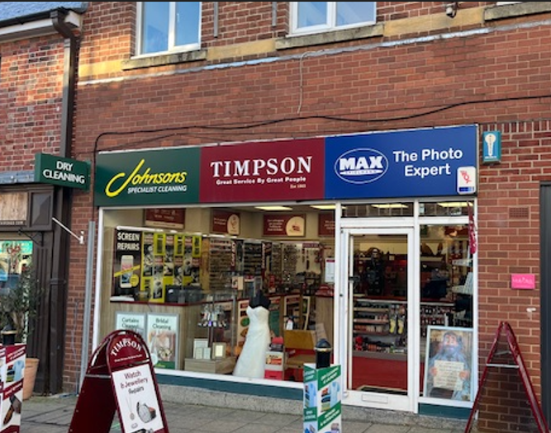
1 SWAN STREET
WARWICK
CV34 4BJ

- GROUND FLOOR SHOP
- SALES AREA 437 SQ FT (40.6 SQ M)
- REAR STORE/POTENTIAL SALES 457 SQ FT (42.5 SQ M)
- REAR STORE 66 SQ FT (6.1 SQ M)
- BOILER ROOM 85 SQ FT (7.9 SQ M)
- REAR GARDE
- £18,500 PER ANNUM

SITUATION  DESCRIPTION  ACCOMMODATION | Swan Street is a vibrant shopping location in the centre of Warwick and is a primary destination within the town, with a variety of independent shops, restaurants and pubs contributing to the town’s historic character and close to Market Place.  The ground floor shop premises comprises an initial sales area, with stores/potential increase in sales area, rear store and rear garden.  Ground Floor  Sales 437 sq ft (40.6 sq m)  Rear Stores/  Potential Sales 457 sq ft (42.5 sq m)  Rear Store 66 sq ft (6.1 sq m)  Boiler Room 85 sq m (7.9 sq m)  Rear Garden  OVERALL AREA 1,045 SQ FT (97.1 SQ M)
Please note : Every effort has been made to ensure that the above floor areas are accurate. They are in accordance with the Code of Measuring Practice. Fittings restricted measurement at the time of inspection. Interested parties should verify these for themselves.

LEASE The property is offered on a new full repairing
lease for a term of years to be agreed.

RENT £18,500 per annum exclusive
RATEABLE VALUE | £16,000 from 1st April 2026.
SERVICES | Mains electricity, water and drainage are connected.
LEGAL COSTS | Each party will be responsible for their own legal costs in the transaction.
VAT  EPC | VAT will be payable where applicable.  Energy Rating Band C
VIEWING | Strictly by appointment with the Agents.



